Over introdoction of inspection training, I had clearly introduced my scheduled testing items , BSMI overview, and my servicing section, polymer section of sixth department 11-20
.
Rigid polyisocyanurate(PIR) and polyurethane(PUR) are foam and closed cell structure. Owing to the property of high thermal insulation, they are almost made to products for building end-use applications( such as internal wall linings, roof). What is the difference between PIR and PUR？ The explanation is stated as follows(cited from Wikipedia, the free encyclopedia).
The reaction of MDI and polyol takes place at higher temperatures compared to the reaction temperature for the manufacture of PUR. At these elevated temperatures and in the presence of specific catalysts, MDI will first react with itself, producing a stiff, ring molecule, which is a reactive intermediate (a tri-isocyanate isocyanurate compound). Remaining MDI and the tri-isocyanate react with polyol to form a complex poly(urethane-isocyanurate) polymer (hence the use of the abbreviation PUI as an alternative to PIR), which is foamed in the presence of a suitable blowing agent. This isocyanurate polymer has a relatively strong molecular structure, because of the combination of strong chemical bonds, the ring structure of isocyanurate and high cross link density, each contributing to the greater stiffness than found in comparable polyurethanes. The greater bond strength also means these are more difficult to break, and as a result a PIR foam is chemically and thermally more stable: breakdown of isocyanurate bonds is reported to start above 200°C, compared with urethane at 100 to 110°C.
PIR typically has an MDI/polyol ratio, also called its index (based on isocyanate/polyol stoichiometry to produce urethane alone), higher than 180. By comparison PUR indices are normally around 100. As the index increases material stiffness but also brittleness also increase, although the correlation is not linear. Depending on the product application greater stiffness, chemical and/or thermal stability may be desirable. As such PIR manufacturers can offer multiple products with identical densities but different indices in an attempt to achieve optimal end use performance.
PIR is typically produced as a foam and used as rigid thermal insulation. Its thermal conductivity has a typical value of 0.16 BTU*in/hr*ft²*°F (0.023 W/(m·K)) depending on the perimeter:area ratio. PIR foam panels laminated with pure embossed aluminium foil are used for fabrication of pre-insulated duct that is used for heating, ventilation and air conditioning systems. Prefabricated PIR sandwich panels are manufactured with corrosion-protected, corrugated steel facings bonded to a core of PIR foam and used extensively as roofing insulation and vertical walls (e.g. for warehousing, factories, office buildings etc.). Other typical uses for PIR foams include industrial and commercial pipe insulation, and carving/machining media (competing with expanded polystyrene and rigid polyurethane foams).
Effectiveness of the insulation of a building envelope can be compromised by gaps resulting from shrinkage of individual panels. Manufacturing criteria require that shrinkage be limited to less than 1% ] (previously 2%]). Even when shrinkage is limited to substantially less than this limit, the resulting gaps around the perimeter of each panel can reduce insulation effectiveness, especially if the panels are assumed to provide a vapor/infiltration barrier. Multiple layers with staggered joints, ship lapped or tongue & groove joints greatly reduce these problems.
According to the standard of BS EN 4841-2, PIR/PUR must conform to testing as belows,
- thermal resistance and thermal conductivity
- dimensions(length and width, thickness, squareness, flatness)
- compressive strength(normal and parallel to the major plane of the board)
- dimensional stability under specified temperature and humidity conditions
- tensile strength normal to the major plane of the board
- reaction to fire

dimensions(length and width, thickness, squareness, flatness)
measuring the length and width of test specimens where both l and b ≦ 1.5m, but for length or width ≧1.5 m, then the over dimensions portion should be additional
test. All length and width shall be read to the nearst millimetre.

compressive strength(normal and parallel to the major plane of the board)
taking the value of 10% strain when no yield or rupture as compressive strength, or maximum peak value occuring on the yield point as compressive strength

dimensional stability under specified temperature and humidity conditions
separately set specimen into the chamber( (70±2℃, 90±5%RH, 48hrs) and (-20℃, 48hrs)) and acquire the difference value of length, width, thickness between before and after test.

tensile strength normal to the major plane of the board
the dimension of specimen is original thickness, length x width list as belows,
50mm x 50 mm, 100mmx 100mm, 150mm x 150mm, 200mm x 200mm, 300mm x 300mm. test speed is 10mm/min.
Suggestion:
- the varied fixures of tensile strength testing should be newly made for fit different size of specimen.

TENSILE TESTING FOR PVC TUBE----11/23

The test are in accordance with ASTM D638-10
The test sample is PVC tube. We cut PVC sheet from tube for making dummy(dogbone) specimen.

According to standard of ASTM D638-10, we set speed of testing and gage length as 5 mm/min as well as 25 mm separately.
Test 1:
The tesile stress and elongation is
49.38 Mpa, 108 %
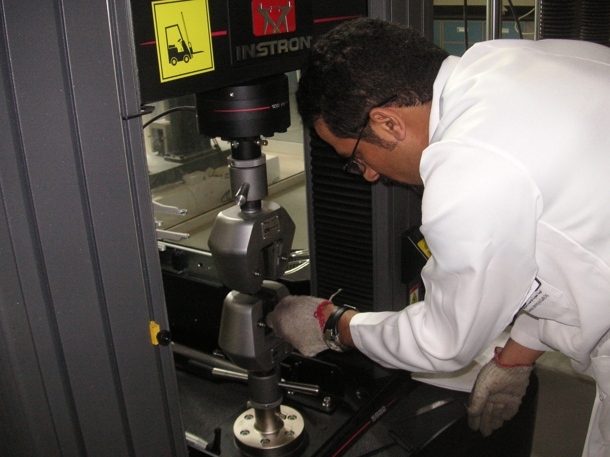
Tensile testing for PVC specimen

