VISITING INSPECTION BUILDING OF SASO-11/16 附件1

Over cruising on the spot of ground, first, second floor, we found the category of testing equipment is divided as bellows,

Tensile testing:
350 tons dynamic tensile testing machine,
10 tons statics tensile testing machine,
1 tons statics tensile testing machine,

Hardness testing:
Universal hardness testing machine(Rockwell, Brenell, Vicas)
Durameter hardness testing device

Weather resistance testing :
Electrical oven
Climate testing chamber
Suntest machine
Uvtest machine

Flame testing:
UL-94 plastics flammability tester
Limiting oxygen index testing machine

Impact testing :
Izod impact tester
Ball type impact tester
Long range for PVC tube impact tester
Du-Pond impact tester

Visual inspection:
Optical microscope
Profile projector

Dimension-measuring:
Caliper
Micrometer
Dial indicator
Suggestion:
- For small measuring equipments, such as caliper, micrometer, dial indicator, weight, maybe all be keeped in standard condition room (23±2℃, 50±5%RH)
and be managed by assigned technician. Over this way, these equipments not only flock together and cannot be lost, but also will not be damaged by variation of environmental factor ( temperature, humidity).
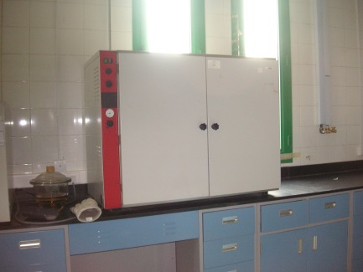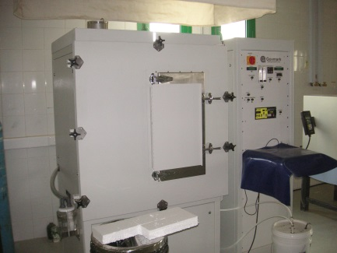
electrical oven fume density tester
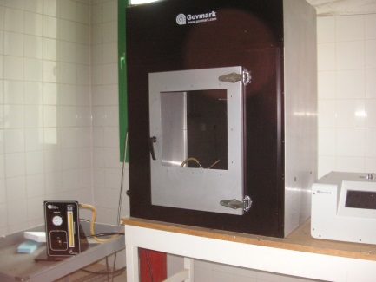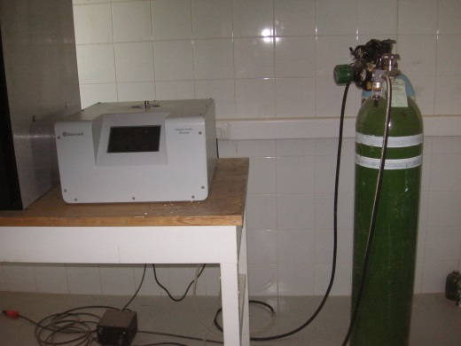
UL-94 plastics flammability tester limiting oxygen index tester
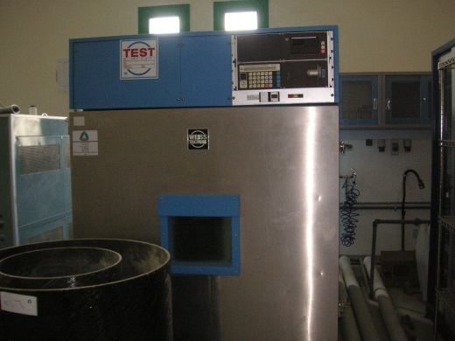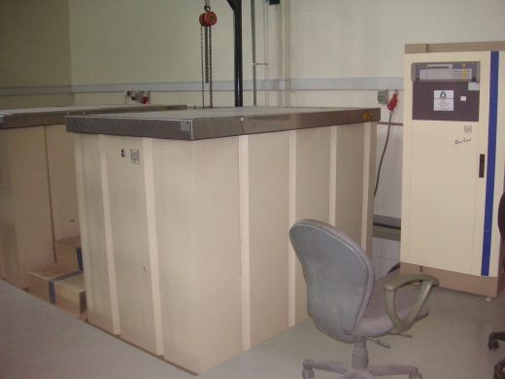
Climate test chamber water pressure tester
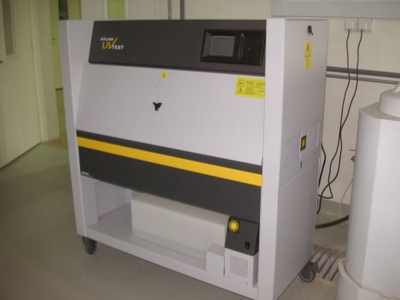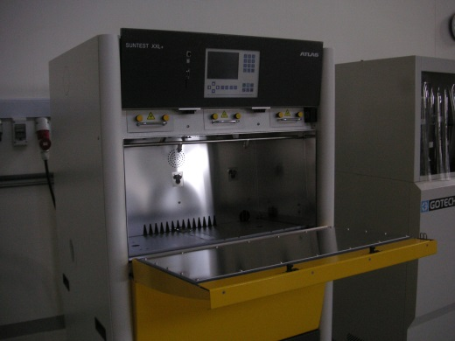
Uvtest machine suntest machine
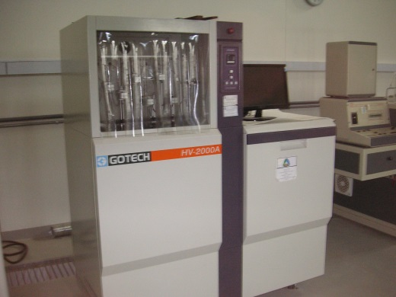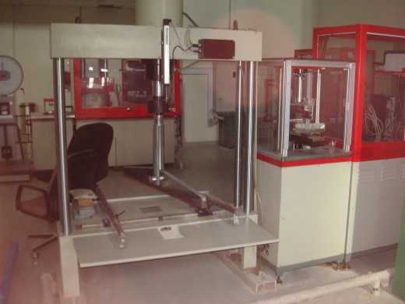
HDT/VICAT testing machine bend testing machine for tile
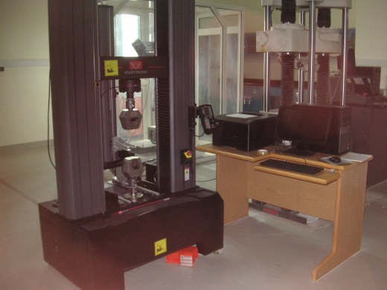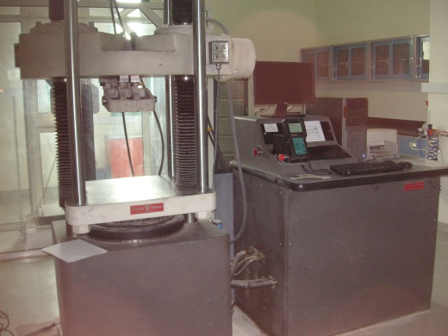
Tensile testing machine(1) tensile testing machine(2)
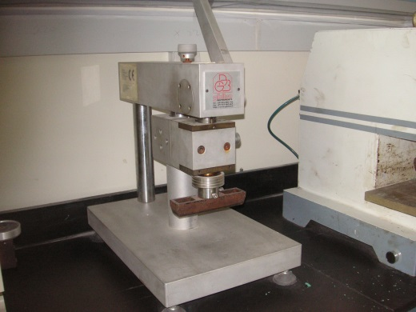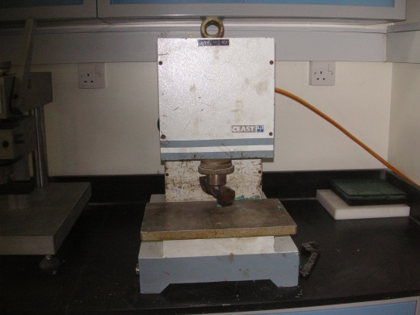
Specimen cuttig machine(by hand) specimen cutting machine(by neumaric)
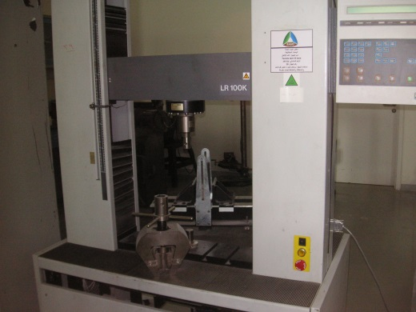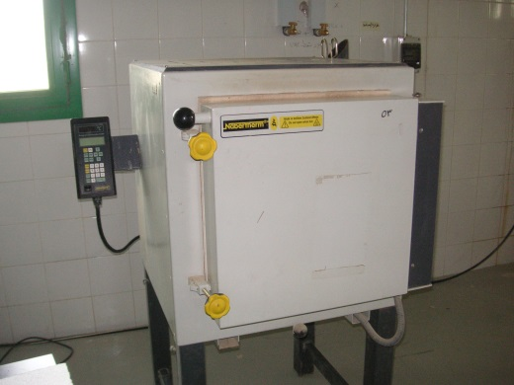
Tensile testing machine(3) high temperature electrical oven

COMPRESSIVE TESTING FOR POLYSTYRENE----11/17

The test are in accordance with ASTM C578 and ASTM D1621.
The test sample is polystyrene board. We cut partial board for making cubic specimen,
100.06(l)＊96.31(w)＊47.1(h).

According to standard of ASTM D1621, we take 10 % deformation as compressive strength when yield point doesn’t occur during test. That is to say, presser connected to cross head downword at 10mm/min until 4.71mm deformation and show the corresponding force is the value what we want to acquire.
Test 1:
The force of 10% defrmation is 721 N and area is 100.06mmx96.31mm

Compressive resistance at 10% deformation=(721/(100.06x96.31))=0.0748 N/mm^2

Owing to 1 Mpa= N/mm^2 = 10^3 kPa, the 0.0748 N/mm^2 will be change to 0.0748x10^3 kPa. The final result is 74.8 kPa. ( applied force in normal direction)

Test 2:
The force of 10% defrmation is 320 N and area is 100.98mmx47.1mm
Compressive resistance at 10% deformation=(320/(100.98x47.1))=0.06728 N/mm^2

Over changing the unit, the final result is 67.3 kPa.(applied force in side direction)

For judging the grade of type, we measure the density and acquir length, width, thickness as follows,

Length: 94.19, 94.56, 95.20 average: 94.65mm
Width: 100.36, 100.61, 100.86 average: 100.61mm
Thickness: 48.34, 48.30, 48.20, 48.00 48.13, 48.19 average:48.193mm

Apparent density = M/V = (5.651/(94.65x100.61x48.193)x10^6 =12.3 kg/m^3

The classification is Type XI and compressive resistance at 10 %deformation is 35 kPa(min). Test 1 and Test 2 are all conform to the minimum value.

Suggestion:

- Owing to lack of band sawing machine, the surface of specimen is very coarse.
For sake of the fine cutting surface of specimen and efficiently cutting process, I
suggest setting one band sawing machine is important and essential.

- According to standard of ASTM D1621, we take 10% deformation as compressive resistance when yield point doesn’t occur during test. How do you know the yield doesn’t occur？
If we set computer, the test process or s-s curve will present in moniter in real time and we can judge the specimen whether the yield point can occur or not. If yield point does’t occur, 10% deformation is right, or the result is wrong.

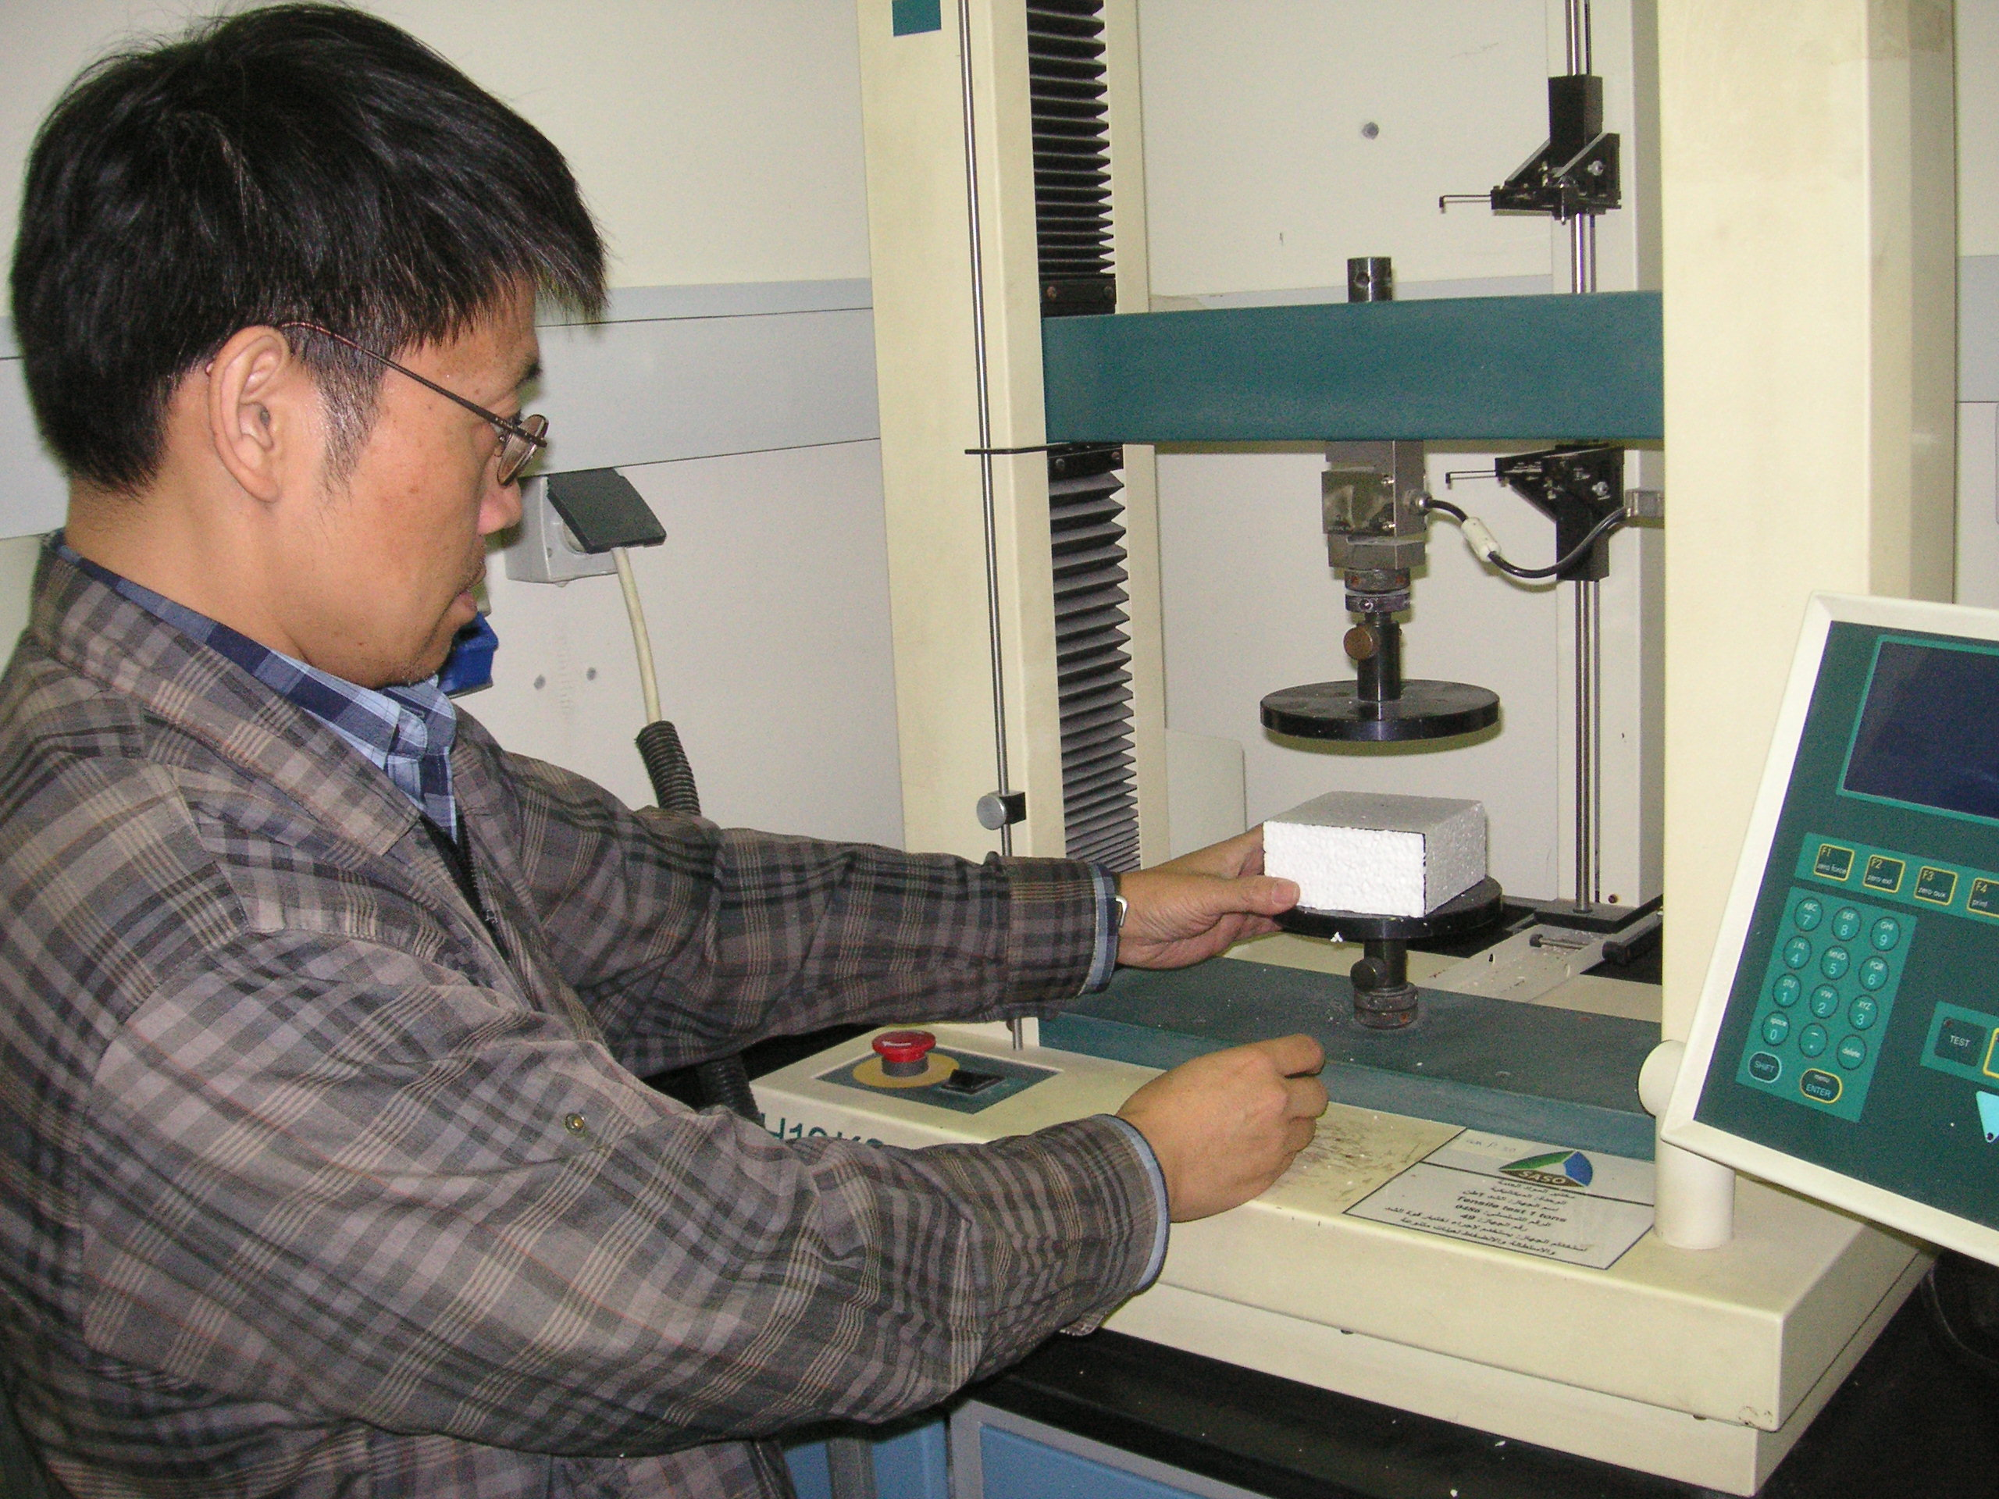
compressive resistance at 10% deformation test over tensile testing machine

