出國報告（出國類別：研討會）

第八屆國際意義研討會

論壇發表：
一位諮商心理師的轉化
--- 從追求卓越到身為學佛者的謙卑

服務機關：高雄師範大學
姓名職稱：卓紋君教授
派赴國家：加拿大
出國期間：103/7/24-27
報告日期：103/10/9
目的
第八屆國際意義研討會(8th Biennial International Meaning Conference)是由國際意義建構網絡學會(International Network on Personal Meaning)所主辦，今年特別還跟甫初成立第二年的建構心理學學會聯合辦理。大會所探討的議題涉及意義治療、失落與哀傷治療、臨終關懷、生命教育與意義重構等，這些議題不僅跟我個人專業的興趣和授課方向有關，而且也是我目前開始關切的普世問題--側重物質而忽略心靈，鮮少思維生命意義與心靈而感到迷失，因而引發眾多自傷傷人的悲劇現象。我個人也因為多年來投入福智團體的學習，逐漸看到自己過去只專注在諮商心理方面的專業，不知心靈提升和無限生命的概念對我們身心的影響更甚於心理健康。這樣的醒覺和該研討會所著重的精神是相呼應的，因此我便積極撰文整理自己的反思和轉變，投入該研討會專題論壇報告的申請(也有壁報論文的投稿) 。我希望能夠透過該會和來自世界各國以及跨領域的學者及實務工作者，互相交流與分享，激盪出更深入和更具省思的學習。
本報告書主要呈現了我在論壇的報告內容，旨在表述個人對於自身專業生涯的意義建構和反思。希望透過這樣的表述能夠帶動國際會議中的與會者也能多關注生命和心靈的面向，成為一種信念和助人專業的核心價值。

過程
- 概述
第八屆國際意義研討會(8th Biennial International Meaning Conference)安排於加拿大溫哥華的 Coast Plaza Hotel，步行出旅館幾條街，就可以看到美麗的海岸，該區是知名的國家公園。該會議共有4天，自7月 24日到27日。每天都有專題演講、高峰論壇、小型工作坊、壁報論文展示和專題論壇，參與者主要是美國、加拿大、歐洲和少數來自亞洲國家的學者、實務工作者和研究生。
我參與的專題論壇報告安排在7/27上午9:45~11:15。該論壇有一位主持人和包括我在內的來自台灣的三位報告者。首先由主持人介紹和開場，接下來由我先開始報告，每人平均約20分鐘，之後便由與會者提問，回應和討論。 以下用英文直接呈現該場論壇的主題、摘述以及我個人所報告內容的重點。

- 論壇主題：
工作與生命的意義建構 --- 三位台灣專業領域工作者的個人敘說
Personal Narratives of Meaning Making in Work and Life --- Experiences of three helping professions in Taiwan
主持人(Modulator)
Wu, Hui-Min Associate Professor, Department of Psychology, Fo Guang University
報告者(Presenters )
- Cho, Wen-Chun Professor, Graduate Institute of Counseling Psychology and Rehabilitation Counseling, National Kaohsiung Normal University
- Chang, Shu-Mei Professor, Department of Education, National Kaohsiung Normal University
- Hsui, Show-Gui Assistant professor, Graduate Institute of Adult Education, National Kaohsiung Normal University
論壇主題摘述：
This symposium focuses on how helping professionals reflect, contemplate, and make meaning in their work, spirituality, and life. The three presenters are professors in the areas of counseling, life education, and adult education in Taiwan. They will share their reflections, insights, and meaning making around these three themes: (1) From a scientific mindset to spiritual insight, (2) From a specialty orientation to an expanding perspective, and (3) From search for the meaning of this lifetime to that of a future life (or afterlife). New meanings in work and life are drawn from Buddhism and literature reviews but constructed through the personal reflections and narratives of the three presenters. Their symposium illustrates how Chinese researchers integrate their spirituality with their professions. The moderator, Dr. Wu, was the first person to translate the “Death Attitude Profile-Revised” (Wong, Reker, & Gesser, 1994) into Chinese and to introduce it to researchers and educators of life and death studies in Taiwan.
- 我的專題報告重點摘要：
一位諮商心理師的轉化--- 從追求卓越到身為學佛者的謙卑
A Transformation of a Counseling Psychologist --- from looking for outstanding to humbleness as a Buddhist disciple

In becoming a helping professional, self-reflection on one’s past, growth, and vision is a common practice for personal and professional development. This presentation is the summary of my contemplation and meaning making on how I stepped into the counseling profession, how I have changed, and how I have become who I am as a certified counseling psychologist in Taiwan. Several aspects of “me” have gradually evolved from being involved in study group in the “Bless and Wisdom Community”1 and from learning “The Great Treatise on the Stages of the Path to Enlightenment” 2. In this talk, I will share with the audience three aspects of changes in “me”, including (1) the shift of motivation: from being a helper to becoming a learner; (2) the expansion of viewing client’s problems: this lifetime vs. infinity of life time (so called “three lives”3); and (3) an evolving self: from being a rescuer vs. a praying person. By reconstructing meaning as a learner of Buddhism and a professional counselor, I retain the energy, as well as commitment, to be devoted to a helping profession in a broader sense.
註解(Footnotes):
- “Bless and Wisdom Community”(BWC, 福智團體) is developed by Master Rih-Chang (日常法師) since1992. The participants in BWC regularly study Lamrim Chenmo once a week and usually devote themselves to the volunteer work in order to practice and fulfill Buddha’s teachings.
- The Great Treatise on the Stages of the Path to Enlightenment” (also called “Lamrim Chenmo”, 菩提道次第廣論), is an English translation from Tibetan teachings of Buddhism, written by Jey Tsong-Kha-Pa (AD.1357-1419). It teaches Buddhists step by step toward becoming a Buddha.
- In Buddhism, “three lives” means the past life, present life, and future life. This concept usually goes with the infallible law of actions and their fruits.
(四)照片
1.個人報告的開場
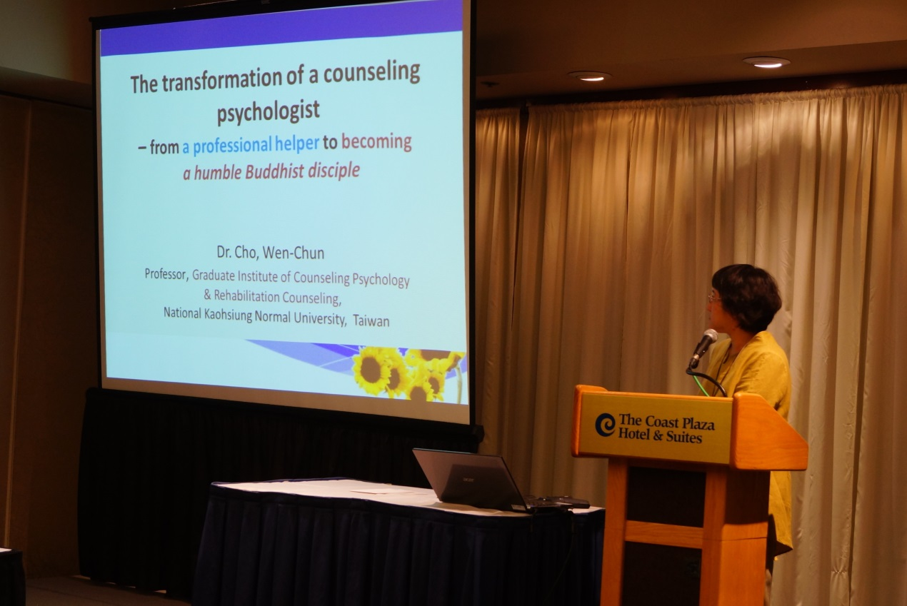
2.個人報告的結語
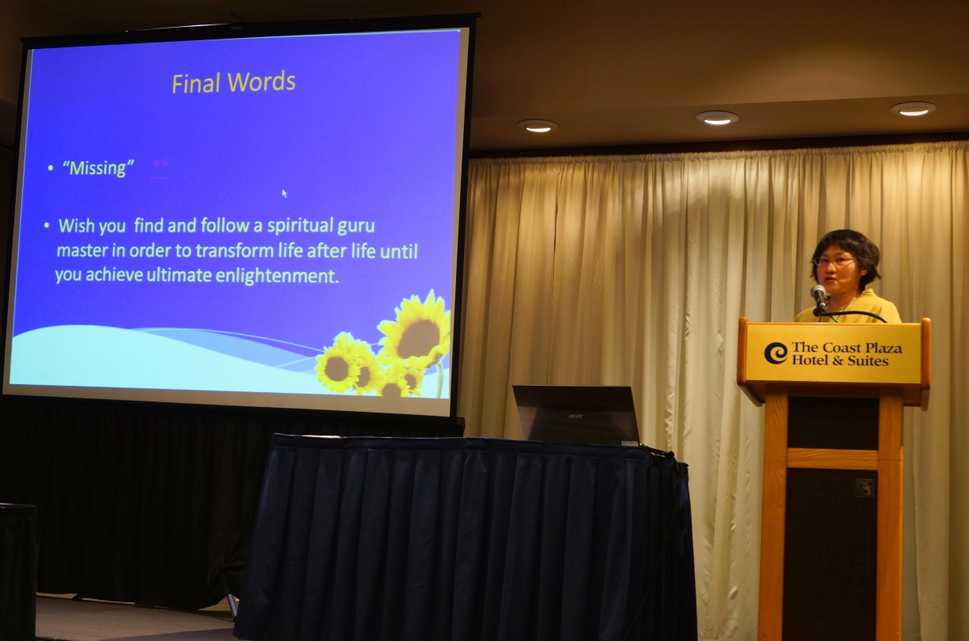
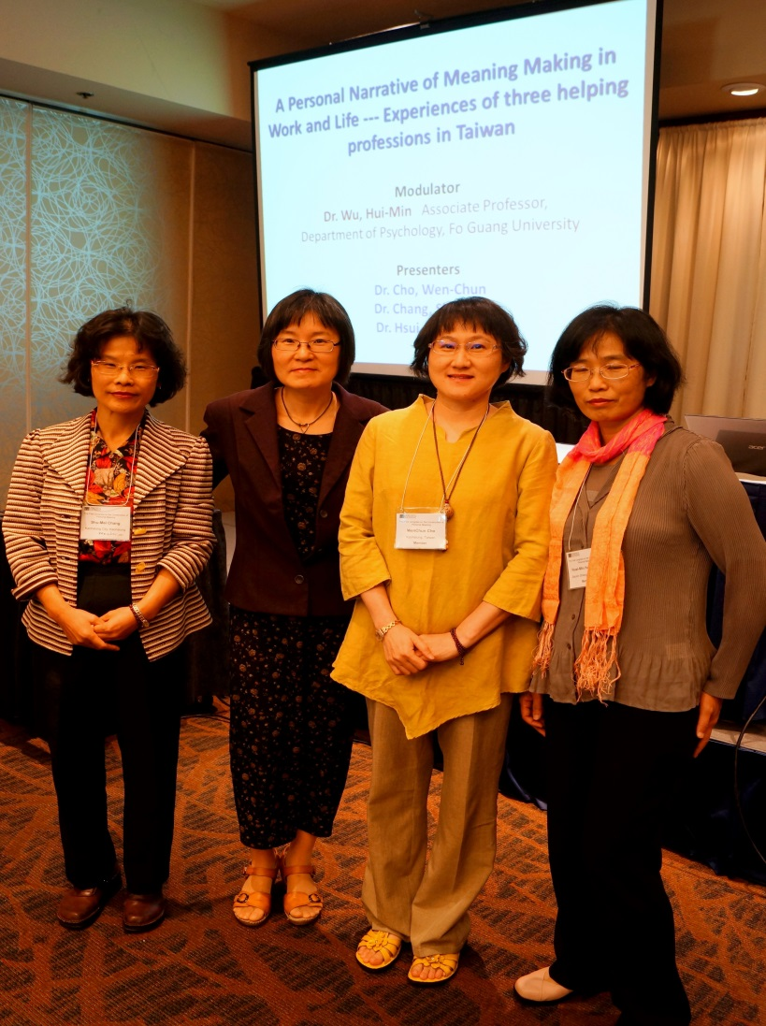
3.該場專題論壇的主持人以及發表者 (由右到左為教育系張淑美教授、成教所徐秀菊教授和我本人)

4.專題論壇結束後邀請與會者合照留念
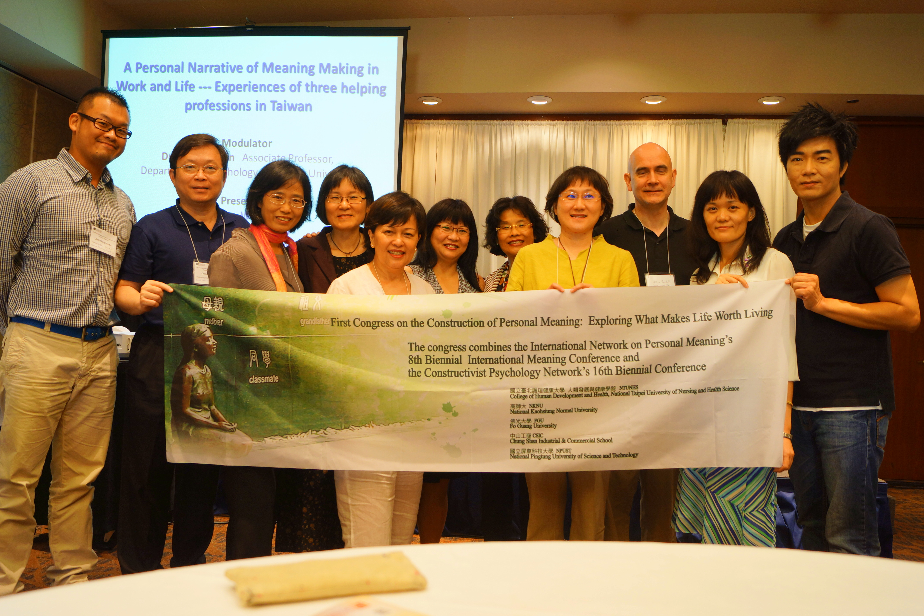

心得與建議
(一)心得部份
自己在專題論壇報告中發現，不同專業領域對於自身角色和專業的反思極為重要，尤其著重於思維心靈是什麼？它對我們專業的提醒是什麼？以及如何調整從專業技術層面的培養到人心靈層次的開發？而我個人也更肯定類似這樣的對話，是很需要在各自以及跨專業的領域中開展的。
其他值得一提的是，我有機會參加失落與哀傷治療的大師，也是建構心理學會第一任的理事長，Dr. Neimeyer的小型工作坊。從中讓我對於最新的失落與哀傷治療的研究主題與發現，有多了一些認識；尤其是他的介入策略也符合現今諮商心理治療所強調的以證據為基礎的實務工作。這些學習均有助於我未來在所上開設失落與哀傷研究時，增進一些教材和課程設計的重點。會後我也自費購買牌卡，準備應用於相關的課程和工作坊。
此外，我也有機會親近加拿大知名的意義治療大師Dr. Paul Wang，他與其夫人也是此次研討會的主要負責人。這個治療取向是淵源自存在主義治療，但在內容和實務操作上則有增補，展現其自有的特色，算是典型的整合取向。這是目前心理治療的發展趨勢，因應不同的當事人，治療者應發展整合而非只著重單一取向的治療方式。我個人也從他重視個體心靈的力量和賦予意義的自由意志，以及他身體力行中所展現的對人的熱誠和奉獻，感到無比的敬佩，也多受啟發。

(二)建議部份
此行除了我之外，尚有其他兩位來自高師大的同事。他們因為不具申請該項補助條件，全程均是自費參加。但是他們在專題論壇也有優異的表現，其中一位教授更是帶領三位博士班學生參與，並做論文發表。建議本校未來可以增列一種補助申請---教授帶領研究生出國於國際研討會發表，達3人和3篇以上的論文發表，師生即可申請團隊型的獎勵補助。希望藉此獎勵，可以鼓勵本校研究所提升其研究和發表的風氣，並讓研究生有出國觀摩、學習和歷練的機會；同時也能提升高師大的學術聲譽。

