出國報告(出國類別:學術研討會)

赴泰國參加
The 29th International Technical Conference
on Circuits/Systems, Computers and Communications
(ITC-CSCC 2014)
返國報告

服 務 機 關 ：海軍軍官學校
姓 名 職 稱 ：李仁軍副教授
派 赴 國 家 ：泰國
報 告 日 期 ：103年7月 2日
出 國 時 間 ：103年6月 30日－7月 6日

摘要
計畫主持人於2014年6月29日清晨由桃園機場出關，期間分別至香港及曼谷國際機場轉機後，最終抵達泰國普吉島(Phuket, Thailand)時已接近傍晚，並於隔日勘查會場及準備提報資料。7月2日上午發表論文，題目為A Novel Detection Algorithm for Image Copy Move Forgery。內容是報告因隨著數位媒體的隨處可見以及媒體編輯軟體的日益普及，多媒體很容易被竄改為惡意目的。因此必須運用可靠和有效的方法來檢測複製偽造移動的影像竄改，以運用於執法與取證。在本提報資料中，我們提出了一個基於方向梯度的直方圖盲取證方法，可用於複製、移動檢測偽造。實驗結果與分析後顯示，即使當影像被平移、旋轉、模糊、亮度改變與色彩還原等竄改操作，該方法仍能有效的檢測出多複製的重複偽造區域。報告後多人發問與發表建言，討論熱烈。
會議期間，主持人亦與一些研究學者討論資訊安全、生物認證以及影像處理在產業上應用的知識與技術。

目次
摘要 1
一、目的: 3
二、會議概況: 3
三、過程與心得: 3
四、論文發表： 5
五、建議事項： 15

出席國際會議心得報告

目的:
出席國際大型研討會，可與國際著名學者討論與交流有關資訊安全及數位影像處理在不同領域下的應用，並發表個人論文，參與討論以增加個人於本研究領域廣度及深度。

會議概況:
國際電路系統、電腦與通信技術研討會（ICT-CSCC）每年舉辦一次。此次為第29屆，於2014年7月1日至4日在泰國普吉島之 Phuket Graceland Resort & Spa舉行。研討內容偏重電路系統、計算機以及通信領域的相關研究技術探討。本次大會邀請了各國頂尖之研究學者提出專題報告，參加的論文超過三百篇。為了提升研討會的重要性，大會除了在Circuits/Systems, Computers and Communications等幾個主要議題外，開闢了數個不同領域的論文場次，包含有雲端資訊安全、巨量資料處理、圖形識別以及影像分析等場次。大會並邀請著名國際學者發表一系列的專題演講，主要課題為介紹未來醫療及健檢技術之相關電子電路、資料儲存之硬體結構簡化以及現今全球最流行的巨量資料之運用及處理，擴展了本次會議的視野與產業應用上的發展潛力。

過程與心得:
計畫主持人參與會議經過，如下所述：
計畫主持人於2014年6月29日凌晨由桃園中正機場出關後，期間分別轉香港以及曼谷國際機場前往泰國普吉島(Phuket, Thailand)，由於抵達時已接近當地時間傍晚，主持人夜宿當地，並於隔日勘查會場並準備所需發表論文之資料。
個人於7月2日上午發表論文，題目為A Novel Detection Algorithm for Image Copy Move Forgery。主要內容是報告因隨著數位媒體的隨處可見以及媒體編輯軟體的日益普及，多媒體很容易被竄改為惡意目的。因此必須運用可靠和有效的方法來檢測複製偽造移動的影像竄改，以運用於執法與取證。在本提報資料中，我們提出了一個基於方向梯度的直方圖盲取證方法，可用於複製、移動檢測偽造。實驗結果與分析後顯示，即使當影像被平移、旋轉、模糊、亮度改變與色彩還原等竄改操作，該方法仍能有效的檢測出多複製的重複偽造區域。報告後多人發問與發表建言，討論熱烈。其中有學者對於論文提問有關偽造影像尺度大小及壓縮等所可能的偽造情形的處理方案；另有學者則是詢問論文的實驗設計以及與結果的比對驗證。顯示此一領域的國際學者在研究上是理論與實驗技術並重的。
大會於1日至4日安排了一系列的專題演講，其中包含了日本大阪大學的Masaharu Imai 教授介紹了未來資訊科技技術運用於健康及醫療的診斷。而他的研究成果包含了研發各種較先進的感測器，在患者未發病前即提前預警，課題相當重要且有趣。美國華盛頓大學的Alan B. Johnston教授發表了針對未來巨量資料下之儲存媒體之硬體研究。此外，韓國電子通信研究機關(ETRI) 的HWANG Seung Ku博士介紹了巨量資料(Big data)的革新與應用技術。並且利用此一概念展示了未來世界的變革。這些研究與個人的研究相當有關連，也激發了個人在相關研究上的靈感。
會議結束後，於7月6日搭機返國，於6日下午返抵國門。

論文發表：

A Novel Detection Algorithm for Image Copy Move
Jen Chun Lee
Department of Electrical Engineering, R. O. C. Naval Academy, Kaohsiung, Taiwan
Corresponding author: Tel.: +886-7-5834700; Email: i923002@gmail.com
KEYWORDS:
Main subjects: Security
Proposed method(s): Histogram of Orientated Gradients
Keywords: Digital Image Forensics; Histogram of Orientated Gradients.
ABSTRACT:
The increasing popularity of digital media and media editing software has led to widespread tampering with multimedia files for malicious purposes; law enforcement and forensics experts therefore require reliable and efficient means of detecting copy-move forgery. The most common form of tampering associated with digital images is copy-move forgery, in which a portion of an image is duplicated and another part of the same image is substituted in a different location. This paper proposes a blind forensics approach for the detection of copy-move forgery. The input image is segmented into overlapping blocks, whereupon a histogram of orientated gradients is applied to each block. Statistical features are extracted and reduced to facilitate the measurement of similarity. Finally, feature vectors are lexicographically sorted, and duplicated image blocks are detected by identifying similar block pairs after post-processing. Experimental results demonstrate that the proposed method is able to detect multiple examples of copy-move forgery and precisely locate the duplicated regions, even when dealing with images distorted by translation, rotation, blurring, adjustment of brightness, and color reduction.

論文中文摘要：

一個新穎的偵測演算法運用於複製貼上的竄改影像

李仁軍

中華民國海軍軍官學校電機工程學系

隨著數位媒體的隨處可見以及媒體編輯軟體的日益普及，多媒體很容易被竄改為惡意目的。因此，必須運用可靠和有效的方法來檢測複製偽造移動的影像竄改，以運用於執法與取證。在本文中，基於方向梯度的直方圖，我們提出了一個盲取證方法用於複製、移動檢測偽造。實驗結果與分析後顯示，即使當影像被平移、旋轉、模糊、亮度改變與色彩還原等竄改操作，該方法仍能有效的檢測出多複製的重複偽造區域。

(附註：由於多媒體軟體的普遍，許多人利用其多媒體軟體做一些非法的運用。偵測偽造影像為現今資訊安全及影像處理研究中相當重要之課題。)
1. Introduction
In today’s digital age, sometimes seeing is no longer believing, since our modern life is full of digital images and (maliciously) tampering these digital images is easy and simple by using digital image processing tools which are widely available (e.g. Photoshop). Since digital images play a crucial role and have an important impact, the authenticity of images is significant in our social and daily life. How much we can believe in seeing is becoming an intractable problem [1]. In general, existing image forgery detection techniques are described as active [2-4] and passive (blind) [5-6] methods. Active methods are usually related to digital signature and watermarking, which have been used in the past to detect image manipulations and forgeries. But the significant drawback in digital signature or watermarking technology is that the data must be preprocessed, such as embedding watermark in the images. In contrast to active methods, passive methods are usually based on supervised learning by extracting certain features to distinguish the original images from tampered ones. The practicality and wider applicability of passive methods make them a hot research topic.
Copy-move is the most common operation for generating a digital image forgery, defined as a part of the image itself is copied and pasted into another part of the same image to conceal an important object or sometimes to show more than one object. Nowadays, the vide availability of image processing software makes the creation of a tampered image using copy-move operation particularly easy. The artificial region introduced by copy-move forgery results in almost imperceptible by human eyes. Therefore, the detection of copy-move forgery is a preliminary but desirable study for image forensics. In this paper, we focus on this topic. We present an effective and robust image copy-move forgery detection algorithm based on Histogram of Orientated Gradients (HOG) [8]. We conducted rigorous experiments using images modified using highly convincing techniques to demonstrate the robustness of the proposed method in dealing with multiple copy-move forgeries. Compared with other methods, the main advantages of our method can be summarized as:
- The proposed technique is able to precisely locate duplicated regions without being affected by common post-processing attacks, such as image translation, rotation, blurring, brightness change, and color reduction operations.
- The dimension of the feature vector is lower that can be used to reduce the computation complexity.
The remainder of the paper is organized as follows. Section 2 introduces the Histogram of Orientated Gradients, while Section 3 presents the proposed method for detecting copy-move forgery. In Section 4, we present the results of experiments designed to evaluate the performance of the proposed method in detection accuracy and computational complexity. Conclusions are presented in Section 5.
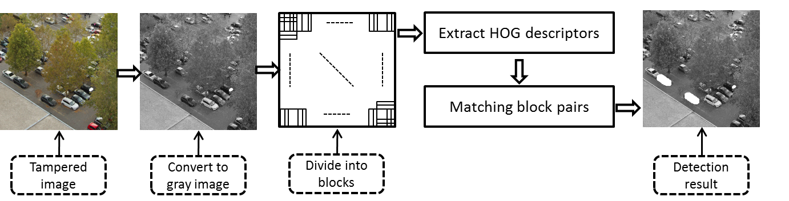
Fig. 1. Diagram of detection algorithm
2. Histogram of Orientated Gradients
The HOG descriptor [7] has gained traction in the vision community, and particularly in object recognition, for several reasons. First, it is a vector-space model, where perceptual similarity is approximated by Euclidian (or cosine) distance between two HOG vectors. This means that many off-the-shelf learning and database algorithms can work directly on HOG representations. Second, it appears to be a reasonably good model of perceptual similarity: it uses intensity gradients rather than intensity directly, which means that the responses of edges are localized; it is sensitive to local but not global contrast due to its normalization scheme; it can handle minor misalignment due to the bilinear interpolation between HOG cells; and many other reasons also apply. Third, it is very fast to compute: computing a HOG pyramid for a 500-by-500 image can take less than 2 seconds on a single core, and firing a sliding-window template at all positions and scales can happen equally fast via fast Fourier-transform convolution.
For copy-move forgery detection, we can only rely on the shape and texture of the tampered images, so HOG feature is more appropriate. The HOG feature is closely related to the scale-invariant feature transform (SIFT) [8-9] feature descriptor, but while SIFT is intended to be run at a sparse set of interest points, HOG is intended to be run over a dense grid. We implemented the HOG feature as it was described in [7], where it was used in the context of pedestrian detection. First, the 2D gradient of the image is computed using a vertical and horizontal [-1; 0; 1] filter. Then, the image is divided into M cells of pixels. A histogram with H bins is computed and normalized given the weighted gradient at each pixel, for each of the cells. The concatenation of the histograms from each cell yields a length feature vector for the image.
3. Proposed scheme
The most important function of an algorithm for the detection of copy-move image forgery is determining whether a given image contains duplicated regions. Since the different post-processing operations, including rotation, blur degradation and contrast changes, etc., of copied regions are unknown, if we compare every possible pairs pixel by pixel, the computational complexity will be very higher, none can endure that. Obviously, it is more practical to divide the suspicious image into blocks for detecting the duplicated regions.
In order to take an efficient detection, some appropriate and robust features must be extracted from the blocks. Therefore, good features are able to represent the entire block, provide robustness against common post-processing operations, and reduce the computational complexity of the detection algorithm.
The diagram of the proposed scheme is shown in Fig.1. The copy-move image forgery detection algorithm includes several steps, the details of which are explained separately in the following.
Step 1: Image pre-processing.
Initially, RGB image C is transformed into grayscale image I, according to the following formula:
(1)
where R, G, B are red, green, and blue channels of the color image , is its luminance component.
Step 2: Dividing of image into overlapping blocks.
In order to find out the forged regions, the image is usually divided into overlapping sub-blocks. Therefore, square blocks are used in the proposed method. We first divide the forgery grayscale image of into overlapped sub-blocks of to calculate HOG descriptors. Consequently, the image is divided into overlap blocks in all.
Step 3: Obtaining HOG features of the same size.
HOG is applied to each block. Here, we consider 9 bins for the local histogram. The histogram channels are evenly spread over 0 to 180 degrees, so each histogram bin corresponds to a 20 degree orientation interval. The obtained cell histograms are then combined into a descriptor vector of each block. Therefore, we can obtain four features to represent each block. For an forgery image of size of , matrix A would have rows and 9 columns, where 9 is the number of features.
Step 4: Comparison of HOG features in each block
In order to reduce the time of matching, the similar feature vectors will be stored into the neighbor rows by lexicographical sorting. Thus the detection can be done by lexicographically sorting the rows of A matrix, so that the features of the duplicated block pairs will come successively. Block matching is to find out the corresponding blocks, and to detect the forged regions correctly. In the proposed scheme, we search for the corresponding blocks by estimating the Euclidean distances of the feature vectors.
Step 5: Post-processing of detection result
The forged regions can be determined, which is achieved by marking the copied region and the tampered region and remove the isolated blocks. In general, all the detected blocks including the original blocks and forgery blocks are marked to generate the final detection result. Fig. 2(c) shows an example of the proposed method of marking.
Normally, there are some falsely detected blocks marked on the initial detection map, and these false blocks should be removed. To this end, we design a detector to remove them. The proposed detector operates as follows. Suppose that the marked image is divided into n non-overlap blocks with the size of . If the number of “white” pixels is less than 64 in the block, all pixels of the block are regarded as original image. Otherwise, keep the number of the white pixels and do nothing. After detecting, some small isolated false matches can be removed. Fig. 2(d) shows the detection result after the proposed detector operation.
4. Experiment results and discussion
This section describes the results obtained from experiments performed using the proposed algorithm. In our experiments, the proposed method is evaluated in two publicly available databases that are designed for image forgery detection. The first one was obtained from the CoMoFoD database [10]. All images are recorded by a Canon EOS 7D camera and stored in CR2 (Canon RAW version 2) format as minimally processed data. These forgery images consist of 200 png images with a resolution of in small image category. Acquisition was performed under various conditions outside, such as a natural setting, among buildings, and overlooking the city. Besides, the second dataset are several color PNG images released by the Image Manipulation Dataset [11]. They all have high resolution images (about to pixels) included 48 base images, separate snippets from these images, and a software framework for creating ground truth data. These images had been manipulated using copy-move forgery with other processes, such as translation, rotation, blurring, and color reduction. Figure 3 presents the forged images used in the experiments. All experiments were performed on a personal computer with 2.1GHz CPU, 4GB memory, running Matlab R2010b. The experimental results are detailed in the following sections, according to the various processes used to manipulate the forged regions.

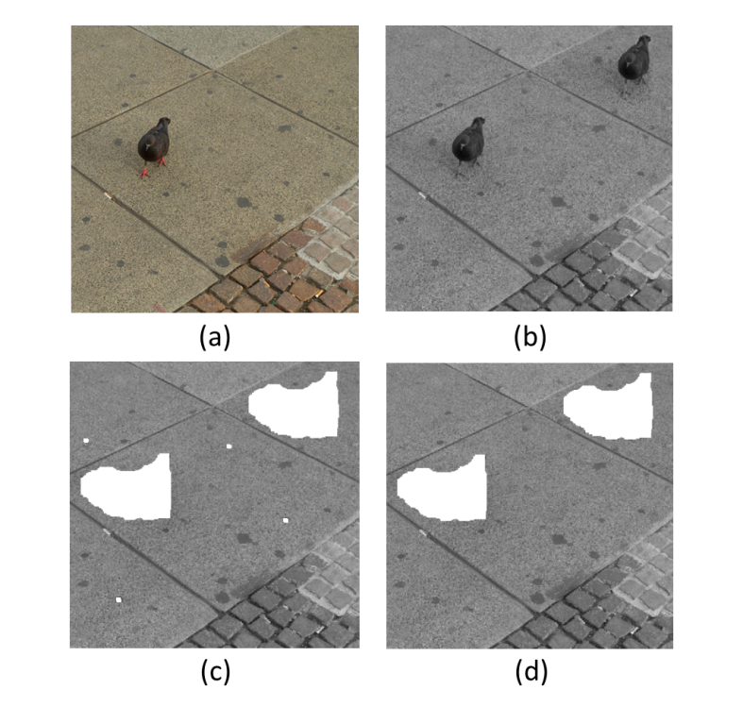
Fig. 2. Post-processing of detection results. (a)Original image, (b) tampered image, (c) initial detection result, and (d) final detection map.
4.1. Performance evaluation
To illustrate the performance of the proposed algorithm, we referenced two evaluation criteria, the correct detection ratio (CDR) and the false detection ratio (FDR), defined as follows:
(2)
(3)
where is the copy region, is the tampered region, while and are the tampered copy region and the detected tampered region, respectively. refers to the area of the region, refers to the intersection of two regions, and – refers to the difference between two regions. CDR indicates the performance of the algorithm in correctly locating the pixels of copy-move regions in the tampered image, while FDR reflects the percentage of pixels that are not contained in the duplicated region but are nevertheless included by the implemented method. The closer CDR is to 1 and FDR is to 0, the more precise the method.
4.2. Effectiveness and accuracy test

In the following experiment, we select some color images with the size of pixels from the first dataset to test the effectiveness of our algorithm. All the doctored images in this experiment are without any post-processing operation and the corresponding detection results are illustrated in Figs. 3. The top row shows the tampered images, and the bottom gives the detection results. Owing to space constrains, just a part of the experimental results are given here.
Fig. 3 shows that the accuracy rate CDR is generally greater than 0.95 and the false positive rate FDR equals to 0, that is, our algorithm can locate the tampered regions quite precisely. In addition, Fig. 3 also indicates that our algorithm can find the duplicated regions precisely when all the duplicated regions are non-regular and meaning, even though there are extremely similar scene or flat regions in the image, such as large areas of sand or leaf.
4.3. Analysis of robustness against post-processing attacks
The ability to resist post-processing attacks is fundamental to copy-move detection methods. There are many different types of post-processing attacks that can be applied to forged images with the aim of hiding tampering traces. Most common post-processing attacks are image rotation, blurring, adjustment of brightness, and color reduction. For each color channel in the forged image, the number of intensity levels was reduced from 256 to 32, 64, or 128. Images obtained by reducing the number of intensity levels have nearly imperceptible degradations compared to the original image with 256 intensity levels per channel. For brightness change, changing the brightness of the image was obtained by mapping the intensity values of the original image that were between lower and upper bound to interval [0, 1].
Table 1: Correct detection ratio and false detection ratio on CoMoFoD databases.
Attacks |  | CDR | FDR
Image rotation |  | 0.814 | 0.232
Images blurred (filter size) | 3*3 | 0.994 | 0.003
Images blurred (filter size) | 5*5 | 0.976 | 0.012
Images blurred (filter size) | 7*7 | 0.946 | 0.092
color reduction(levels) | 32 | 0.981 | 0.041
color reduction(levels) | 64 | 0.986 | 0.029
color reduction(levels) | 128 | 0.992 | 0.014
adjustment of brightness (ranges) | [0.01, 0.95] | 0.995 | 0.006
adjustment of brightness (ranges) | [0.01, 0.9] | 0.992 | 0.011
adjustment of brightness (ranges) | [0.01, 0.8] | 0.983 | 0.025

The experiments are also conducted on the first dataset to test the robustness of our algorithm. In implementation, the detection of duplications with block sizes of 16*16 is employed. The CDR and the FDR are listed in Table 1.
It is known from the Table 1 that the correct detection ratios are very high on blurring, color reduction and adjustment of brightness. Detection results using tampered images that were distorted by color reduction are presented in Table 1. These results show that the proposed method works better when dealing with colors of a higher bit depth. In addition, the proposed method clearly provides high detection performance when the images are distorted using and averaging filters, but not as well when a averaging filter was employed. According to the various brightness of image, the CDR/FDR is also presented in Table 2. As the detection results show, even in the range of [0.01, 0.8], the detection performance of the proposed method is still reliable. It also demonstrates that the proposed algorithm is highly robust against changes in image brightness. However, the proposed scheme can obtain the higher false detection ratio on rotation. The main reason is that the HOG descriptors differ between the original regions and the rotated region, which can reduce the effectiveness of the algorithm. Nonetheless, the proposed method still provides good detection performance for small rotations.
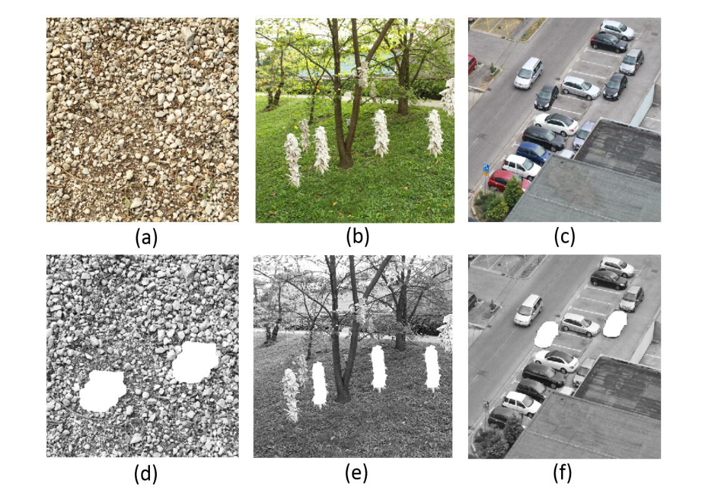
Fig.3. An example to detect multiple copy-move forgery image. (a)-(c) The tampered images, and (d)-(f) the detection results of tampered images.
5. Conclusion
Copy-move is a common method to create forgery images. It works without any digital watermarks or signatures information. This paper proposes an effective method for detecting duplicated regions based on the HOG. Compared with previous works, our approach used less features to represent each block. Experiment results demonstrate that the proposed algorithm could not only endure the multiple copy-move forgery, but also robust against actions aimed at concealing forgery, including image slight rotation, color reduction, blurring, adjustment of brightness, and with low computational complexity. This study therefore makes a valuable contribution to the field of multimedia forensics.
Ackonwledgment
This study was supported by the National Science Council of the R. O. C. (Taiwan) though the grant NSC 102-2221-E- 012-003-
References
[1] T. Gloe, M. Kirchner, A. Winkler, R. Behme, “Can we trust digital image forensics?” In: Proceedings of the 15th international conference on Multimedia, pp. 78-86, 2007.
[2] C. Rey, J. L. Dugelay, “A survey of watermarking algorithms for image authentication”, EURASIP J. Appl. Signal Process. Vol. 1, pp. 613-621, 2002.
[3] N. M. Yeung, “Digital watermarking introduction”, CACM. Vol. 41, pp. 31-33, 1998.
[4] J. Fridrich, “Methods for tamper detection in digital images”, In: Proceedings of the ACM Workshop on Multimedia and Security, pp. 19-23, 1999.
[5] J. Fridrich, D. Soukal, and J. Lukas, “Detection of copy–move forgery in digital images”, In Proceedings of Digital Forensic Research Workshop, pp. 19-23, 2003.
[6] W. Luo, Z. Qu, F. Pan, J. Huang, “A survey of passive technology for digital image forensics”, In: Front. Comput. Sciences of China, Vol. 1, pp. 308-322, 2009.
[7] N. Dalal, B. Triggs, “Histograms of oriented gradients for human detection”, Computer Vision and Pattern Recognition, pp. 20–25, 2005.
[8] X. Pan, S. Lyu, “Region duplication detection using image feature matching”, IEEE Trans. Inf. Forensics Security, Vol. 4, pp. 857–867, 2010.
[9] I. Amerini, L. Ballan, R. Caldelli, A. Del Bimbo, G. Serra, “A SIFT-based forensic method for copy-move attack detection and transformation recovery”, IEEE Trans. Inf. Forensics Secur, vol. 6, pp. 1099–1110, 2011.
[10] CoMoFoD database, available at: http://www.vcl.fer.hr/comofod.
[11] Image Manipulation Dataset, available at: http://www5.cs.fau.de/research/data/image-manipulation/

建議事項：
國際電路系統、電腦與通信技術研討會（ICT-CSCC）每年舉辦一次，此次為第29屆。研討內容偏重電子電路設計、研發以及相關於未來資訊的應用技術及探討。本次大會邀請了各國頂尖之研究學者提出專題報告，參加的論文超過三百篇。
筆者參加此次會議，除了有機會與關於資訊安全與影像處理研究領域的頂尖學者就近討論，更可增進本人的研究方向以及增加本人研究廣度及深度。
而個人的另一個感想，則是與會學者所提出的問題，多為先進技術的理論問題。這顯示了尖端技術的發展，還是要有透徹的理論基礎。如何尊重專業，建立專業，培養出能夠真正分析問題、尋求根本解決之道的海軍軍官，這或許是我們必須反思的課題。
此次個人參加此國際學術研討會，受益良多，建議可多鼓勵本校教師多爭取國科會的研究經費，利用寒、暑期赴國外研習，吸收新知，並將其應用於教學內容。

附錄：活動照片
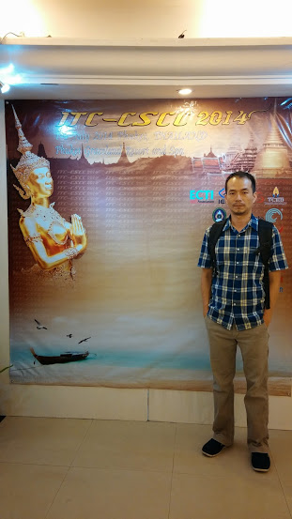
本人於29th ITC-CSCC研討會會場註冊
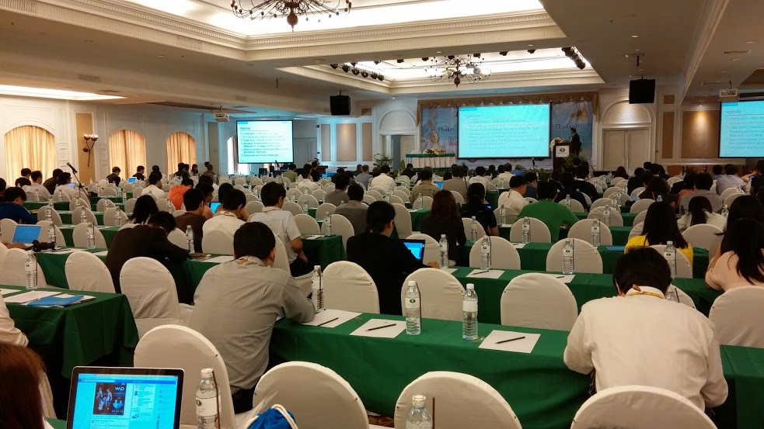
本人於29th ITC-CSCC研討會發表論文

大會議程截錄

