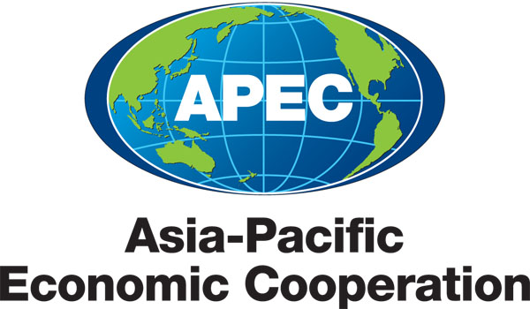
附件21
___________________________________________________________________________
2013/SOM3/ACT/003
Agenda Item: 3

APEC Secretariat Report on Key Developments – June 2013

Purpose: Information

Submitted by: APEC Secretariat

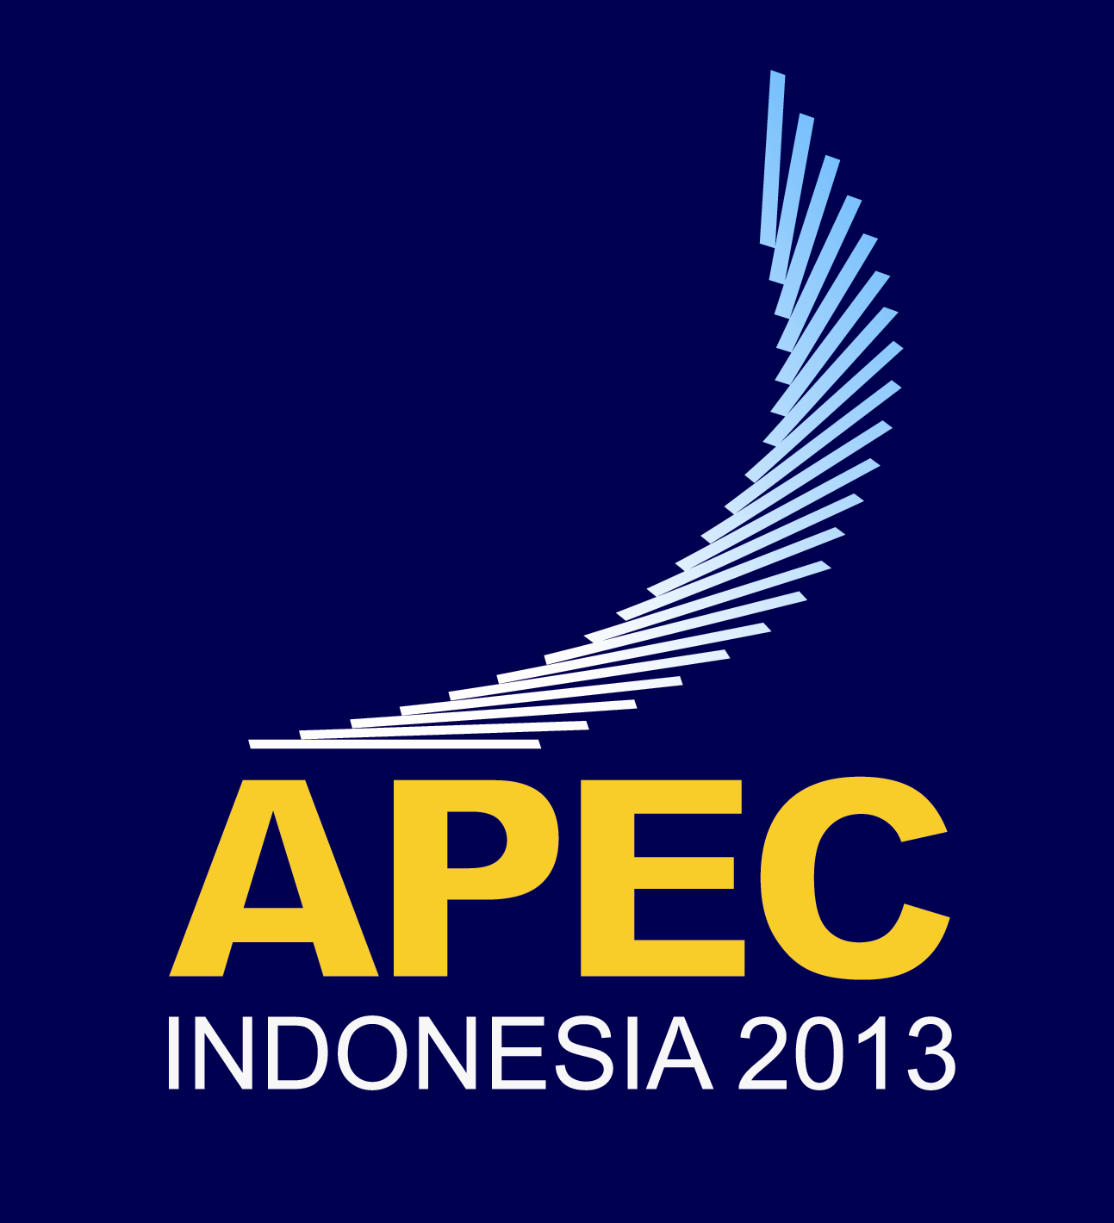 | 17th Anti-Corruption and Transparency Experts’ Working Group Meeting  Jakarta, Indonesia  25 June 2013

APEC Secretariat Report on Key Developments – June 2013

- APEC 2013 PRIORITIES

In 2013, APEC’s theme is “Resilient Asia-Pacific, Engine of Global Growth.” The priority areas include:

- Attaining the Bogor Goals;
- Sustainable growth with equity; and
- Promoting connectivity.

- KEY OUTCOMES OF SENIOR OFFICIALS AND COMMITTEE MEETINGS

Second Senior Officials’ Meeting

The second Senior Officials Meeting (SOM) on 18-19 April addressed the following priorities:

- Attaining the Bogor Goals: SOM noted Indonesia’s intention to develop a credible package for the WTO MC9 in Bali in December 2013, particularly on trade facilitation, extending the protectionism standstill and expansion of the Information Technology Agreement. SOM exchanged views on how CTI should organise its work in the years ahead to best contribute to achieving the Bogor Goals and encouraged CTI to streamline, prioritise and consolidate its agenda.

- Sustainable growth with equity: SOM discussed the preparations for the SME Ministerial Meeting, which will focus on enhancing SMEs global competitiveness, and supported plans for a joint SME and women’s ministerial meeting. SOM discussed renewable energy and plans for a Conference on Clean, Renewable Energy, and Sustainability in the APEC Region to be held during Leaders’ Week in Bali. SOM noted progress on preparing a template of the APEC Ocean-related Activities Work Plan. SOM noted work planned on promoting food security including the development of a “Roadmap for Food Security 2020”.

- Promoting connectivity: SOM noted progress towards developing a multi-year framework on connectivity that would incorporate physical, institutional and people to people dimensions. The framework will be considered at SOM3. SOM agreed to prepare a multi-year work plan on infrastructure investment and development, which will include workstreams from the Finance Ministers’ Process. SOM agreed to the preparation of a work plan on promoting cross border education cooperation and established an ad hoc coordinating committee to progress this work.

Committee on Trade and Investment (CTI)

To-date, the Committee has had two meetings. At its first meeting for the year in Jakarta, the Committee adopted a work program that is organised around five key areas:
- support for the multilateral trading system;
- attaining the Bogor goals, trade and investment liberalization, regional economic integration;
- promoting connectivity;
- expanding regulatory cooperation and advancing regulatory coherence; and
- contributions to APEC growth strategy and cross-cutting mandates.

At the second meeting in Surabaya on 13-14 April, the Committee discussed and advanced its work program in the above areas. It will continue to progress its work program at its forthcoming meeting in Medan on 2-3 July.

The progress made by CTI thus far included amongst others, the following:

- Attaining the Bogor Goals: CTI discussed a proposal for work on non-tariff measures (NTMs) and agreed that the Policy Support Unit (PSU) should undertake research on the use of NTMs in the region and report at CTI3. CTI agreed to the public release of the PSU’s updated Bogor Goals Dashboard, with easy-to-understand figures that summarise advances in areas critical to promoting greater regional economic integration. CTI agreed to a Proposal on Local Content Requirements (LCRs) at CTI1. A half-day trade policy dialogue on the “Impacts of LCRs on Regional Integration and Economic Growth in APEC Economies” was held on 12 April. CTI also exchanged views/perspectives on alternative policies and measures to LCRs and agreed to the United States preparing such a list for discussion at CTI3.

- Next Generation Trade and Investment Issues: CTI will continue to take forward the next generation trade and investment issues identified by APEC Leaders in 2011 and 2012 through a Friends of the Chair group led by the United States. The final report of a case study on the supply chains for the electrical and electronics industries in the APEC region is being undertaken by the PSU and is to be presented at CTI3. An APEC Conference on Innovation in Trade: Implementation Practices is being scheduled to take place on 29 June in Medan in the margins of CTI3.

- Environmental Goods and Services/Green Growth: CTI will continue to discuss additional work to ensure implementation of the actions agreed by APEC Leaders and Ministers in 2012 with respect to the APEC List of 54 Environmental Goods, including proposals to develop an APEC Framework for Capacity Building Initiative on Implementing the Environmental Goods List. Following CTI2, the Committee undertook a questionnaire on economies’ experiences and approaches to electronic stewardship with the responses to be fed into a half-day trade policy dialogue to be held on 1 July.

- Supply-Chain Connectivity Framework and Action Plan (SCFAP): CTI adopted a Work Plan on Supply-Chain Connectivity to progress the supply-chain connectivity framework and action plan. Lead economies are working to finalise draft policy inventories as part of the systematic approach to address the eight chokepoints by CTI3. An interim assessment of the implementation of the Supply Chain Connectivity Framework Action Plan (SCFAP) has been undertaken by the PSU. The final report was presented and endorsed at CTI2.

- Expanding Regulatory Cooperation and Advancing Regulatory Convergence: In accordance with the 2010 APEC Regulatory Cooperation Process Mechanism on Trade-related Standards and Technical Regulations, CTI reviewed the APEC Regulatory Cooperation Advancement Mechanism (ARCAM) and agreed to change it to a two-year cycle. In Medan, CTI will be considering proposals on possible topics for the 2014 ARCAM Dialogue.

Economic Committee (EC)

The first EC meeting in February included two policy discussions on “Competitive Neutrality” and “Best Practices for ICT Strategy and Public Sector Governance.” The EC discussed the APEC New Strategy on Structural Reform (ANSSR), including the ANSSR mid-term progress reporting to be conducted in 2013 and various on-going capacity building activities to assist member economies with implementation of their ANSSR plans. The EC also discussed the progress on the Ease of Doing Business (EODB) Action Plan and the updates on Good Regulatory Practices (GRP). The EC considered the work plans of the Competition Policy and Law Group (CPLG) and its five FotCs including: competition policy, regulatory reform, corporate law and governance, public sector governance and ease of doing business.

The EC agreed on the outline and timeline for 2013 the APEC Economic Policy Report (AEPR), with the topic being Promoting Fiscal Transparency and Public Accountability. Good regulatory practices were selected as the topic for AEPR 2014.

The next EC meeting will be held in Medan, Indonesia on the margins of SOM3.

SOM Steering Committee on ECOTECH (SCE)

At the second SCE meeting on 17 April, the SCE noted progress on a survey of fora and economies focussing on the effectiveness of the SCE’s work, capacity building and communication. A report on the survey will be discussed at SCE3 in Medan. SCE discussed the importance of using monitoring and evaluation to make capacity building activities as effective as possible. Monitoring and evaluation tools that are available on the APEC website were noted. SCE noted progress on completing strategic plans and emphasised the importance of all fora having a plan drafted this year.

The next SCE meeting will be held in the margins of SOM3 in Medan on 3 July 2013.

Budget and Management Committee (BMC)

From January to May 2013, the Secretariat received a contribution of A$1,500,000 (equivalent to US$1,580,550) from Australia to the APEC Support Fund (General Fund) and JPY241,446,000 (equivalent to US$2,519,524) from Japan to the APEC Support Fund Energy Efficiency and Low-Carbon Measures Sub-fund.

During the same period, the Secretariat received fixed contributions for 2013 to a total of S$3,190,913 and US$620,751 to the Administrative Account and Operational Account respectively from 16 Member Economies.

The BMC has established a Small Working Group on Financial Realignment that is examining the Secretariat’s recommendations on realigning the financial processes of APEC and the Secretariat. The BMC will consider the recommendations in its second meeting in Medan in June 2013.

APEC Business Advisory Council (ABAC)
This year ABAC’s work will continue to focus on improving supply chain connectivity and enhancing the flow of FDI. The Council endorsed the letter sent to the APEC MRT: (i) urging the 9th WTO Minister Meeting in 2013 come to a tangible package of Doha-related decisions; (ii) supporting both TPP and RCEP and recommend related Ministers to keep the two track compatible with the ultimate goal of FTAAP; (iii) urging Ministers to keep their economies open for FDI and facilitating FDI; (iv) encouraging Minister to remove barrier to service trade, including considering to form a Service Experts Group drawn from the public, private and academic sectors; (v) recommending global product data standards and Supply Chain infrastructure technology in support of APEC Chair’s Priority on enhancing connectivity.
The Council also endorsed a letter to TPP Leaders urging the completion of TPP negotiations by the aspiration time in October 2013.
Among other issues, ABAC still expressed their concerns about the recent financial regulations that caused negative impacts on prospective growth and the choke points in the ABTC schemes.
ABAC is actively preparing a letter to be sent to APEC SME Ministers and a Letter and Annual Report for APEC leaders. These documents are to be endorsed at the next ABAC Meeting in Kyoto on 8-11 July 2013.
More information on ABAC can be found at: http://www.apec.org/Groups/Other-Groups/APEC-Business-Advisory-Council.aspx.
APEC CEO Summit 2013, 5-7 October, Bali, Indonesia

The theme of the Summit: 'Towards Resilience and Growth: Reshaping Priorities for Global Economy' aims to provide a platform to engage in enriching strategic discussions to chart a new way forward. The organiser has prepared a notional agenda and launched the official website at http://www.apec2013ceosummit.com/.

- DEVELOPMENTS WITHIN THE SECRETARIAT AND POLICY SUPPORT UNIT

Key Staff Movements and Appointments

Two Program Directors have left the Secretariat since the last update in April 2013, namely Mr Luis Vertiz from Mexico, who left in April and Ms Natalie Nii from the United States of America, who left in June.

Project Management Unit (PMU)

The first project approval session for 2013 was completed in May. The selection process was undertaken in accordance with the ranking and prioritization system for APEC projects approved by BMC in 2010. A total of 76 Concept Notes were submitted for funding and 39 standard projects were approved for funding at a total cost of $4.6 million.

In addition to the above, three MYPs were also approved for funding this session at a total value of $1.41 million. This is the final batch of MYP funded under the pilot phase. A review of the pilot is scheduled for the last part of 2013 with the timing to be confirmed by BMC.

The external consultancy on developing a framework and methodology for undertaking evaluations of APEC projects has been completed with the results of the findings of the pilot evaluation to be discussed at BMC 2 in Medan. A review of the ranking and prioritization system is underway and the results will be discussed at BMC2.

Policy Support Unit (PSU)

The PSU Board in April 2013 approved the PSU Annual Report 2012. The Board will next meet in Medan on 3 July 2013. Since April 2013, PSU has completed five projects, namely:
- The 2013 Interim Assessment for Supply Chain Connectivity Framework Action Plan, for CTI and SOM
- Report on APEC Economic Trends Analysis, for EC, SOM, MRT
- Report on Key Trends and Developments Relating to Trade and Investment Measures and their Impact on the APEC Region, for SOM and MRT
- Policy Brief on Expanding the Information Technology Agreement, for MAG
- APEC Bogor Goals Dashboard 2013, for CTI

For SOM3 and related meetings in June-July 2013, the PSU’s deliverables are:
- Study on APEC Framework on Connectivity, for SOM
- Global Supply Chain Operation in the APEC Region: Case Study of the Electrical and Electronics Industry, for CTI3
- Ease of Doing Business: Interim Assessment 2009-2012, for EC2
- Policy discussions in “The State of the Regional Economy” and “Regulatory Reform in Green Investments”, for EC2

Working on these projects is ongoing:
- Asia Region Funds Passport: A Study of Potential Economic Benefits and Costs, for SFOM
- Issues Paper on Trade Finance in APEC, for SFOM
- Perceptions in the Use of NTM/NTBs in the APEC Region, for CTI
- StatsAPEC and its mobile website

PSU’s reports and monthly work program are available on its website (http://www.apec.org/About-Us/Policy-Support-Unit/PSU-Products-Publications.aspx).

Communications and Public Affairs

The Communications and Public Affairs Unit (CPAU) continues to carry out its operational plan by implementing Phase 3 (Sustain) of the SOM FotC on Communications’ Branding Strategy.

Between 1 April and 15 June 2013, Dr Alan Bollard conducted outreach. Remarks were delivered to:
- APEC Study Centre and the Institute of Southeast Asian Studies, Singapore.
- Temasek Foundation Centre for Trade & Negotiations-WTO Parliamentarian workshop, Singapore.
- The American Chamber of Commerce, Singapore.

Since 1 April 2013, the APEC Secretariat has received delegations from the London School of Economics, the University of Southern California, Singapore Management University, Executive MBA School of Arcadia University-Singapore campus, Marshall Business School of the University of Southern California, and the Korea Environmental Industry & Technology Institute and the WTO’s Director of the Information and External Relations Division.

A joint op-ed, “APEC Shows the Way on Trade,” by Dr Bollard and WTO Director-General Pascal Lamy was published in The Wall Street Journal a day after the conclusion of MRT.

Media interviews and background discussions were conducted with AFP, Australian Broadcasting Corporation, Bloomberg—First Up (television), CNBC Asia—Squawk Box, Channel News Asia—Biz Central, China Central Television, The Jakarta Post, Voice of Indonesia and Indonesian domestic media.

The APEC Bulletin was published in April and featured articles on:
- APEC SME Innovation Center and APEC Start-up Conference—how they have benefited an Indonesian manufacturer and a Peruvian internet start-up.
- APEC project on identifying barriers to women-owned SMEs
- An APEC pilot project to help develop branding and intellectual property.
- An APEC project on upgrading SME human resource capacity
- Dr Bollard and Pascal Lamy’s joint op-ed in the Wall Street Journal

CPAU Support for fora:
- Released the APEC Social Media Guidelines in May 2013 to assist APEC fora establish their own Facebook and Twitter accounts and are available on the APEC Secretariat’s ACS site.
- Updated the APEC Logo Guidelines to include ‘the use APEC Logo in motion graphics.
- Developed and printed a new ECOTECH brochure highlighting success stories of ECOTECH capacity building projects.
- Working to launch the Apple (iPhone) version of the APEC Glossary App to help iPhone users look up APEC acronyms.
- Launching its annual APEC Photo Contest at SOM3. The deadline for photo entries will be mid-August and winners will be announced in early October.

APEC Technical Assistance and Training Facility

The APEC Technical Assistance and Training Facility (APEC TATF) works closely with the APEC Secretariat to implement a range of activities designed to strengthen the APEC Secretariat as a customer-driven institution. Since early February 2013, APEC TATF’s accomplishments include:

- In close collaboration with the ITU and the successful vendor, the APEC Secretariat’s email system was successfully migrated to Microsoft 365 Cloud.

- Conducted a user needs assessment at the end of March to collect data from all APEC Secretariat staff on what they would like from an intranet. Organized a focus group to discuss key components of an intranet, and based on inputs, drafted and released an RFQ to qualified vendors. Vendor questions were due June 17 and full proposals are due July 1, 2013. The APEC Secretariat will review proposals and invite short list in to present proposals on an Intranet.

- Working with the Finance Unit, will provide support to engage an expert to review and make recommendations on aspects of APEC financial processes, broadly in line with the industry’s best practices and Singapore Financial Reporting Standards.

- Continued discussions on organizing an APEC Secretariat retreat for 2013, including themes that will link to the development of the APEC Secretariat’s strategic plan.

- Worked with the APEC PMU and the BMC small working group to examine APEC’s monitoring and evaluation framework. Phase 2 was launched post SOM 1 and is pilot testing the methodology developed in Phase 1. Five APEC fora volunteered to participate in the pilot, including Economic Committee, Small and Medium Enterprise Working Group, Sub-Committee on Standards and Conformance, Emergency Preparedness Working Group, and Energy Working Group. Initial results will be presented at SOM 3 in Medan.

- Continued to work with SCE sub-fora in their efforts to develop medium-term strategic plans to ensure that their goals and future work are in line with APEC’s overall objectives.

Separately, the Secretariat is liaising with a Member Economy on the year a contribution of US$75,000 is designated for.

