出國報告（出國類別：學術交流）

參加亞洲氣膠研討會

服務機關：國立雲林科技大學
姓名職稱：李經民副教授
派赴國家：中國大陸
出國期間：100年8月14日至8月21日
報告日期：100年12月7日
參加亞洲氣膠研討會

摘要

8月14日赴西安參加亞洲氣膠研討會及第八屆海峽兩岸氣膠研討會，同行包含博士生莊智仁。 14日由廣州轉機飛西安， 15日晚上一場秋雨 隔日溫度下降身體極不適應。16日開始報到參加為期四天研討會，今年參加人數頗多，百餘篇論文發表內容豐富，博士生莊智仁以英文發表生質燃燒特徵論文。 會中遇到來自台大、交大、成大等教授，也見到幾位大陸與美國的老友 Prof. Judith Chow等，交換研究心得受益頗多。17日開始身體不舒服重感冒，接著發連續發燒3日無法去鄭州交流，鄭大張院長特別指派參加研討會的博士生王佳來旅館慰問，王佳談到她的論文方向及博士生交流事項。 臨時加訂由西安飛廣州機票， 21日吃了退燒藥帶口罩搭機返台，連吃六天高劑量抗生素才沒有轉為肺炎。深感出門在外要保重身體，國外生病真是辛苦。

目次
一、目的 : 2

二、過程 : 2

三、心得及建議： 4

四 附錄: 5

一、目的 :
參加亞洲氣膠研討會及第八屆海峽兩岸氣膠研討會，海峽兩岸氣膠研討會主要目的在瞭解兩岸粒狀污染物研究進展，以促進兩岸彼此技術交流為目標。

二、過程 :

8月14日赴西安參加亞洲氣膠研討會及第八屆海峽兩岸氣膠研討會原本無法參加，受研討會主持人曹軍驥教授力邀，也為博士生打氣，最後才決定成行，同行包含博士生莊智仁。 14日由廣州轉機飛西安，晚上到西安，15日西安特別熱溫度高達35 C，傍晚參加會前會及大陸招待兩岸研討會成員，包含台灣氣膠學會前會長中山大學袁中新教授等人，討論未來兩岸氣膠發展方向。15日白天感受到陣陣熱氣而晚上一場秋雨， 隔日溫度立即下降至18-19 C, 身體極不適應與不舒服。

16日開始報到，參加為期四天研討會，今年參加人數頗多，百餘篇論文發表內容豐富。博士生莊智仁以英文發表生質燃燒特徵論文 ”Characteristics of Sized-resolved Anhydrosugars and Pollutants Derived from Rice Straw Burning in Controlled Chamber” (論文如附件 A，照片如下)，有助於鑑別大氣粒狀物來自生質燃燒貢獻。 另會中遇到來自台大、交大、成大等教授，包含台大工衛陳志傑教授、交大蔡春進教授、成大蔡俊鴻教授、及中山袁中新教授等人，同時也見到幾位大陸與美國的老友，包含本次亞洲氣膠研討會主持人曹軍驥教授及中科院張仁健教授，及來自美國Prof. Judith Chow等，老朋友見面相互說明近況，交換研究心得受益頗多。 會中由Prof. Judith Chow及台大工衛陳志傑教授分別發表大會演講： ”New Approaches in Multiple Pollutant Air Quality Management” 及”呼吸系统微粒沉積與產生”， 解析目前Aerosol 領域的新方向，倍受啟發。 研討會有百餘篇 Aerosol 論文發表 (會議內容與議程 參閱 附件B)，內容豐富，其中有多篇生質燃燒領域論文，隨全球溫度上升森林火災頻傳，亞洲環境研究學者逐漸開始重視生質燃燒與全球環境變遷研究。當晚，大會晚宴遇到幾位日本與韓國的研究學者交換研究心得。

17日下午，身體巳感覺不舒服，勉強留在會場，當晚曹軍驥教授及中科院張仁健教授邀請的晚餐聚會無法參加，回到旅館休息。 17日晚開始發燒，確定是重感冒，但大陸醫院不太敢進去，巿面上買些感冒藥，買藥時才發現大陸感冒藥多數是中西複方，藥效不是很好，很難找到台灣西式感冒藥如思思等，感覺台灣的醫療與藥品在大陸是有競爭力的。 會後原本預計至鄭州大學交流；18日通知鄭州大學張院長因重感冒發高燒無法去鄭州交流，張院長特別指派參加研討會的博士生王佳來旅館慰問，王佳談到她的論文方向及博士生交流事項，王佳本人有意願來台，我表達歡迎之意；原本要帶至鄭州大學的禮物請王佳轉交張院長。 連續發燒3日，到20日才逐漸退燒，但還有嚴重的咳嗽與身體微燒。 原本由鄭卅經廣州回台灣的機票，也辦理退票 ( 20%退票費由本人自付)，另臨時加訂由西安飛廣州機票，不想滯留外地延誤回台灣行程。

21日吃了退燒藥帶口罩搭機返台，次日立即看病，連吃六天高劑量抗生素，嚴重的呼吸道感染才沒有轉為肺炎。 此次因天氣變化太大，得了流感重感冒被迫取消鄭州大學行程，倍感遺憾，也深感出門在外，要保重身體，國外生病非常不便，真是辛苦。

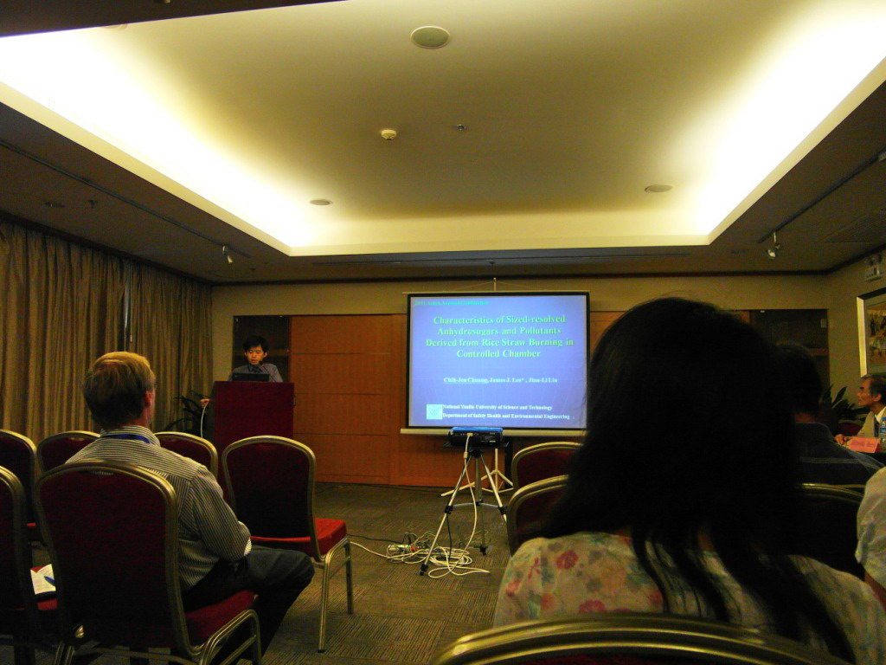

生質燃燒特徵論文發表 (博士生莊智仁)

三、心得及建議：

建議事項與感想，分述如下：近年來，全球溫度逐步上升，乾旱造成野火與森林火災頻傳，生質燃燒領域日益受到國際環保相關專家學者重視；只可惜台灣受海洋氣候調節，甚少造成大規模的野火與森林火災，相對的生質燃燒領域也末受重視。此外，全球氣溫暖化是大勢所趨，應即早防患於未然，重視生質燃燒與森林防災之技術研究。

四 附錄:
A. 博士生莊智仁 論文摘要與全文
”Characteristics of Sized-resolved Anhydrosugars and Pollutants Derived from Rice Straw Burning in Controlled Chamber”

Characteristics of Sized-resolved Anhydrosugars and Pollutants Derived from Rice Straw Burning in Controlled Chamber

Chih-Jen Chuang¹, James J. Lee ^{2*}, Jian-Li Lin²

1. Engineering Science and Technology, National Yunlin University of Science and Technology, Yunlin, Taiwan
2. Environmental Health and Safety Engineering, National Yunlin University of Science and Technology, Yunlin, Taiwan

ABSTRACT
This study discusses the particle-sized emission characteristics of three combustion conditions (smoldering, flaming, and mixing conditions). The purpose of this paper is to investigate the compositions of particulate mass, carbon species (OC and EC), three anhydrosugars (levoglucosan, mannosan, and galactosan) and water-soluble inorganic material derived from burning rice straw in a controlled chamber. Results show that the smoldering condition releases the highest particulate mass concentration of the three combustion conditions. The particle-size emission of rice straw burning was concentrated in PM_{2.5} particles (66~77% of TSP). Levoglucosan accounted for 90% of the three anhydrosugars produced by burning rice straw burning in the experiment. The levoglucosan to mannosan (Levo/Mann) ratio from rice straw burning ranged from approximately 25-40 due to cracking cellulose composition in several burning conditions. The carbonaceous composition from rice straw burning primarily consisted of organic carbon (OC > 90%), indicating that rice straw burning leads to incomplete combustion. Water-soluble ions of particles from rice straw burning abounded in species of Cl⁻, F⁻, SO₄²⁻, K⁺, and NH₄⁺. The smoldering condition of rice straw burning led to a higher CO/CO₂ value (>11%). These results indicate that levoglucosan is a unique molecular tracer that can be used to help identify rice straw burning emission characteristics in the future.

KEYWORDS : Biomass burning, Levoglucosan, Particle-size distribution, Ions, Carbon dioxide
Introduction
Biomass burning is the result of clearing agricultural land, removal of agricultural waste, forest fires, and other combustion ^{[1]}. Biomass burning emits a lot of particulate pollutants and gaseous pollutants. Biomass materials produce many toxic substances and greenhouse gases that form the Asian Brown Cloud ^{[2]}. Biomass burning pyrolysis (300~600℃) cellulose produces dehydro-monosaccharides consisting primarily of levoglucosan, and secondarily of galactosan and mannosan ^{[3,4]}. Related atmospheric research ^{[5]} shows that levoglucosan is stable in the atmosphere and is difficult to decompose. As such, it can be used as a unique biomass burning tracer. Rice is a major crop in Asia, which accounts for 90 percent of the world total rice production. This often leads to biomass burning to remove agricultural waste. Inhaling this combustion smoke into the body may cause respiratory problems, asthma, chronic obstructive pulmonary disease, and cause human health hazards. Current international research is focusing on biomass combustion in forest fires ^{[6,7]}, and most chamber study investigates the softwood and hardwood combustion of the emission characteristics of species^{[8,9,10,11]}. Relatively few studies discuss the emission characteristics of rice particulate combustion (smoldering vs. flaming). Therefore, this study analyzes the combustion of rice in a chamber to identify the emission characteristics of the particle mass concentration, anhydrosugars, carbon particle composition, water-soluble ions (anions/cations), and gaseous pollutants.

Experimental Methods
The experiment in this study used Taiwan rice straw (Oryza sativa subsp. Keng) as burning material, and investigated the distribution characteristics of fume particles for three kinds of rice straw combustion (flaming, mixing, and smoldering). The combustion chamber (0.5 m × 0.3 m × 0.6 m) and the mixing chamber (0.5 m × 0.5 m × 0.8 m) were both made of stainless steel. A PEM and MEM size sampler (TSP, PM₁₀, PM_{2.5}) was used for the rice smoke sampling, while a of flue gas monitor (TELEGAN Sprint V2) and indoor air quality monitor (TSI 7545 ICQ-Calc) were used for real-time monitoring of CO, CO₂, temperature, and humidity.

Results and Discussion
Mass concentration of particle size distribution characteristics in rice burning
Figure 1 shows the concentration distribution characteristics of three kinds of combustion chamber (flaming, smoldering, and mixing) in terms of particle size (PM_{2.5}, PM_{2.5-10}, PM_{> 10}). The average concentration of PM_{2.5} particles with flaming combustion was 141.28 ± 68.15 mg / m³, while mixing burning was 485.81 ± 280.23 mg / m³ and smoldering combustion was 679.46 ± 241.99 mg / m³. The PM_{2.5-10} average concentration of three kinds of combustion were 23.26 ± 16.24 mg / m³, 42.2 ± 41.77 mg / m³, and 62.61 ± 64.83 mg / m³. The PM_{> 10} average mass concentration of three kinds of combustion conditions were 53.79 ± 45.82 mg / m^{3,} 79.42 ± 79.25 mg / m³, 145.34 ± 111.32 mg / m³. In addition, the three combustion methods for fine particle emissions begin mainly about TSP 70%, coarse particles (PM_{> 10}) followed by approximately 20%, coarse particles (PM_{2.5-10}) accounted for only 10 %. This study presents results similar to Yunlin field biomass burning ^{[12]}.

Emission characteristics of anhydrosugar concentration in rice straw burning
The main emissions of the combustion of rice straw burning were fine particles. The PM_{2.5} particles in three combustion (flaming, mixing, and smoldering) and the levoglucosan concentrations were 10.43 ± 5.22,13.01 ± 5.02,13.32 ± 5.02 mg / m³, while mannosan concentrations were 0.37 ± 0.18,0.48 ± 0.21,0.55 ± 0.15 mg / m³, and galactosan concentration were 0.77 ± 0.54 mg / m³, 0.26 ± 0.17 mg / m³, 0.34 ± 0.09 mg / m³ . The main concentration of PM_{2.5} particles emitted in levoglucosan account for three kinds of anhydrosugar (levoglucosan, mannosan, and galactosan) is approximately 89 - 92 percent. According to existing literature ^{[12,13,14]} rice straw burning (in a chamber or in the atmosphere close to the combustion source), levoglucosan accounted for three kinds of anhydrosugar components 91 - 93%. This study presents similar results, indicating that levoglucosan is the main sugar produced in rice burning and functions as a major atmospheric trace substance. Previous research ^{[15]} also uses the Levo / Mann ratio to identify sources for biomass burning (such as hardwood, with a value of 14.5, compared with 3.6 for softwood). In this study, the PM_{2.5} particle Levo / Mann characteristic ratio ranges from 25~40. However, rice field experiments Levo / Mann ratio was 25, have slightly different ^{[14]} . The Levo / Mann ratio was more closely with the burning species.

Carbon particles OC, EC and soluble ions emission characteristics
In this study, rice burning carbon particle OC concentrations were significantly higher than the concentration of EC, whose smoldering emissions OC concentrations for the three combustion highest were higher than flaming emissions 3.6 times. Results show that OC accounted for TC 95 - 98%, and the burning temperature increased as the proportion of the EC concentration increased. Figure 2 shows the water-soluble ion concentration. In the flaming state, the major ions emitted include Cl⁻> SO₄²⁻ > K⁺ > NH₄⁺ >F⁻ , while the order in the smoldering state is F⁻> Cl⁻> SO₄²⁻> Na ⁺> K ⁺. The chloride ion (Cl⁻) is the main source of fertilizer (ammonium chloride, potassium chloride); sulfate (SO₄²⁻) comes from a wide variety of sources, from the crustal elements, ocean spray, and burning oil ; fluoride (F⁻) may be due to air or water plants to absorb pollutants and fertilizers. Other studies ^{[16]} show that rice straw may be part of the water-soluble ions from the soil contribution. The concentration of water-soluble ions accounted for an average of 1.91%, which is similar to the results in related literature ^{[13,16]} (3.91% and 2.65%).
Figure 1. The particle mass concentration Figure 2. The proportion of emission distribution (2.5, 2.5-10, >10 µm) in water-soluble ions.

Gaseous pollutants (CO, CO₂) emission characteristics
Figure 4 analyzes the CO, CO₂ emission levels in flaming and smoldering biomass burning conditions. In terms of △ CO / △ CO₂ ratio shows characteristics of biomass burning conditions (△ net background concentration), this study flaming ratio (△ CO / △ CO₂) of 8.4%, , Smoldering 73.1%. These results are consistent with Reid (2005) ^{[17]}, and show that △ CO / △ CO₂ <11% can be regarded as flaming combustion, while a ratio > 11% is smoldering burning. This study shows that although the flaming burning of rice biomass emits less CO and particulate (TSP concentrations average 73.9 ± 32.9 mg / m³), flaming increases CO₂ emission concentration by more than 3 times compared to smoldering. Thus, large-scale rice straw burning of the flaming type may cause dramatic increases in CO₂ emissions.

SUMMARY OR CONCLUSION
Three kinds of burning type (flaming, smoldering, and mixing) of the order particle mass concentrations were smoldering>mixing>flaming. Rice straw burning three kinds of anhydrosugar composition characteristics (levoglucosan, mannosan, galactosan) shows that levoglucosan accounts for approximately 90% of the anhydrosugar, with the other two representing 10%. These results indicate that levoglucosan is the major carbohydrate of rice burning, and also the main tracing marker. The main combustion emission ions in the chamber were Cl^{-,} SO₄²⁻, F⁻, K⁺. The rice straw may have been affected by fertilizer during its growth. The rice biomass burning and emissions characteristics of the particle size distribution characteristics presented in this study contribute to existing research and serve as a reference for future studies.

ACKNOWLEDGMENTS
The authors thank Dr. Engling (University of Tsinghua, Taiwan) for help with analyzing the rice straw sample and providing useful advice. This valuable assistance is greatly appreciated.
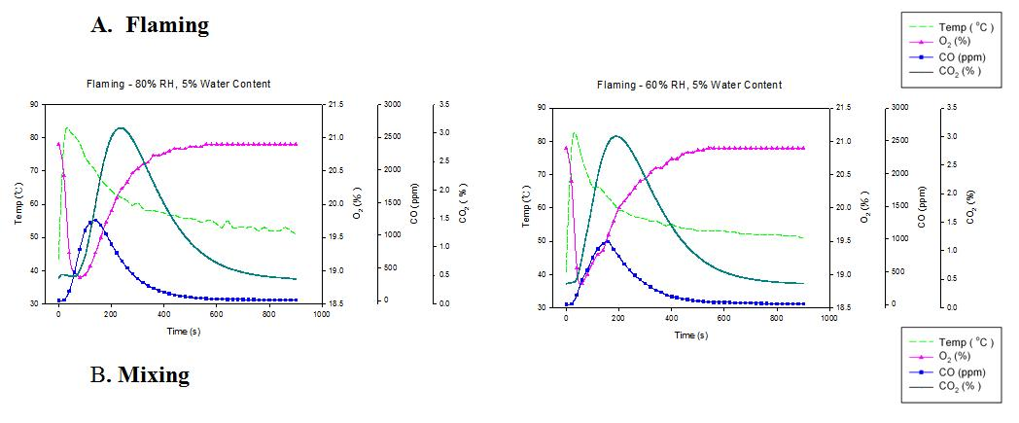
Flaming
Smoldering
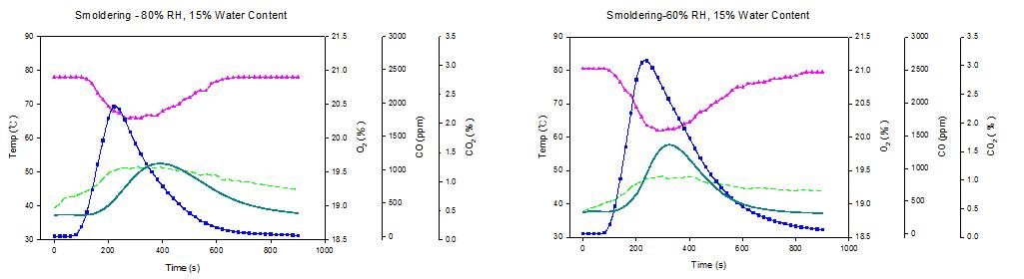
Figure 3. The distribution of combustion (flaming vs. smoldering) emission for CO, CO₂, and O₂

REFERENCES
- Andreae, M.O., and Crutzen, P.J.Science.1997, 276, 1052-1058.
- Ramanathan, V.; Crutzen, P. J. ; Mitra, A. P. ; Sikka, D, Current Science, 2002 , 83, 947-955.
- Simoneit B.R.T.;Schauer J.J.;Nolte C.G.; Oros D.R.; Elias V.O.; Fraser M.P.;Rogge W.F.; Cass G.R. Atmos Envi,1999, 33, 173–182.
- Simoneit B.R.T.; Elias V.O. Marine Pollution Bulletin, 2001, 42, 805-810.
- Fraser M.P.; Lakshmanan K. Envi Sci & Tech, 2000, 34, 4560-4564.
- Bowman D.M.J.S.;Johnston F.H. EcoHealth, 2005, 2, 76-80.
- Moore D.; Copes R.; Fisk R.; Joy R.; Chan K.; Brauer M. J. Pub Health, 2006, 97, 105-108.
- Zdráhal Z.; Oliveira J.;Vermeylen R.; Claeys M.; Maenhaut W. Envi Sci & Tech, 2002, 36, 747-753.
- Ward T.J.; Hamilton Jr, R.F.; Dixon, R.W.; Paulsen, M.; Simpson, C.D.Atmos Envi, 2006, 40, 7005-7017.
[10]Fine P.M.; Cass G..R.; Simoneit B.R.T. Envi Sci & Tech, 2001, 35, 2665-2675.
[11]Engling G.; Carrico C.M.; Kreidenweis S.; Collett Jr., J.L.; Day D.E.; Malm, W.C.; Hao W.M.; Lincoln E.;Iinuma Y.;Herrmann,H. Atmos Envi, 2006, 40, 299~311.
[12]Lee J.; Engling G.; Lung S.C.; Lee K.Y. Atmos Envi,2008, 42, 8300–8308.
[13]Sheesley R.J. ; Schauer J.J.; Chowdhury Z.; Cass G.R.; Simoneit B.R.T. J.Geophy Res ,2003, 108(D9).
[14]Engling G.;Lee J.; Tsai Y.W.; Lung S.C.;Chou C.;Chan C Y. Aero Sci & Tech,2009, 43, 1–11.
[15]Schmidl C.; Marra L.I.; Caseiro A.; Kotianov P.; Berner A.; Bauer H.; Anne Kasper-Giebla.; Hans Puxbaum. Atmos Envi, 2008, 42, 126–141.
[16] Hays M.D.;Fine P.M.; Geron C.D. Atmos Envi,2005, 39, 6747-6764.
[17] Reid J. S.; Koppmann R.; Eck T. F.; and Eleuterio D. P. Atmos Chem & Phys, 2005,5, 799–825

附錄B

會議內容與議程如下:
一、會議內容
- 氣溶膠物理化學特性及源解析
- 污染氣體及氣溶膠測量與儀器分析
- 大氣氣溶膠的氣候與環境效應
- 大氣氣溶膠與人體健康
- 空氣污染控制技術
二、議程參閱
http://aac2011.uconferences.com

