出國参加會議報告

日本G30國際學生策略訪視評估會議

團長：胡智偉 國科會科教處處長
團員：廖文峰 國科會自然處處長
團員：蘇慧貞 教育部顧問室主任
團員：傅昭銘 台灣大學物理系教授
派赴國家：日本國 大阪大學
出國期間：2009/11/29~12/02
報告日期：2009/12/02
經費來源：國科會國合處

I、Brief background of Japan G30
The Ministry of Education, Culture, Sports, Science and Technology (MEXT) formulated the 300k International Students Plan in July of 2008, with the aim of receiving 300k international students by 2020. Thus MXET has launched "Global 30 Project" to realize this goal by selecting measures for the internationalization of universities including the recruitment of international students, along with forming Japan’s centers of internationalization. In 2009, thirteen universities were selected, as listed in the following table, there are in total thirteen selected universities which composed of seven National universities and six private universities. These core universities will play a major role in boosting the number of international students educated in Japan as well as Japanese students studying abroad. Selected universities will receive prioritized financial assistance of 200 to 400 million yen per annum over the next 5 years. Endowed with this aid, each university will strive to recruit 3000 to 8000 international students. The final goal of Japan G30 is to nurture advanced human resources capable of international success in an environment where students work and learn from each other.

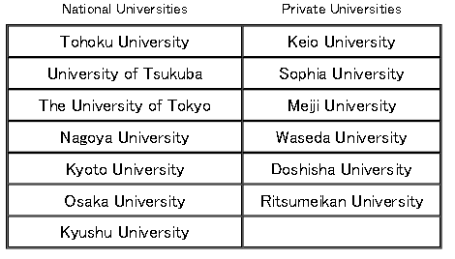

Action Plans for the Core Universities will take the following steps to create an attractive educational and research environment for international students.
1）Expansion of course programs by which degrees can be earned through English-only classes. → Establish courses at the universities selected through which English-only degrees can be obtained: 33 undergraduate courses and 124 graduate courses over the next 5 years
2）Enhancement of systems for receiving/hosting international students. → Enhance systems for receiving/hosting international students, such as specialist support in studying and academics, as well as for completing various procedures and formalities both in/out of the university; and provide internship programs at Japanese corporations, etc.
3）Provide international students with opportunities to learn about Japanese language and culture. → A plan to provide high-quality instruction in Japanese language and culture
4）Promotion of strategic international cooperation. → Establish two separate overseas offices per core university, to enable local recruitment through admissions tests, etc., and boost the number of Japanese students studying abroad through exchange study programs, etc.

II、Osaka University and G30 Action

The Osaka University is recognized as one of the leading research universities and at the forefront of technological innovation in Japan. Situated at an economic and cultural hub of Western Japan, Osaka University’s strong orientation towards innovation, partnership with local society and industry, pioneering efforts in interdisciplinary research and education, all reflect the city’s unique history and characteristics.
The Osaka University is the most pioneer action for the Japan G30 project. The chartered goal of Osaka University G30 Project (OU G30) is aimed at making efforts to provide high-quality education, by forming an implementation structure for classes held in English and streamlining the system for accepting international students and to offer an environment where international students can easily study.
As for G30 Action, Osaka University has designed several new English-language degree programs in English (leading to BS/BA, MS, & Ph.D.) and short-term programs (up to 12 months), as following.
The English- degree programs:
- Human Sciences (Undergraduate: to commence in April 2011)
- Chemistry/Biology Double Major (Undergraduate: to commence in October 2010)
- Physics International Course (PIC) (Graduate: to commence in October 2010)
- Special Integrated Science (Graduate: to commence in October 2010)
As well, there are ongoing Graduate Degree Programs in English:
- Frontier Biotechnology
- Engineering Science
- Naval Architecture and Ocean Engineering
- Quantum Engineering Design
Also, new “Chemistry/Biology Double Major” program and “Special Integrated Science” offer international students the new opportunity to learn fundamental and interacting fields and prepare them for the challenges of the rapidly advancing scientific frontier. “The Human Sciences” bachelor program offers a practical approach to exploring and understanding pressing social and human issues. “The Physics International Course” focuses on enhancing capacities to conduct largescale international collaborative research with large-scale laser and/or accelerator facilities.
Various short-term programs are also available for international students:
- OUSSEP (Liberal arts in English)
- Regular Exchange (All fields in Japanese language)
- FrontierLab@OsakaU (Scientific empowerment program)
- Maple (Japanese language and culture).

The action plan of Osaka University is structured as:
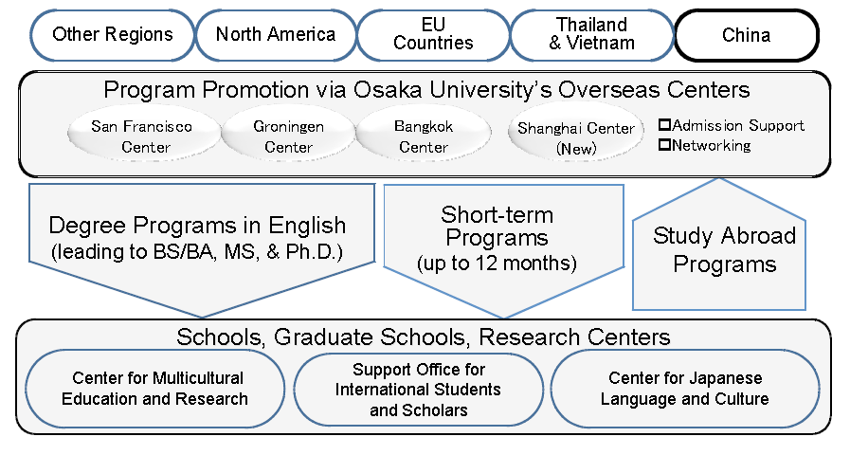
Taiwan

III. Summary of important points of discussion

The Project: be more clearly stated about the objectives and operations of the project
- Consider undergraduate and graduate “degree” program separately, and design incentives differently.
- For graduate students, an attractive program has the following features: famous university, solid program (department/research institute), good professors, well equipped lab and financial support (tuition waiver, scholarship, TA and/or RA).
- For undergraduate students, mechanism such as host family and others which provide students with psychological support and cultural/social consultation may add points to the program.

Strategies:
- Link the G30 program with an existing Japan/Taiwan student exchange program, such as Japanese culture exchange foundation.
- Sign agreement with a government agency (e.g., MOE, NSC) to create a new mutual beneficiary program. (more G30 universities).When signing the agreement, more universities and high level of government agency involved should add the G30 program’s attractiveness. (Note: The NSC provides support for research, instead of studying.)
- Sign agreement with a few individual universities, and recruit students from these universities.
Before going to Taiwan to promote the G30 program the next Jan., it is better to define the targeting population for the explanation sessions. Explanation sessions better be arranged through proper channels.
