捌、台灣數位新浪潮─錄影帶內容簡介

WANG Ya-Hui
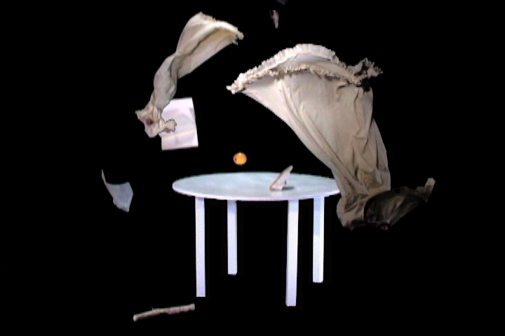
WANG Ya-Hui
Falling, Video installation, 2002

A white table is set in a dark space where lots of objects start to fall at different speeds. Sometimes they stop in the air and sometimes they are drawn back into the dark space. Time became pieces and gives different layers in the same space.
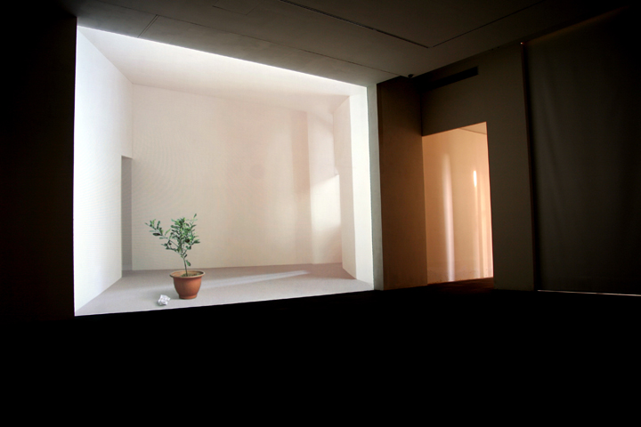
WANG Ya-Hui
Sunshine on Tranquility, Video Installation, 2005

The borders of the white room slowly move and change. The sunlight follows the changes of the space, and shadows project different expressions on the front object. It indicates a strange experience for the body.

TSUI Kuang-Yu
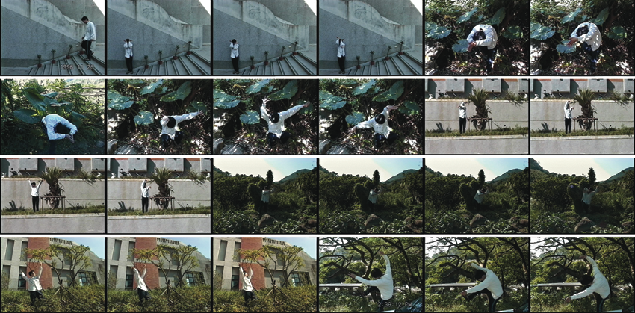

TSUI Kuang-Yu
An Imitation: Mimicry, Video Art, 1996

This work shows the artist—the performer—encountering plants in his surrounding and imitating or mimicking their forms. The plants are of various sizes and in different locations, some of them in a pot and some of them out on a street. The performer extends his hands and legs to imitate the appearance of the plants. In this work, Tsui extends the measurement of the body movement into body gestures. The performer’s physical movement or action aims to inform a gesture that signifies a plant. Here, the performer’s body movement is used to imitate or mimic. This concept of imitation or mimicry is further developed later in a series of works called The Shortcut to the Systematic Life, in which the performer mimics the urban environments he encounters. For the artist, An Imitation: Mimicry shows a way to learn—or, for him, a shortcut—how to conceal the human body in an urban environment. The artist has been interested in biology for some time, and through this interest he became obsessed with the insect’s natural instinct of mimicry. Unlike the mimicry of the insect, however, mimicry in Tsui’s performer does not transform him in response to any dangerous surroundings he encounters. Rather, the performer imitates the plants and conceptually becomes the “plants. ” Thus, the notion of mimicry in An Imitation: Mimicry informs a simple and generic meaning of mimicry in terms of imitation. But imitation, in fact, does not necessarily equate to mimicry. An Imitation: Mimicry reveals this ambiguity. In The Shortcut to the Systematic Life, the performer becomes inclined to mimicry, rather than to imitation of the urban environment. An Imitation: Mimicry can also be regarded as the artist’s development of the art/game concept. Imitation or mimicry is a kind of game, particularly seen at carnival, in which people wear elaborate costumes. The notion of game in An Imitation: Mimicry addresses appearance and characteristics, rather than competition. An Imitation: Mimicry also creates a sense of comic effect. Through the exaggeration of body movements and gestures, the performer attempts to accomplish a ridiculous imitation or even mimicry.

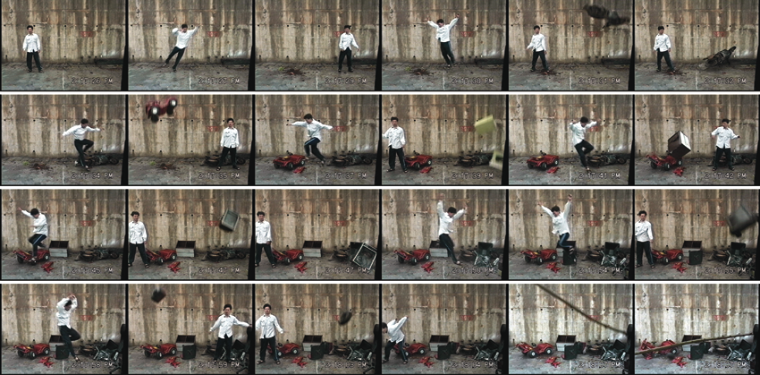
TSUI Kuang-Yu
The Welcome Rain Falling from the Sky, Video Art, 1997

In this work, the audience sees that the performer, the artist himself, jumps between two areas, divided by a simple white line on the ground and the wall, in order to avoid a wide range of falling objects, including flower pots, TV sets and motorcycles. The pace of the objects falling and the performer’s jumps are very consistent and steady.

The title of the work evokes a Chinese idiom associated with a story in which God sends rain to people after a long period of drought. It is an idiom associated with superstition, addressing people’s struggle as a matter of life and death, and thus anticipates help from God.

Tsui uses this idiom for the title of the work in a parodic way. In The Welcome Rain Falling from The Sky, he transforms the rain into falling objects, and the human struggle into the performer’s avoidance of dangerous situations. This parodic use of a title has appeared often in his works, as we discussed in The Vehicle and will discuss in the series works entitled Eighteen Copper Guardians in Shao-Lin Temple and Penetration and The Shortcut to the Systematic Life. Since these Chinese idioms are well-known by Chinese people, the works immediately create a sense of irony and the ridiculous for Chinese audience.

In The Welcome Rain Falling from The Sky, Tsui again places his performer in a game-like situation, playing in the dangerous environment. This game also involves the performer’s use of body movement and the forces of gravity and acceleration, represented by the falling objects.

The performer seems to play on a stage: the spatial environment here resembles a drama stage. The impression of drama is strengthened by the artist’s parodic appropriation of the Chinese idiom and by his simple and droll body movements. The falling objects also create a theatrical feeling of danger and ironic absurdity for the audience. The elements of drama and theatricality appear and form a core for the series Eighteen Copper Guardians in Shao-Lin Temple and Penetration and The Shortcut to the Systematic Life.

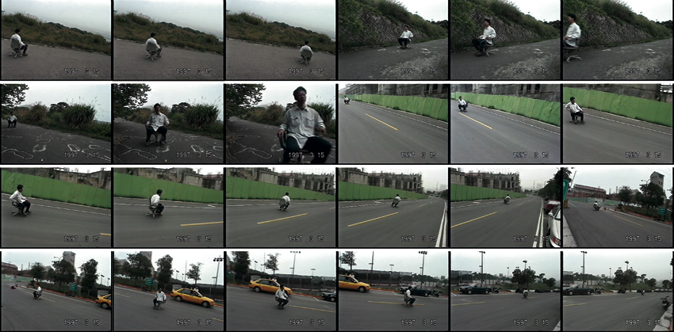
TSUI Kuang-Yu
The Vehicle, Video Art, 1997

In this work, the performer “rides” a typical wheeled office chair, sliding down gentle slopes at various locations, such as a typical city street and in the countryside. This work is reminiscent of The Measurement of Friendship in several respects. In The Vehicle, the performer plays a game of roller coaster, and the game involves the effect of vertigo and chance. The title implies the parodic use of a vehicle, creating a comic effect, because this vehicle looks ridiculous—even absurd—reminding us of a “vehicle” road test. Unlike The Measurement of Friendship, The Vehicle measures gravity and acceleration. The performer allows gravity to control his speed naturally since he does not touch the ground or other objects to influence his speed or direction during the rides. Both works measure the natural force of gravity on different orientations: The Measurement of Friendship on right/left, and The Vehicle on up/down. The Vehicle seems like an ironic experiment with the acceleration of gravity on the body’s movements. During this “road test,” there is no other traffic, and the “chair vehicle” is completely controlled by the body and gravity.

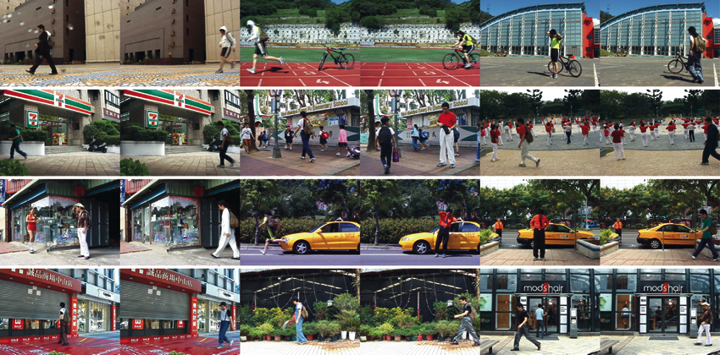
TSUI Kuang-Yu
The Shortcut to the Systematic Life: Superficial Life, Video Art, 2002

This is one of the trio of video works in the series The Shortcut to the Systematic Life. This series of works develops from the concept of the “shortcut” in the series of Eighteen Copper Guardians in Shao-Lin Temple and Penetration. Both works explore the impact of the urban environment upon an individual played by the performer. Rather than confrontation as the shortcut in Eighteen Copper Guardians in Shao-Lin Temple and Penetration, transformation or mimicry is the shortcut to life in The Shortcut to the Systematic Life.

The systematic life in Taiwan is known as a specific type of living environment characterizing the function and attribute of the urban environment. This term, regarded in a biological sense, signifies the everlasting growth of the environment. In a sense, this term is similar to the biological cycle of nature. The artist apparently parodies this concept to involve both the attribution of the urban in Taipei and an insect’s mimicry.

In The Shortcut to the Systematic Life: Superficial Life, the performer changes his outfit according to various environments that he encounters in daily life. For instance, he walks into a parking plot and masquerades as a parking attendant. Through his repetitive changes of clothing, the performer mimics the attributes of the environment and then transforms his identity in order to play various roles. Mimicry here serves as a shortcut for the artist to easily and quickly adapt to a new environment. This series of works invites us to consider the following question: will the matching outfit automatically or quickly adjust the performer to a specific environment or life style?

The concept of mimicry in this series of works originated in Imitation: Mimicry, which I discussed earlier. However, the concept of mimicry in The Shortcut to the Systematic Life: Superficial Life is associated with transformation rather than imitation. The artist has been interested in biology, and through this interest he became obsessed with insects’ adaptation of mimicry: an insect changes the appearance of its colors in order to protect itself from danger. This biological adaptation inspires this series of works. The title of this work, The Shortcut to the Systematic Life: Superficial Life, reflects the performer’s parodic use of mimicry through his changing of clothes. However, unlike insects, the performer aims not to protect but rather to conceal himself within the environment or even to intrude into the environment in concealing clothes.

Furthermore, Tsui explores this notion of mimicry as a game or art activity. In this work, the performer repetitively mimics the surrounding environment, thus role-playing multiple identities. The manner in which he plays in the environment resembles a game in which the player needs to become the role that he/she plays.
For the artist, this role-playing implies the schizophrenia caused by the everlasting change of living environments. In the work, the performer’s consistent and repetitive act of mimicking represents a compulsive act like schizophrenia. This act ironically reveals the reality of an individual’s urban identity.

