行政院公務出國報告

95年 7 月 3 日
報告人姓名 | 洪政欣 | 服務機構  及職稱 | 國立暨南國際大學 資訊工程系副教授
時間  地點 | 95/04/03- 95/04/10  法國南錫 | 計畫 名稱 | 台法雙博士學位考察洽談及學位考試

國立暨南國際大學資訊工程系與法Inria有多年之學術交流，於2001於本校與Inria共同主辦『第二屆中法多媒體研討會』，本計畫主持人洪政欣副教授於2001及2002年受國科會補助赴Inria於南錫的分支Loria短期研修，其後並積極落實雙方之合作機制，於2004年與Loria學者Dr. Laurent ROMARY, 及Dr. Samuel Cruz-Lara 共同促成暨大與南錫大學之雙博士學程。Dr. Laurent ROMARY原為Loria之 Language & Dialogue Team的Director, 同時為ISO Committee TC37/SC4 on Language Resource Management的 Chairman。今年年底剛被任命為法國國家實驗室CNRS 的 Institute of Scientific and Technical Information的Director, 在法國的學術界有相當聲望及影響力，目前有關雙方合作事宜大都由同實驗室之 Dr. Samuel Cruz-Lara負責。目前暨大暨大現有兩位博士生參與本雙博士學程，同時學士班也有交換學生七名赴南錫第二大學修課。其中博士生呂承諭於2005年七月份赴法國Loria修業一年。

本次出國主要任務再於探視博士生呂承諭在法國的修業研究狀況，並與Dr. Samuel Cruz-Lara洽談呂承諭的論文主要內容及相關技術上的探討。雙方合作計畫為暨大資工系與法國Loria之 Language & Dialogue Team的合作計畫，長期目標研發由多媒體內容來自動合成情境式超媒體展示的相關技術，由暨南資工系負責情境式超媒體展示自動合成系統的開發，由Loria學者負責由英文文字內容自動偵測情感(Affect)的機制開發。中法雙方之專長研究方向不同，在本計畫目標下可彼此互補，為良好研究團隊組合。同時雙方由於有雙博士學程的設計，博士生參與合作計畫的意願強烈，更有助與長久合作關係的建立，利用本次出國機會，本人與Samuel Cruz-Lara洽談自動偵測情感技術的執行細節,目前呂承諭同學已經開發一套利用Semantic Role Labeling及 Web mining技術偵測英文句子之情感的系統， 並在第三屆中法資訊科技研討會發表 “Emotion Detection in Textual Information by Semantic Role Labeling and Web Mining Techniques”一篇學術論文(如附錄) 。雙方合作進度應合乎預期。唯在法國學生人力資源部分，目前尚未有專職人力參與台法的合作，感覺上法國方面在經費及人力資源的投入較為保守，有待日後突破，以期待更為密切及對等的學術合作。

暨大資工系與南錫大學的中法雙博士學程已進入第二年，展望未來石勝文教授將在今年度至Loria 進行與法國學者的新合作洽談，暨大資工系將逐步甄選更多博士生參與出國歷練的機會。

附錄: 與南錫大學學者Samuel Cruz-Lara在TFIT2006中法資訊科技研討會
共同發表之學術論文
Emotion Detection in Textual Information
by Semantic Role Labeling and Web Mining Techniques
Cheng-Yu Lu1,2, Jen-Shin Hong1, Samuel Cruz-Lara2
1 Depart of Computer Science and Information Engineering,
National ChiNan University
No.1, University Rd., Puli, Nantou, Taiwan
{cylu, jshong}@ncnu.edu.tw

2 LORIA (UMR 7503) – University of Nancy 2
CNRS – INRIA – Universities of Nancy
Campus Scientifique – BP 239
54506 Vandoeuvre-lès-Nancy, France
{Cheng-Yu.Lu, Samuel.Cruz-Lara}@loria.fr
Abstract. Automatic emotion detection in textual information is critical for the development of intelligent interfaces in many interactive multimedia applications. In the literature, existing approaches based on keyword spotting or statistic natural language process techniques, have limited success rate in free text emotion sensing applications. In this paper, we describe a system, developed in the framework of the National ChiNan University and LORIA collaboration, that associates semantic labeling and web mining techniques, to detect several basic emotions. A common sense knowledgebase – ConceptNet – is also used in order to retrieve some additional contextual information that can be used to retrieve appropriate background images for the presentation. Our objective is to adapt a multimedia presentation by detecting emotions contained in the textual information.
- Introduction
In the current web-based environment, to make an “affective” and aesthetic hypermedia presentation needs serious collaborating work among content experts, computer engineers and multimedia designers. This process usually is very time consuming and labor intensive.
During the past 3 years, the Digital Archive team of the National ChiNan University has devoted much effort on developing intelligent styling techniques [1] that can automatically compose Flash-based hypermedia presentations based on the emotion desired by users.
At LORIA, MLIF “Multi Lingual Information Framework” [2, 3] is being designed with the objective of providing a common conceptual model and a platform allowing interoperability among several translation and localization standards, such as XLIFF [4], TMX [5] and i18n [6], and by extension, their committed tools. MLIF is based on a methodology of standardization resulting from the ISO (sub-committees TC37 / SC3 "Computer Applications for Terminology" and SC4 "Language Resources Management"). The asset of MLIF is the interoperability which allows experts to gather, under the same conceptual unit, various tools and representations related to multilingual data.
Of all the multimedia modalities, text is particularly important for sensing emotion because the majority of today’s computer user interfaces are textual-based. To detect emotion out of textual data is not easy. Some research work using “Keyword-Spotting” [7, 8], “Lexical affinity” techniques to extract the emotion [9], but the results are not satisfactory. In this article, we will present a novel approach of emotion detection using based on shallow semantic analysis of English textual content. A common sense knowledgebase – ConceptNet – is also used in order to retrieve some additional contextual information that can be used to retrieve appropriate background images for the presentation. In the following section, the underlying approach and an example application of an affective chatting room will be described.
As a collaborating work between the National ChiNan University and LORIA, the next step is to develop techniques that automatically sense the underlying emotion from multimedia and multilingual contents to invoke corresponding hypermedia presentations with correct styles. In particular, we would like to:

- Enhance the current mechanism to detect emotion out of textual data;
- Apply the MLIF as a bridge allowing to process multilingual textual data;
- Study the mechanisms for intelligent styling system to make presentations with styles corresponding to the correct emotions.

As a first step of our collaboration, we have developed a prototype system that associates a semantic labeling tool and a web mining engine, in order to detect emotions (i.e. happiness, sadness, anger, fear, surprise, …). It should be noted that, currently, multilingual and intelligent styling aspects have not yet been implemented in the proposed prototype system. These important aspects of our research work will be taken progressively into account.
- Literature review.
In the literature, there are a number of approaches to textual emotion detection. Keyword spotting approaches apparently can’t apply to sentences without clear affective keywords. Lexical affinity techniques classify the emotion of a linguistic unit based on the affinity of the linguistic unit and an affective keyword. For example, if a phrase appears closely much more often with the work “happy” than “sad”, it is reasonable to believe that the emotion associated this phrase is happy. Such approach requires a really large scale corpus and a really sophisticated search engine to get statistically significant results. The search engine need not only retrieves all documents with the phrases but also need to determine the distance of the two phrases. Without the distance information, the approach can be trapped easily. For example, a query to Google using “war, happy” gets many more pages than “war, sad”.
Alm [13] proposed a sentence level emotion classifier by feeding a machine learning algorithm in a training corpus of affectively annotated texts. The approach take into account a number of features such as the emotion words, punctuation, and story progress, thematic story type, etc. The primitive results appear to be promising when given a sufficiently large text input within certain narrative structures. However, the applicability of such emotion sensing to domain-independent text in sentence level has to be investigated further. Hugo [14] provides a novel approach to detect sentence-level emotion based on a large-scale common sense knowledgebase. The approach inherits affective nature of everyday situations (such as “getting into a car accident”) to classify sentences into emotion categories. Essentially, a number of affect keywords act as the “emotion grounds” for assigning the sentences with clear affect keywords. Emotion of sentences without clear affect keywords are assigned automatically by propagating the emotion with a certain relationship between. The accuracy of such propagation process has not yet been investigated. Also, limited coverage of the knowledge based present limitation of such approach in more general applications.
Emotion theories, particularly that of Ortony, Clore and Collins [15], have been used widely in order to detect emotion within interaction systems [16, 17, 18]. Through a variety of hand-crafted models of affect, based on psychological theories, such approach specifies how events, agents and objects are appraised according to an individual’s goals, standards and attitudes. Because of the thorough nature of the approach, its application in free text requires a deep understanding and analysis of the text which require deep semantic parsing technology that is rather beyond the reach of current naturally language processing technologies. On the other hand, over the past few years, the advancement of the shallow semantic parsing tools actually reaches to an acceptable accuracy rate in English sentences [19]. Before the birth of a really sophisticated deep semantic parser, we argue that the emotion theories should be modified to some extent to fully take advantage of the state-of-art semantic labeling techniques for emotion detection. In the following section, we will explain the general idea and primitive results of our methodology. Note that, each of the above mentioned existed approaches might find their best applications in certain scenarios. A real through system should combine those existed approaches to achieve a higher accuracy rate.
- A System for Emotion Detection
Currently, we are building a system that uses a semantic role labeling tool in order to detect emotions within textual information. In order to validate our ideas, we are only working with English. Later, by using MLIF, the system should also include French and Chinese.
In our current emotion detection system, we are using two publicly available tools: a semantic labeling tool developed by the Cognitive Computation Group of the University of Illinois at Urbana-Champaign [20], and a web mining engine as Google [21].
The semantic labeling tool implements a semantic role labeling (SRL) in which, for each verb in a sentence, the goal is to identify all constituents that fill a semantic role, and to determine their roles, such as Agent, Patient or Instrument, and their adjuncts, such as Locative, Temporal or Manner.
By using this tool, some input text may be parsed and labeled with several different components: “subjects”, “objects”, “verbs”, etc. Figure 1(a) shows the labeling of the input text: “A girl met a tiger”. The semantic role labeling output gives a three parts result: “A girl” is tagged with A0 (i.e. subject), “met” is tagged with V:met and “a tiger” is tagged with A1 (i.e. object). Figure 1(b) shows more some tags and their corresponding annotations in the semantic labeling tool.

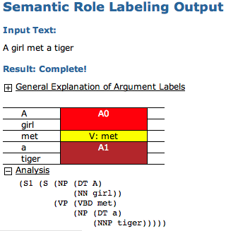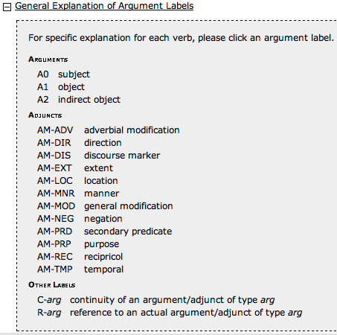
Figure 1. “Semantic Role Labeling of the sentence “A girl met a tiger” ”.
A web mining engine (i.e. “Google”) is also used within the proposed system. A web mining engine allows searching from a specific keyword and provides purely empirical answers to lexical questions. Google’s “define” function is a service which gives up-to-date definitions automatically gathered from the internet. Figure 2 and Figure 3 shows the definitions of “Tiger” and “Wolf” respectively.
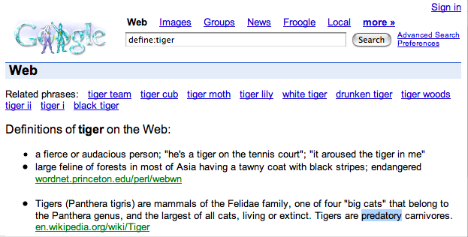

Figure 2. “Google’s definition of “Tiger””.
One of the definitions of “Tiger” mentions that: “Tigers are predatory carnivores”. We also found that, one of the definitions of “Wolf” indicates “any of various predatory carnivorous canine mammals of North America…”.

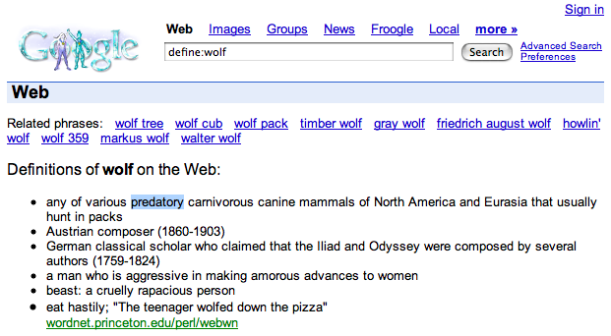
Figure 3. “Google’s definition of “Wolf””.
From the two definitions above, we find that the adjective “predatory” appears in the definitions of “Tiger” and “Wolf”. Next, we save the specific adjective “predatory” into a table with some code like “ADJ_#”. If the system detects different words containing the same definition, it will reference them by using the same adjective. So far, we have only considered 15 different adjective categories (see Table 1). We will increase the number of adjective categories progressively.

id | adjective | adj code | id | adjective | adj code
29 | illicit | ADJ_13 | 6 | youthful | ADJ_3
30 | illegitimate | ADJ_13 | 7 | carnivorous | ADJ_5
31 | criminal | ADJ_13 | 4 | predatory | ADJ_5
32 | felonious | ADJ_13 | 5 | rapacious | ADJ_5
25 | unlawful | ADJ_13 | 13 | reptile | ADJ_7
37 | difficult | ADJ_14 | 17 | hazardous | ADJ_8
38 | hard | ADJ_14 | 8 | lacking | ADJ_9
39 | rough | ADJ_14 | 83 | precious | ADJ_20
40 | laborious | ADJ_14 | 33 | awful | ADJ_18
Table 1. “Some adjective categories and their corresponding code numbers”.

Our approach differs from other related research work significantly. Some methods can only perform classification to tell which emotional category a sentence belongs to by detecting the emotional keywords out of the sentences [7, 8]. Our method takes into account some semantic issues that help to analyze sentences like “A girl met a tiger”. We are currently working only with seven different emotions: “Happiness”, “Sadness”, “Anger”, “Fear”, “Disgust”, “Surprise” and “Neutral”.
So, how do we detect emotions? Let’s go back to the sentence “A girl met a tiger”. When we analyze (i.e. Semantic Labeling Role) this sentence, we obtain that: “A girl” is the subject of the sentence, “met” is the verb of the sentence, and “a tiger” is the object of the sentence. Next, subjects and objects are linked to adjectives respectively based on their Google-define results. In the sentence “A girl met a tiger”, the subject (i.e. “A girl”) is linked to the adjective “youthful” (i.e. ADJ_3), and the object (i.e. “a tiger”) is linked to the adjective “predatory” (i.e. ADJ_5). Finally, we combine ADJ_3 and ADJ_5 by using the verb “meet”. The result is a “Fear” emotion (see Figure 4 and Table 2).

In our current prototype system, the primitive emotion model is created using a manual procedure. Table 2 shows a partial list of the emotion rules for different combination of some selected adjectives and a verb. If we take the record (id:35) as an example (i.e. Girl buy jewel), the subject (i.e. Girl) and the object (i.e. jewel) of this sentence are related to adjectives “ADJ_3” (i.e. youthful) and “ADJ_20” (i.e. precious) respectively. If we combine these adjectives with the verb “buy” (or “purchase”, “shop”), we obtain a “happy” emotion.
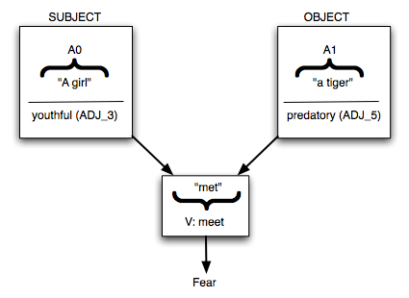
Figure 4. “Combining subjects and objects with verbs for emotion detection”.

id | verb | combination | emotion | Example
35 | buy | ADJ_3:ADJ_20 | happy | Girl buy jewel
22 | abandon | ADJ_3:ADJ_8 | happy | Girl abandon smoking
23 | kill | ADJ_5:ADJ_3 | sad | Tiger kill girl
25 | kill | ADJ_3:ADJ_5 | surprised | Girl kill tiger
34 | compete | ADJ_3:ADJ_5 | surprised | Girl compete tiger
36 | ease | ADJ_3:ADJ_8 | happy | Girl ease smoking
30 | hate | ADJ_3:ADJ_16 | angry | Girl hate tsunami
31 | hate | ADJ_3:ADJ_5 | angry | Girl hate tiger
4 | meet | ADJ_3:ADJ_7 | fear | Girl meet tiger
6 | meet | ADJ_5:ADJ_3 | fear | Tiger meet girl
7 | meet | ADJ_9:ADJ_3 | sad | Poor meet girl
8 | meet | ADJ_3:ADJ_9 | sad | Girl meet poor
9 | meet | ADJ_3:ADJ_5 | fear | Girl meet tiger
33 | compete | ADJ_3:ADJ_16 | surprised | Girl compete tsunami.
Table 2. “Combining adjectives and verbs”.

Also, in order to be able to handle more verbs, a table which contains verbs and their synonyms has been constructed (see Table 3). By establishing this table, the system will handle more verbs which have the same attribute with the same rules. For example, we consider that “abandon”, “leave”, and “cease” are synonyms. So far, we have 13 classifications in our system. The synonyms in Table 3 are referred from the on-line Yahoo-Dictionary (http://tw.dictionary.yahoo.com/).

id | verb | group | id | verb | group
5 | discard | abandon | 28 | hate | hate
12 | acquire | acquire | 29 | dislike | hate
13 | gain | acquire | 30 | despise | hate
14 | earn | acquire | 1 | destroy | kill
15 | secure | acquire | 8 | kill | kill
16 | obtain | acquire | 9 | slay | kill
24 | astonish | astonish | 10 | slaughter | kill
25 | surprise | astonish | 11 | murder | kill
26 | amaze | astonish | 6 | meet | meet
27 | astound | astonish | 50 | encounter | meet
31 | buy | buy | 51 | join | meet
32 | shop | buy | 7 | see | meet
Table 3. “Some verbs and their synonyms”.
So, the Semantic Role Labeling of the sentence “A girl met a tiger” allows to detect a “Fear” emotion.
In our prototype system, Concept Net is just used in order to retrieve some additional information (i.e. Location, for example). Actually, we can use Concept Net in order to find a place associated to “tiger”. Figure 5 shows a request sent to Concept Net.

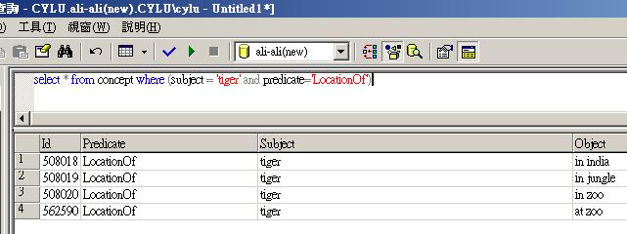
Figure 5. Sending a request to Concept Net.
So, one of the possible locations (i.e. LocationOf) related to “tiger” is “in jungle”. This information may be useful, essentially, in order to change the background image or the background audio of a multimedia application.
- A chatting room application.
In order to illustrate our proposals, we have built an “affective chatting room”. Figure 6 shows the general architecture of this application.
Figure 6. The general architecture of a “chatting room application”.
This kind of application has been frequently used in order to illustrate emotion detection from textual information [22, 23]. However, it should be noted that, even if the chatting room application we have developed is similar to those of [22, 23], we have not used the same models, techniques and methods. In these systems [22, 23] emotions are detected by means of “Keyword-Spotting”. In our system, emotions are detected by combining subjects and objects with verbs. Subjects and objects are identified by associating results obtained from: a semantic labeling tool and a Google’s define operation. Finally, ConceptNet requests are used in order to retrieve some additional information (i.e. Location, for example).

Figure 7 shows the user interface of our chatting room application. On the right-hand side of this interface one should note that the analysis (i.e. Semantic Role Labeling) of the sentence “It’s a good car” leads to the “happiness” emotion. Detecting this emotion may allow to change, for example, the background image and color of the user interface.

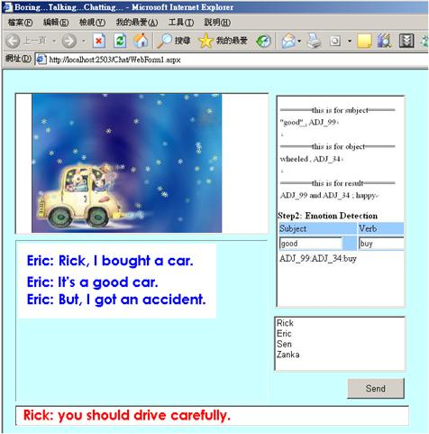
Figure 7. The chatting room application.
To present the sentences in the chatting room, we use an intelligent styling engine developed by ChiNan university to properly adapt the hypermedia presentation based on the emotion of the sentence. In the overall framework, intelligent styling engine will receive the information “subject” and “object” from the semantic labeling procedure and emotion results of each sentence. A corresponding presentation containing background images, background audios, and others with appropriate style will be selected.

- Conclusion and future work.
In the framework of the National ChiNan University and LORIA collaboration, we have presented a prototype system that associates a semantic labeling tool to a web mining engine in order to detect emotions. A common sense knowledgebase as, Concept Net, may also be used in order to retrieve some additional information that can be used to retrieve appropriate background images for the presentations.

To make the emotion detection system more robust, in the future there are a number of issues we intend to explore further.

- First, more argument labels within the semantic labeling techniques should be taken into account in the emotion model;
- Second, more adjective groups need to be included in the emotion model to account for more emotions.
- Third, it should be noted that, frequently, in order to obtain an accurate emotion for a sentence, the context in which a sentence is used must be taken into account. We intend to incorporate various “story-understanding” techniques to take account of the context information for emotion detection;
- Finally, we intend to apply to other languages, such as French, Chinese, Spanish, … etc. with the assistance of MLIF.
- Acknowledgement
This work is supported by the National Science Council of Taiwan, under grant NSC-94-2422-H-260-002, and the doctoral student program numbered NSC- 094-JFA-12-001. The authors wish to thank Professor Dan Roth of the Department of Computer Science of University of Illinois at Urbana-Champaign for allowing us to access the semantic labeling tools; and many graduate students at the Digital Archive Lab of ChiNan University for contributing to the development of the affective hypermedia chatting room.
- References.
- Jen-Shin Hong, Bai-Hsuan Chen, Sheng-Hao Hung, Jieh Hsiang. Towards an Integrated Digital Museum System- the ChiNan Experiences. Journal of Digital Libraries (Springer). Special Issue on Digital Museum, in Print.
- S. Cruz-Lara, S. Gupta, L. Romary. Handling Multilingual Content in Digital Media: The Multilingual Information Framework. EWIMT, 2004 European workshop on the Integration of Knowledge, Semantics and Digital Media Technology.
- S. Cruz-Lara, S. Gupta, J.D. Fernández García, and L. Romary. Multilingual Information Framework for Handling Textual Data in Digital Media. IEEE AMT 2005, The Third International Conference on Active Media Technology. Takamatsu, Kagawa, Japan. 19-21 May, 2005.
- XLIFF. Oasis (2003). XML Localisation Interchange File Format, http://www.oasis-open.org/committees/tc_home.php?wg_abbrev=xliff. Accessed 2003-10-31
- TMX. Oscar / Lisa (2000) Translation Memory eXchange, http://www.lisa.org/tmx. Accessed 2001-06-27
- i18n. W3C (2003) Internationalization (i18n). http://www.w3.org/International/.
- Elliott, C. The Affective Reasoner: A Process Model of Emotions in a Multi-agent System. PhD thesis, Northwestern University, May 1992. The Institute for the Learning Sciences, Technical Report No. 32.
- Zhe, X. & Boucouvalas, A. C. 2002. Text-to-Emotion Engine for Real Time Internet Communication. In Proceedings of International Symposium on Communication Systems, Networks and DSPs, Staffordshire University, UK, pp 164-168.
- Jonathon Read, Recognising Affect in Text using. Pointwise-Mutual Information. Master of Science. University of Sussex, UK. 2004.
- ITEA “Information Technology for European Advancement”. Passepartout project “Exploitation of advanced AV content protocols (MPEG 4/7)” ITEA 04017. http://www.itea2.org/public/project_leaflets/PASSEPARTOUT_profile_oct-05.pdf
- XMT. extended MPEG-4 Textual format. ISO/IEC FCD 14496-11, Information technology -- Coding of audio-visual objects -- Part 11: Scene description and application engine; ISO/IEC 14496-11/Amd 4, XMT & MPEG-J extensions.
- Synchronized Multimedia Integration Language (SMIL 2.0) . World Wide Web Consortium. http://www.w3.org/TR/smil20/
- C. O. Alm and D. Roth and R. Sproat, Emotions from text: machine learning for text-based emotion prediction, Proceedings of HLT/EMNLP, 2005
- Hugo Liu, Henry Lieberman, Ted Selker. (2003). A Model of Textual Affect Sensing using Real-World Knowledge. Proceedings of the 2003 International Conference on Intelligent User Interfaces, IUI 2003, 125-132. ACM Press.
- Ortony A., Clore, G. L., and Collins, A. The cognitive structure of emotions. New York: Cambridge University Press. 1988.
- Dyer, M.G. Emotions and Their Computations: Three Computer Models. Cognition and Emotion, Vol. 1, No. 3, 323-347, 1987.
- Prendinger, H. & Ishizuka, M. 2001. Simulating Affective Communication with Animated Agents. In Proceedings of Eighth IFIP TC.13 Conference on Human-Computer Interaction, Tokyo, Japan, 182-189.
- Bartneck, C. (2002). Integrating the OCC Model of Emotions in Embodied Characters. Proceedings of the Workshop on Workshop on Virtual Conversational Characters: Applications, Methods, and Research Challenges.
- V. Punyakanok, D. Roth, W. Yih, and D. Zimak, Semantic Role Labeling via Integer Linear Programming Inference. Proc. the International Conference on Computational Linguistics (COLING) (2004) pp. 1346—1352.
- Cognitive Computation Group. University of Illinois at UIrbana-Champaign. Software & Demos. Semantic Role Labeling Demo. http://l2r.cs.uiuc.edu/~cogcomp/srl-demo.php
- Google. http://www.google.com
- JunHee Park. Mood Chat Emotional Interface. Thesis documentation. Parsons School of Design - Master of Fine Arts in Design and Technology. May 2001.
- Chunling Ma, Helmut Prendinger, Mitsuru Ishizuka. A Chat System Based on Emotion Estimation from Text and Embodied Conversational Messengers. ICEC 2005, The Seventh International Conference on Electronic Commerce. Xi'an, China. August 2005.

It should also be noted that, within the framework of ITEA “Passepartout” project [10], we are experimenting with some basic scenarios where MLIF is associated to XMT (eXtended MPEG-4 Textual format [11]) and to SMIL (Synchronized Multimedia Integration Language [12]). Our main objective in this project is to associate MLIF to multimedia standards (e.g. MPEG-4, MPEG-7, and SMIL) in order to be able, within multimedia systems, to represent and to handle multilingual content in an efficient, rigorous and interactive manner.

