行政院及所屬各機關出國報告
（出國類別：其它）

汰換中正機場氣象雷達計畫
工廠驗收測試
出國報告書

出國人 | 服務機關： | 民用航空局飛航服務總台
出國人 | 職 稱： | 台 長、分析師、工務員
出國人 | 姓 名： | 簡慶芳、陳順發、劉錦郎
出國地區： | 美國佛羅里達
出國時間： | 92/02/10~92/02/21
報告日期： | 92/04/16

系統識別號： C09201530
行政院及所屬各機關出國報告提要
頁數：60頁 含附件：是

報告名稱：
汰換中正機場氣象雷達計畫工廠驗收測試
主辦機關：
交通部民用航空局
連絡人/電話：
陳碧雲/(02)23496197
出國人員：
簡慶芳 交通部民用航空局飛航服務總台 中正航空氣象台 台長
陳順發 交通部民用航空局飛航服務總台 航電技術室 分析師
劉錦郎 交通部民用航空局飛航服務總台 中正裝修區台 工務員

出國類別：其他
出國地區：美國
出國期間：民國九十二年二月十日-民國九十二年二月二十一日
報告日期：民國九十二年二月十六日
分類號/目：H2/航空 H2/航空
關鍵詞： RDA,RPG,FAT,SAT,UTC,DWR,RVP7,RCP02,IRIS
內容摘要：
民航局飛航服務總台為提高氣象服務品質，增進飛航安全，於民國七十六年四月於中正國際機場架設全國首套都卜勒氣象雷達。此雷達使用迄今已逾十五年，維護零組件補充日漸不易，為免影響機場整體運作，爰編列預算「汰換中正機場氣象雷達系統一套」，以汰換現有氣象雷達系統，提昇中正國際機場飛安。本購案於民國九十年十二月二十日決標，由美國Baron Service,Inc公司得標，承商應於九十年十二月三十一日採購契約簽訂後之二十個月內完成履約。本次工廠驗收測試(FAT)乃是依據「汰換中正機場氣象雷達系統」採購契約規定辦理，為確保裝備配備及系統功能皆能滿足契約規範需求，此行之目的在於原製造廠商Baron Services, Inc.公司於系統製造整合完成後能對所承購之整套系統設備功能，一一予以進行驗證，以降低採購風險，如遇有與契約規範不符處，則能利用原廠較為豐厚之後勤支援立即修改，以避免設備裝運來台之事後修改，而造成測試驗收及未來設備維護之困擾，工廠驗收測試所得結果並能建立一份最佳及完整的測試資料，做為未來系統架設、維護之參考。

本文電子檔已上傳至出國報告資訊網http://report.gsn.gov.tw

出國報告名稱：汰換中正機場氣象雷達計畫工廠驗收測試
出國計畫主辦機關名稱：交通部民用航空局
出國人姓名/職稱/服務單位:簡慶芳等3人/台長/民用航空局飛航服務總台
出國計畫主辦機關審核意見 | □1.依限繳交出國報告  □2.格式完整  □3.內容充實完備  □4.建議具參考價值  □5.送本機關參考或研辦  □6.送上級機關參考  □7.退回補正,原因：□①不符原核定出國計畫  □②以外文撰寫或僅以所蒐集外文資料為內容  - ③內容空洞簡略  - ④未依行政院所屬各機關出國報告規格辦理  □⑤未於資訊網登錄提要資料及傳送出國報告電子檔。  □8.其他處理意見：
承轉機關審核意見 | □同意主辦機關審核意見 □全部 □部分 （填寫審核意見編號）  □退回補正，原因： （填寫審核意見編號）  □其他處理意見
說明：
- 出國計畫主辦機關即層轉機關時，不需填寫『承轉機關審核意見』。
- 各機關可依需要自行增列審核項目內容，出國報告審核完畢本表請自行保存。
三、審核作業應於出國報告提出後二個月內完成。
汰換中正機場氣象雷達計畫工廠驗收測試
出國報告書
目 錄
標題
- 目的……………………………………………………………5
- 過程……………………………………………………………7
- 內容……………………………………………………………9
  - 第三次合約管理審查會議決議事項…………………….9
  - 工廠測試驗收前會議…………………………………....10
  - 工廠測試驗收之進行方式………………………………12
  - 工廠驗收測試之架構…………………………….13
  - 工廠測試驗收之進行……………………………………17
  - 工廠驗收測試結果………………………………….38
- 心得…………………………………………………………...41
- 建議…………………………………………………………...42
- 附錄…………………………………………………………...43
附錄一 第三次合約管理會議會議紀錄………………………44
附錄二 測試前會議簡報內容…………………………………50
附錄三 工廠測試驗收(FAT)驗收紀錄………………………..56
汰換中正機場氣象雷達計畫工廠驗收測試
出國報告書
- 目的
民航局飛航服務總台為提高氣象服務品質，增進飛航安全，於民國七十六年四月在中正國際機場架設全國首套都卜勒氣象雷達。此雷達使用迄今已逾十五年，維護零組件補充日漸不易，為免影響機場整體運作，爰編列預算「汰換中正機場氣象雷達系統」乙套，汰換現有都卜勒氣象雷達系統，以提昇中正國際機場飛安。
前述計畫於民國九十年十二月二十日決標，由美國Baron Services, Inc公司得標，承商應於民國九十年十二月三十一日採購契約簽訂後之二十個月內完成履約(含架設、安裝、陣地測試及720小時不中斷信心測試)。
本次工廠驗收測試乃是依據「汰換中正機場氣象雷達計畫」採購契約規定辦理，為確保裝備配備及系統功能皆能滿足契約規範需求，此行之目的在於原製造廠商Baron Services, Inc.公司於系統製造整合完成後能對所承購之整套系統設備功能，一一予以進行驗證，以降低採購風險，如遇有與契約規範不符處，則能利用原廠較為豐厚之後勤支援立即修改，以避免設備裝運來台之事後修改，而造成測試驗收及未來設備維護之困擾，工廠驗收測試所得結果並能建立一份最佳及完整的測試資料，做為未來系統架設、維護之參考。
本次同行參與同仁均能秉持細心、嚴緊的態度，依據合約規範及原廠提供之測試步驟，逐一比對各項數據及測試結果，在原廠經理、工程師努力配合下，順利完成此次工廠測試工作。

- 過程
  - 參與工廠驗收測試人員
簡 慶 芳 民用航空局飛航服務總台
中正航空氣象台 台 長
陳 順 發 民用航空局飛航服務總台
航電技術室 分析師
劉 錦 郎 民用航空局飛航服務總台
中正裝修區台雷達設備台 工務員

  - 日 期：
自民國九十二年二月十日至民國九十二年二月二十一日止，共計十二日。

  - 行 程：
    - 九十二年二月十一日搭程長榮航空BR-016班機由中正機場至美國洛杉磯。
    - 九十二年二月十二日由美國洛杉磯搭程美國Delta航空公司DL-1454班機至達拉斯，再從達拉斯轉搭Delta航空公司DL4450班機飛往佛羅里達，由Baron公司之資深雷工程師Mr. Billy Walker接送至預訂之住宿旅館；並與Mr. Billy Walker先行議定：隔日（12日）上午0900L(當地時間)開始進行工廠驗收測試（Factory Acceptance Test；FAT）。在工廠驗收測試之前，首先由Baron公司人員為參與測試人員做一簡報，說明該公司與民航局委託之獨立驗證公司(ROBERT W.HUNT COMPANY)驗證人員先行執行測試驗證之測試結果，並討論往後數日測試驗收的進行程序，以利後續工廠驗收測試程序之進行。
    - 九十二年二月十三日至九十二年二月十八日於承商美國BARON公司測試工廠進行都卜勒氣象雷達設備及系統功能測試。
    - 民國九十二年二月十九日由佛羅里達搭乘Delta航空公司DL-1894班機飛往亞特蘭大（Atlanta），再從亞特蘭大搭程Delta航空公司DL-341班機轉飛洛杉磯；直接從洛杉磯轉搭乘長榮航空公司BR-111班機於二月二十一日飛抵中正國際機場。

- 內容
  - 第三次合約管理審查會議決議事項
民航局與承商每國BARON公司於民國九十一年十二月九日至十二月十一日在佛羅里達與承商對執行本購案「汰換中正都卜勒氣象雷達案」召開第三次合約管理審查會議，會中針對有關工廠驗收測試(Factory Acceptance Test)議題部份，雙方達成之重要決議內容如下：
      - BARON公司必須於民國九十一年十二月十六日前將工廠驗收測試(FAT)測試程序文件初稿送民航局審查。
      - 工廠測試期間自九十二年二月十二日至二月十九日，為期能如期完成工廠驗收測試，雙方同意視實際執行測試情況，視需要於週末彈性增測試時程。
      - 基於測試項目繁多及民航局人員能於工廠驗收測試期間內完成驗測，決定先由民航局委託之獨立驗證公司(Robert W.Hunt)依工廠驗收測試內容與程序將所有須測項目先行測試，再由本次民航局參與測試人員抽測及對所有技術規範文件(Technical Specification Proposal – TSP)內所述之關鍵性需求(Critical Requirement)功能項目需求確實進行測試驗證，以核對測試結果確實符合契約規範。

  - 工廠測試驗收前會議
依據第三次合約管理審查會議雙方協議，工廠驗收測試前會議，由BARON公司代表Mr. Billy Walker說明測試程序及其與民航局委託獨立驗證公司測試驗證之結果。並向民航局測試人員說明目前測試情形如下：
      - 於九十二年二月二日至九十二年二月九日由民航局委託之獨立驗證公司負責監督BARON公司依工廠驗收測試程序所有項目進行查驗、分析、模擬及實測。
      - 監控查驗、分析、模擬及實測項目包括：
- RDA 分析(analysis) – 27項。
- RDA 模擬(demonstration) – 74項。
- RDA 測試(test) – 99項。
- RDA 查驗(inspection) – 62項。
- RPG 分析(analysis) – 12項。
- RPG 模擬(demonstration) – 74項。
- RPG測試(test) – 196項。
- RPG查驗(inspection) – 7項。
- 工作站模擬(demonstration) – 247項。
- 工作站查驗(inspection) – 9項。
      - 在進行系統整合時發生一些小問題，有10個4接頭導波管尺寸無法完全密合，正確規格之組件將於二月十日送達，預計於二月十三日完成更換。
      - 部份組件烤漆顏色不一致部份，BARON於運交前將重新烤漆。
      - 31呎雷達罩已完成組裝測試，目前已裝櫃待運送，在美國不再重覆組裝測試。
民航局代表要求BARON公司於測試期間提供下列資料，置於測試場所，以便測試期間隨時查閱：
- 將其與民航局委託之獨立驗證公司測試紀錄影本乙份供民航局進行審查。
- BARON公司投標之建議書。

工廠驗收測試依性質分為雷達設備(RDA)、雷達產品(Radar Product Generation - RPG)、電腦顯示工作站(Workstation)三部份，承商依民航局技術規範文件(TSP)之需求分別將其歸類為分析、模擬、測試及查驗四類，BARON公司依此方式撰寫測試程序，各類測試驗證方式之定義分別說明如下：
- I=查驗(Inspection)：實體查驗廠商所提之產品可以滿足技術規範文件所要求之規格需求。
- A=分析(Analysis)：透過計算公式推導(equations)、圖表(charting)、資料歸納(data reduction)、圖說(drawing)、廠商測試資料(Vendor test data)、商用規格資料(commicial specification sheet)或其他相關資料來證明提供之廠商產品可以滿足技術規範文件所要求之規格需求。
- D=模擬(Demonstration)：觀察在規定的條件下進行模擬資料測試其結果可以滿足技術規範文件所要求之規格需求。
- T=測試(Test)：證明在適用的條件下，透過設備/系統相關元件處理的結果，可以滿足技術規範文件所提數據或品質要求之規格需求。

三、工廠測試驗收之進行方式
系統驗收測試(FAT)分為雷達設備、雷達產品及工作站三部份，為期能於有限的時間內完成測試程序所列的測試項目，雙方同意分兩組進行，雷達設備及工作站測試為一組、雷達產品測試為一組，預有問題時再進行併組討論。
系統驗收測試(FAT)之進行，除依BARON公司所提供之測試程 序進行測試外，必須同時對民航局委託獨立驗證公司(ROBERT W.HUNT COMPANY)驗證人員與BARON公司進行審查，對於引用數據有誤或有疑慮的地方，隨時要求廠商依測試程序進行重測或驗證，以確認廠商所提供之設備及系統均能民航局技術規範文件所提之規格需求要求。

四、工廠驗收測試之架構
BARON公司為證實其所提供之設備及系統功能可以
完全滿足合約技術規範文件所提之規格及功能需求，於工廠驗收測試(FAT)一開始，就由BARON公司代表說明並確認系統設備測試驗收環境，完全模擬未來現場(中正航空氣象台都卜勒氣象雷達作業室、航空氣象觀測室、中正雷達台及台北航空氣象中心)建置架構連結一致，民航局設備及網路連線架構圖詳如附圖一，工廠測試驗收之設備及網路連線架構圖詳如附圖二及附圖三。

附圖一 民航局設備及網路連線架構圖
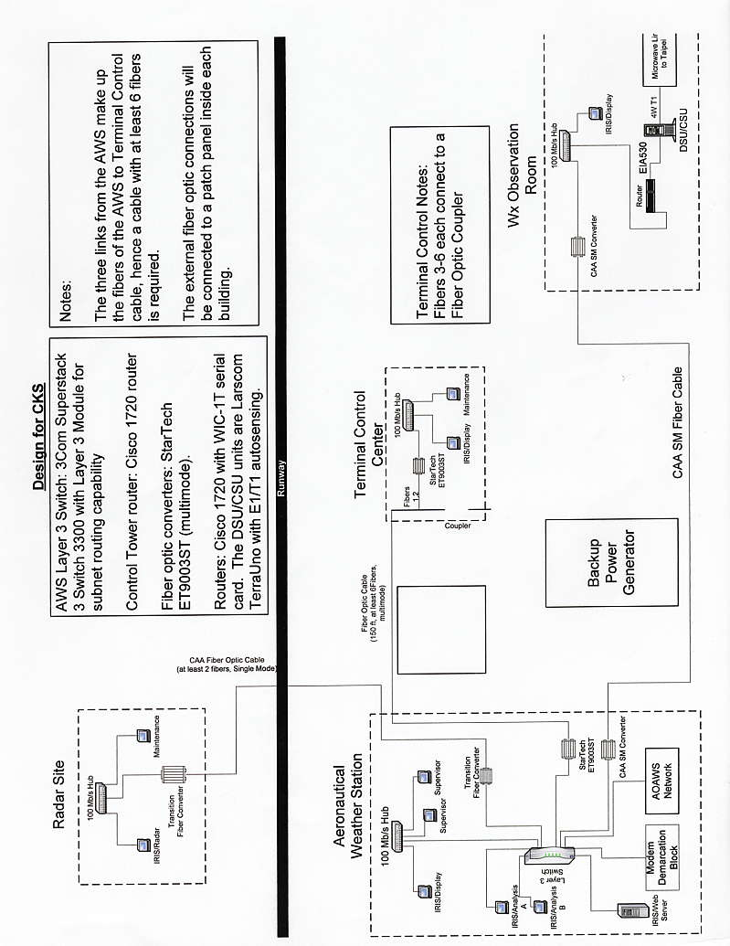

附圖二 工廠測試驗收之設備及網路連線架構圖(中正地區)
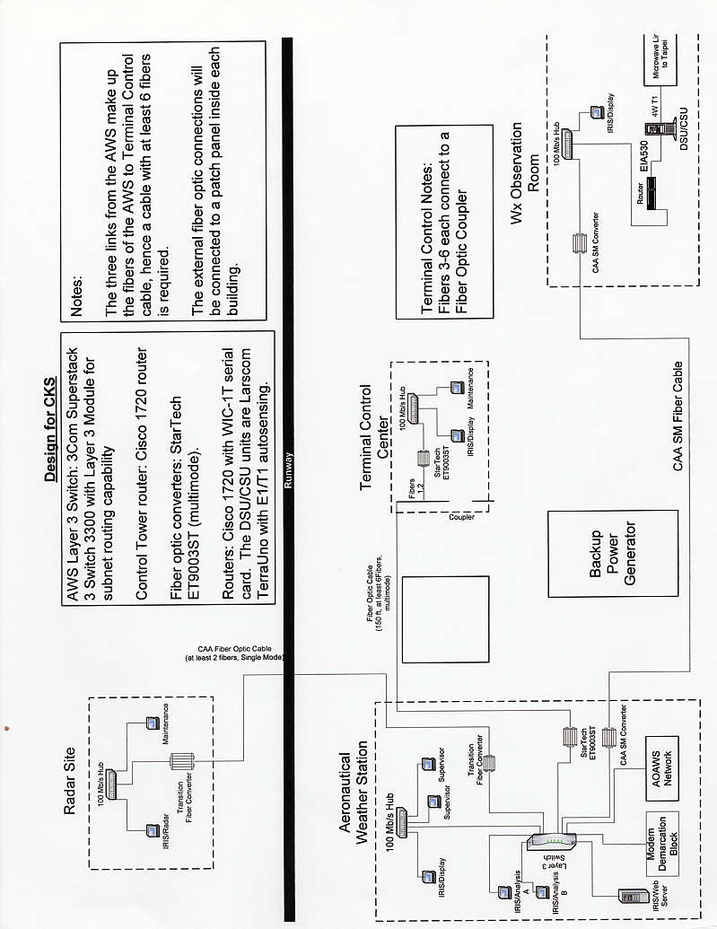

附圖三 工廠測試驗收之設備及網路連線架構圖(中正地區)
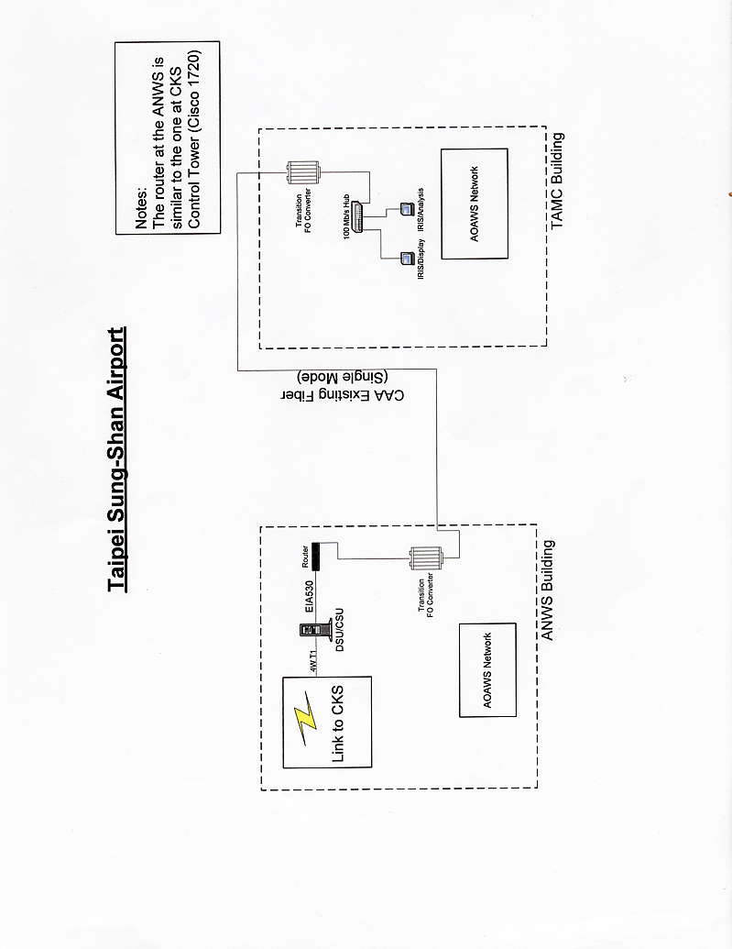

五、關鍵性需求(Critical Requirement)測試及結果
(一) RDA關鍵性需求測試及結果
- RDA INSPECTION
項次 | 章節 | 內容說明 | 測試結果 | 日期
1 | 4.2.7 | The antenna assembly design shall include provisions for routine inspection of critical internal pedestal and drive mechanism parts without disassembly. | PASS | 92.02.12
2 | 4.2.8 | A rigid radome shall be included as part of the DWR system. | PASS | 92.02.12
3 | 4.2.9.1 | The following pedestal requirements shall be met: TYPE-Elevation over Azimuth | PASS | 92.02.12
4 | 4.2.9.3 | A pedestal drive safety switch shall be provided on the last landing leading to the antenna platform. | PASS | 92.02.12
5 | 4.2.9.3 | Access to the antenna platform shall be via a door or hatch in the CAA supplied building. | PASS | 92.02.12
6 | 4.2.9.3 | An interlock having the same functions as the safety switch shall be provided on the access door/hatch. | PASS | 92.02.12
7 | 4.2.9.3 | Provisions shall be made to permit access to all items such as the antenna, etc., with built-in ladders or equivalent | PASS | 92.02.12
8 | 4.2.10 | The transmitter shall meet the following requirements: Modulator: Solid State | PASS | 92.02.12
9 | 4.2.14 | A separate antenna control box shall be provided at the RDA site such that either hardware or software control of the antenna can be permitted. | PASS | 92.02.12
10 | 4.12.8.2 | The transmitter shall have monitoring features so that critical parameters can be measured and reported to the maintenance workstation. | PASS | 92.02.12
11 | 4.12.8.3 | Critical parameters of the receiver shall be measured and reported to the maintenance workstation. | PASS | 92.02.12

- RDA ANALYSIS
項次 | 章節 | 內容說明 | 測試結果 | 日期
1 | 4.2.2.1 | The RDA shall provide quantitative reflectivity detection over Non-Doppler Operation Range: 240 km | PASS | 92/02/12
2 | 4.2.2.1 | The RDA shall provide quantitative reflectivity detection over Doppler Operation Range: 120 km | PASS | 92/02/12
3 | 4.2.2.2 | The Doppler mean radial velocity detection shall be at least 48 meters per second with no ambiguities to a range of 120 km for the DWR System. | PASS | 92/02/12
4 | 4.2.2.3 | The RDA shall provide volume Non-Doppler Operation Range: 240km coverage. | PASS | 92/02/12
5 | 4.2.2.3 | The RDA shall provide volume Doppler Operation Range: 120km coverage. | PASS | 92/02/12
6 | 4.2.2.3 | The RDA shall provide volume Altitude: 70,000 feet Mean Sea Level (MSL) coverage. | PASS | 92/02/12
7 | 4.2.4.1 | The RDA shall meet mean radial velocity and spectrum width requirements for the range of possible dwell times and mean radial velocities of 48 m/s. Accuracy: Less than 0.3 m/s for S/N equal to 10 dB. | PASS | 92/02/12
8 | 4.2.4.1 | The RDA shall meet mean radial velocity and spectrum width requirements for the range of possible dwell times and mean radial velocities of Accuracy: Less than 0.6 m/s for S/N equal to 0 dB. | PASS | 92/02/12
9 | 4.2.4.1 | The RDA shall meet mean radial velocity and spectrum width requirements for the range of possible dwell times and mean radial velocities of 48 m/s. Precision: equal to of less than 0.5 m/s. | PASS | 92/02/12
10 | 4.2.4.2 | The RDA shall meet spectrum width requirements for the range of possible dwell times and mean radial velocities of 48 m/s. Accuracy: For a true spectrum width of 4 m/s, the standard deviation of the spectrum shall be less than or equal to 1.0 m/s for S/N greater | PASS | 92/02/12
11 | 4.2.4.2 | The RDA shall meet spectrum width requirements for the range of possible dwell times and mean radial velocities of 48 m/s. Precision: equal to or less than 1.0 m/s. | PASS | 92/02/12
12 | 4.2.4.4 | The range resolution of the system shall be less than or equal to 100 meters. The error in range placement of base data output from the RDA due to timing instabilities shall be less than 50 meters. | PASS | 92/02/12
13 | 4.2.7 | The antenna and the system shall operate in winds up to 270 kilometers per hour with the antenna in a radome. | PASS | 92/02/12

- RDA demonstration
項次 | 章節 | 內容說明 | 測試結果 | 日期
1 | 4.2.2.3 | The RDA shall provide volume antenna Scan: 360 degrees coverage. | PASS | 92.02.12
2 | 4.2.2.3 | The RDA shall provide volume Elevation: 0 to +90 degrees coverage. | PASS | 92.02.12
3 | 4.2.2.3 | A number of automatic antenna scanning programs shall be provided for the volume coverage for a maximum of 6 minutes. | PASS | 92.02.12
4 | 4.2.2.3 | The scanning rate may vary with elevation, but should be consistent with reasonable dwell times for the required system performance for reflectivity and radial velocity data. | PASS | 92.02.12
5 | 4.2.3.1 | The RDA shall provide an azimuth sample interval of no greater than one degree. | PASS | 92.02.12
6 | 4.2.9.2 | A programmable control of antenna scanning shall be provided. | PASS | 92.02.12
7 | 4.2.9.2 | The capability shall be provided for selecting a single scanning strategy to be employed at any given time from a set of up to 8 scan strategies. | PASS | 92.02.12
8 | 4.2.9.3 | Appropriate status indication of the switch position shall be provided to the maintenance workstation. | PASS | 92.02.12
9 | 4.2.9.3 | An appropriate interlock by-pass and status indication of the interlock shall be provided. | PASS | 92.02.12
10 | 4.2.14 | The RDA shall include all hardware and software necessary for operational control and monitoring of the RDA function area. | PASS | 92.02.12
11 | 4.2.14 | The RDA control capability shall also support the running of offline diagnostics. | PASS | 92.02.12
12 | 4.2.15 | The RDA shall include a capability for equipment monitoring and reporting the status of radar functions to the RDA maintenance position. | PASS | 92.02.12
13 | 4.2.18.1 | Monitoring requirements for the system are: Antenna and pedestal | PASS | 92.02.12
14 | 4.2.18.1 | Monitoring requirements for the system are: System Integrity | PASS | 92.02.12
15 | 4.2.18.1 | Monitoring requirements for the system are: Redundant channel/equipment | PASS | 92.02.12
16 | 4.2.18.1 | Monitoring requirements for the system are: System Configuration | PASS | 92.02.12
17 | 4.2.18.1 | Monitoring requirements for the system are: System/equipment status | PASS | 92.02.12
18 | 4.2.18.1 | Monitoring requirements for the system are: Critical equipment parameters | PASS | 92.02.12
19 | 4.2.18.1 | Monitoring requirements for the system are: Critical system areas | PASS | 92.02.12
20 | 4.2.18.4 | Critical function of the signal processor and preprocessor shall be measured and reported to the maintenance workstation. | PASS | 92.02.12
21 | 4.2.18.5 | Appropriate test and monitor features shall be incorporated to provide staus information on the pedestal, the antenna, and the waveguide to the maintenance workstation. | PASS | 92.02.12

- RDA TEST
項次 | 章節 | 內容說明 | 測試結果 | 日期
1 | 4.2.4 | The RDA shall provide the capability of operating over a range of dwell times compatible with nominal scan rates of from 2 rpm to 6 rpm in both Doppler and Non-Doppler operation. | PASS | 92.02.13
2 | 4.2.6 | The frequency band of the DWR shall be C-band with frequencies from 5600 MHz to 5650 MHz. | PASS | 92.02.13
3 | 4.2.9.1 | The Pedestal Requirements shall be Rotation rate: Variable to a maximum of 36 degrees per second. | PASS | 92.02.13
4 | 4.2.9.2 | The contractor shall provide a method for controlling and prohibiting unauthorized changes to the scan strategies. | PASS | 92.02.13
5 | 4.2.9.2 | A manual override of the defined strategies shall be available for maintenance actions. | PASS | 92.02.13
6 | 4.2.9.3 | The pedestal drive safety switch shall disconnect all primary power from the drive assembly to inhibit the rotation when the "safe" position is selected. | PASS | 92.02.13
7 | 4.2.9.3 | The pedestal drive safety switch shall also inhibit the DWR transmitter from radiating into the antenna. | PASS | 92.02.13
8 | 4.2.9.3 | The pedestal drive safety switch shall be capable of being locked in the "safe" position with a padlock. | PASS | 92.02.13
9 | 4.2.10 | The transmitter shall meet the following requirements: Frequency Range: 5.60 to 5.65 GHz. | PASS | 92.02.13
10 | 4.2.10 | The transmitter shall meet the following requirements: RF Peak Power: 250 kW | PASS | 92.02.13
11 | 4.2.10.1 | The set of PRFs available for selection shall be adjustable, over a range of at least +/- 1%. | PASS | 92.02.13
12 | 4.2.11 | The receiver unit shall consist of the following characteristics: Operating Frequency: Frequency range of 5.60 to 5.65 | PASS | 92.02.13
13 | 4.2.11 | The receiver unit shall consist of the following characteristics: Dynamic Range: Greater than 93 dB. | PASS | 92.02.13
14 | 4.2.13 | The DWR shall provide a ground clutter suppressing capability to improve the measurement of weather return parameters in the presence of clutter. | PASS | 92.02.13
15 | 4.2.18.2 | Transmitter parameters that should be monitored include: Peak power. | PASS | 92.02.13
16 | 4.2.18.2 | Transmitter parameters that should be monitored include: Pulse width. | PASS | 92.02.13
17 | 4.2.18.2 | Transmitter parameters that should be monitored include: Transmit frequency. | PASS | 92.02.13
18 | 4.2.18.2 | Transmitter parameters that should be monitored include: Pulse shape. | PASS | 92.02.13
19 | 4.2.18.2 | Transmitter parameters that should be monitored include: Pulse stability. | PASS | 92.02.13
20 | 4.2.18.3 | Receiver Parameters that should be monitored include: RF generator stability. | PASS | 92.02.13
21 | 4.2.18.3 | Receiver Parameters that should be monitored include: Overall receiver stability. | PASS | 92.02.13
22 | 4.2.18.3 | Receiver Parameters that should be monitored include: Receiver linearity. | PASS | 92.02.13
23 | 4.2.18.3 | Receiver Parameters that should be monitored include: Receiver dynamic range. | PASS | 92.02.13
24 | 4.2.18.3 | Receiver Parameters that should be monitored include: Receiver sensitivity. | PASS | 92.02.13
25 | 4.2.18.4 | Functions that should be monitored include: System timing. | PASS | 92.02.13
26 | 4.2.18.4 | Functions that should be monitored include: Synchronization. | PASS | 92.02.13
27 | 4.2.18.4 | Functions that should be monitored include: Processor memory. | PASS | 92.02.13
28 | 4.2.18.4 | Functions that should be monitored include: Doppler filtering. | PASS | 92.02.13
29 | 4.2.18.4 | Functions that should be monitored include: System load. | PASS | 92.02.13

(二) RPG 關鍵性需求測試及結果
- RPG Inspection
項次 | 章節 | 內容說明 | 測試結果 | 日期
1 | 5.3 | The RPG on-line storage of products shall be capable of storing at least 30 GB of the full load product mix capability of the DWR system (excluding Derived Data Arrays). | PASS | 92.02.12
2 | 5.4.1 | The RPG shall provide communications ports for the interface of the three CKS Aeronautical Weather Station. | PASS | 92.02.12
3 | 5.4.1 | The RPG shall provide those products requested by the workstations; this includes both products to be sent on a routine basis and products requested on a one-time basis. | PASS | 92.02.12
4 | 5.4.1 | Products generated because alert criteria were met shall be transmitted to the requesting operational positions prior to all other products defined for transmission to that operational position. | PASS | 92.02.12
5 | 5.5 | The RPG shall include a maintenance workstation located in the Radar Maintenance Room next to the CKS Terminal Control Center. | PASS | 92.02.12
6 | 5.5 | The RPG maintenance workstation shall include the same display, data entry, and hard copy equipment and provide the same functional capabilities as defined in Section 6 of this specification. | PASS | 92.02.12

- RPG Analysis
項次 | 章節 | 內容說明 | 測試結果 | 日期
1 | 5.1 | The Radar Product Generation (RPG) functional area shall process the base data received from the Radar Data Acquisition (RDA) functional area to generate a set of products that contains information concerning the following meteorological phenomena listed below: | PASS | 92.02.13
2 | 5.1 | Precipitation | PASS | 92.02.13
3 | 5.1 | Wind and Wind Shear | PASS | 92.02.13
 | 5.1 | Fronts and Fine Lines | PASS | 92.02.13
4 | 5.1 | Tropical Cyclones | PASS | 92.02.13
5 | 5.1 | Mesocyclones | PASS | 92.02.13
6 | 5.1 | Thunderstorms | PASS | 92.02.13
7 | 5.1 | Freezing/Melting Level | PASS | 92.02.13
8 | 5.1 | Microburst | PASS | 92.02.13

- RPG Demonstration
項次 | 章節 | 內容說明 | 測試結果 | 日期
1 | 5.1 | CAPPI= Constant Altitude Plan Position indicator (R, V, SW) | PASS | 92.02.14
2 | 5.1 | ETOP Echo Top | PASS | 92.02.14
3 | 5.1 | HMAX Height of Maximum Reflectivity | PASS | 92.02.14
4 | 5.1 | HMI Horizontal Maximum Reflectivity Indicator (R. V, SW) | PASS | 92.02.14
5 | 5.1 | VMI = Vertical Maximum Reflectivity Indicator (R, V, SW) | PASS | 92.02.14
6 | 5.1 | RHI = Range Height Indicator (R, V, SW) | PASS | 92.02.14
7 | 5.1 | VSI = Vertical Cross Section Indicator | PASS | 92.02.14
8 | 5.1 | VAD = Velocity Azimuth Display | PASS | 92.02.14
9 | 5.1 | HRR = Hourly Rainfall Rate | PASS | 92.02.14
10 | 5.1 | PPI = Real-time PPI | PASS | 92.02.14
11 | 5.1 | Horizontal Shear | PASS | 92.02.14
12 | 5.1 | Vertical Shear | PASS | 92.02.14
13 | 5.1 | Microburst | PASS | 92.02.14
14 | 5.1 | Gust Front | PASS | 92.02.14
15 | 5.3 | The RPG shall provide the capability for on-line storage (e.g., hard disk) of all products. | PASS | 92.02.14
16 | 5.3 | The RPG shall provide the capability for defining and changing the product mix and retention time for products to be retained in the on-line RPG storage function. | PASS | 92.02.14
17 | 5.3 | This capability shall be controlled by commands from the maintenance position or set by adaptation. | PASS | 92.02.14
18 | 5.3 | Products stored within the RPG on-line storage function shall not be capable of being altered from a user display workstation, nor by input from any principal user or other user interface. | PASS | 92.02.14

- RPG Test
項次 | 章節 | 內容說明 | 測試結果 | 日期
1 | 5.2.1 | Base products shall provide reflectivity estimates for each elevation angle to a range of 240 km. | PASS | 92.02.17
2 | 5.2.1 | Base products shall provide mean radial velocity and spectrum width estimates for each elevation angle to a range of 120 km. | PASS | 92.02.17
3 | 5.2.1 | The highest resolution provided in a base product shall be equal to the resolution available from the base data. | PASS | 92.02.17
4 | 5.2.1 | These products shall be displayed as a vertical projection onto the earth’s surface, e.g., 100 km at 200 shall be displayed at approximately 94 km. | PASS | 92.02.17
5 | 5.2.1 | For a given coverage area, each elevation scan shall be displayed at the same geographic scale relative to the earth’s surface. | PASS | 92.02.17
6 | 5.2.1 | A technique shall be provided to present the mean radial velocity and spectrum width data at the correct range (range unfolding). | PASS | 92.02.17
7 | 5..2.1 | Data significantly contaminated due to overlaid weather echoes or ground clutter shall be identified. | PASS | 92.02.17
8 | 5.2.2 | Derived products shall provide users with access to large volumes and varieties of data in easily displayable formats. | PASS | 92.02.17
9 | 5.2.2 | These large volumes of data shall be concentrated into easily interpretable products, which may include annotations (added either automatically as a result of an algorithm, or manually) to identify specific meteorological phenomena. | PASS | 92.02.17
10 | 5.2.2 | The annotations, which include alphanumeric data, special symbol data and line segments, shall be nondestructive of the data and shall remain apart of the product unless they are removed by manual action. | PASS | 92.02.17
11 | 5.2.2 | Products not requiring manual annotations shall not be delayed by a manual annotation function that may be required for other products. | PASS | 92.02.17
12 | 5.2.2 | Derived products may also be used for further processing by a user. | PASS | 92.02.17
13 | 5..2.3 | Alphanumeric products shall provide weather information in a form suitable for display on both graphic and alphanumeric display devices. | PASS | 92.02.17
14 | 5.2.3 | This information shall include alert messages, summary data, and free text messages. | PASS | 92.02.17
15 | 5.2.4 | Derived data array products shall provide information in a form suitable for transmission to and processing in a system external to the DWR System. | PASS | 92.02.17
16 | 4.2.4 | These products are not in a displayable format. | PASS | 92.02.17
17 | 5.3 | The RPG shall have the capability of off-line optical disk storage (at least 5GB) of all online storage products for archiving purposes. | PASS | 92.02.17
18 | 5.3 | The off-line storage function shall be automatically initiated as set by adaptation or by commands entered by the supervisor workstation. | PASS | 92.02.17
19 | 5.3 | When the on-line storage function reaches a set storage capacity threshold, it shall automatically transfer data to the off-line storage function. | PASS | 92.02.17
20 | 5.3 | A manual capability for transferring and retrieving of data to/from the off-line storage function shall be provided. | PASS | 92.02.17
21 | 5.4 | Each RPG shall make products available for distribution to users in accordance with Section 7 of this specification. | PASS | 92.02.17
22 | 5.4 | Each RPG shall provide import/outputs communication ports for the workstation interfaces defined here: | PASS | 92.02.17
23 | 5.4 | CKS Aeronautical Weather Station | PASS | 92.02.17
24 | 5.4 | Taipei Aeronautical Meteorological Center | PASS | 92.02.17
25 | 5.4 | CKS Weather Observation Room | PASS | 92.02.17
26 | 5.4 | CAA Advanced Operations Aviation Weather System (AOAWS) Users | PASS | 92.02.17
27 | 5.4.1 | Different associated workstations may request different product set for routine receipt from the RPG. | PASS | 92.02.17
28 | 5.4.1 | All products stored on-line within the RPG shall be available to any associated workstations. | PASS | 92.02.17
29 | 5.4.1 | The RPG shall support on-line requests for changes and additions to the set of products routinely sent to an associated workstation. | PASS | 92.02.17
30 | 5.4.1 | It shall also support on-line changes to their frequency or priority. | PASS | 92.02.17
31 | 5.4.2 | The RPG shall provide communications ports for interface with the two Taipei Aeronautical Meteorological Center workstations identified in Section 7 of this specification. | PASS | 92.02.17
32 | 5.4.2 | The RPG shall provide those products requested by the workstations. | PASS | 92.02.17
33 | 5.4.2 | This includes both products to be sent on a routine basis and products requested on a one-time basis. | PASS | 92.02.17
34 | 5.4.2 | Products generated because alert criteria were met shall be transmitted to the requesting operational positions prior to all other products defined for transmission to that operational position. | PASS | 92.02.17
35 | 5.4.2 | All products stored on-line within the RPG shall be available to these workstations. | PASS | 92.02.17
36 | 5.4.2 | The RPG shall support on-line requests for changes and additions to the set of products routinely sent to an associated workstation. | PASS | 92.02.17
37 | 5.4.2 | It shall also support online changes to their frequency or priority. | PASS | 92.02.17
38 | 5.4.2 | In additional, the RPG shall provide analog time-domain data (raw weather data) to one of the specified workstations located in the Taipei Aeronautical Meteorological Center. | PASS | 92.02.17
39 | 5.4.3 | The RPG shall provide the communications port for the interface with the one CKS Terminal Control Center Workstation identified in Section 7 of this specification. . | PASS | 92.02.17
40 | 5.4.3 | The RPG shall provide those products requested by the workstation. | PASS | 92.02.17
41 | 5.4.3 | This includes both products to be sent on a routine basis and products requested on a one-time basis | PASS | 92.02.17
42 | 5.4.3 | Products generated because alert criteria were met shall be transmitted to the requesting operational positions prior to all other products defined for transmission to that operational position. | PASS | 92.02.17
43 | 5.4.3 | All products stored on-line within the RPG shall be available to these workstations. | PASS | 92.02.17
44 | 5.4.3 | The RPG shall support on-line requests for changes and additions to the set of products routinely sent to an associated workstation. | PASS | 92.02.17
45 | 5.4.3 | It shall also support online changes to their frequency or priority. | PASS | 92.02.17
46 | 5.4.4 | The RPG shall provide the communications port for the interface with the one CKS Terminal Weather Observation Facility identified in Section 7 of this specification. | PASS | 92.02.18
47 | 5.4.4 | The RPG shall provide those products requested by the workstation. | PASS | 92.02.18
48 | 5.4.4 | This includes both products to be sent on a routine basis and products requested on a one-time basis. | PASS | 92.02.18
49 | 5.4.4 | Products generated because alert criteria were met shall be transmitted to the requesting operational positions prior to all other products defined for transmission to that operational position. | PASS | 92.02.18
50 | 5.4.4 | All products stored on-line within the RPG shall be available to these workstations. | PASS | 92.02.18
51 | 5.4.4 | The RPG shall support on-line requests for changes and additions to the set of products routinely sent to an associated workstation. | PASS | 92.02.18
52 | 5.4.4 | It shall also support online changes to their frequency or priority. | PASS | 92.02.18
53 | 5.4.5 | The RPG shall provide the communications port with the Web Server for interfacing with the CAA Advanced Operations Aviation Weather System (AOAWS) as identified in Section 7 of this specification. | PASS | 92.02.18
54 | 5.4.5 | The RPG shall provide digital base data (digital product sets) using the Web Server interface to the CAA AOAWS network. | PASS | 92.02.18
55 | 5.4.5 | The RPG shall be capable of providing products controlled by adaptation to these users. | PASS | 92.02.18
56 | 5.4.5 | The products requested by the AOAWS users include products to be sent on a routine basis and products requested on a one-time basis. | PASS | 92.02.18
57 | 5.4.5 | All products stored on-line within the RPG shall be available to these users but will be limited by access control defined in adaptation. | PASS | 92.02.18
58 | 5.4.5 | The RPG shall support on-line requests for changes and additions to the set of products routinely sent to these users. | PASS | 92.02.18
59 | 5.4.5 | It shall also support on-line changes to their frequency or priority. | PASS | 92.02.18
60 | 5.6.7 | The capability shall be provided to activate or deactivate the on-line archiving function, and to select the product types to be routinely archived and their frequency of archiving. | PASS | 92.02.18
61 | 5.6.7 | The capability shall also be provided to select products stored within the RPG for archiving on a one-time basis. | PASS | 92.02.18
62 | 5.6.7 | On-line threshold storage parameters | PASS | 92.02.18
63 | 5.6.7 | Scheduling of off-line archiving | PASS | 92.02.18
64 | 5.6.8 | The capability shall be provided to select the set of products to be routinely generated. | PASS | 92.02.18
65 | 5.6.8 | Severe Weather Products | PASS | 92.02.18
66 | 5.6.8 | Wind Shear Products | PASS | 92.02.18
67 | 5.6.9 | The capability shall be provided to select or change the set of product types to be stored in the on-line storage. | PASS | 92.02.18
68 | 5.6.9 | In addition, the capability shall be provided to specify, on a per product basis, the frequency at which the product is stored and the storage time period. | PASS | 92.02.18
69 | 5.6.10 | The capability shall be provided to select or change additional adaptation parameter values. | PASS | 92.02.18
70 | 5.8 | The capability shall be provided within the RPG to generate the archive record of background maps and selected products, on a permanent and easily transportable medium. | PASS | 92.02.18
71 | 5.8 | The RPG shall have the capability to get from the archive medium, products previously archived for processing or display. | PASS | 92.02.18
72 | 5.8 | The capability shall be provided to display archived RPG or workstation status messages on the maintenance or supervisor workstation. | PASS | 92.02.18
73 | 5.8 | Selection of product types to be archived and the frequency of archiving shall be made by manual action from the maintenance or supervisor workstation. | PASS | 92.02.18
74 | 5.8 | The capability shall be provided to select continuous status message archiving. | PASS | 92.02.18
75 | 5.11 | The RPG shall include a Timing and Synchronization capability to synchronize the different equipment segments and for distribution of the Universal Time Coordinates (UTC) to the DWR workstations for display. | PASS | 92.02.18
76 | 5.11 | The Timing and Synchronization system shall use GPS derived timing signals. | PASS | 92.02.18
77 | 5.12 | The RPG shall include a recording and playback capability for replay purposes at the Supervisor workstation. | PASS | 92.02.18

(三) Workstation 關鍵性需求測試及結果
- Workstation Inspection
項次 | 章節 | 內容說明 | 測試結果 | 日期
1 | 6.2.1 | Each color graphic display provided as part of the workstation configuration shall be a raster scan, 60 Hz, non-interlaced unit with a diagonal dimension of at least 21 inches and a resolution of at least 1024 x 1024 (horizontal x vertical) picture elemen | PASS | 92.02.14

- Workstation Test
項次 | 章節 | 內容說明 | 測試結果 | 日期
1 | 6.4.5 | Each workstation shall contain a time-lapse display capability for each type of base and derived product maintained in the local workstation database. | PASS | 92.02.18
2 | 6.4.5 | The time-lapse display of RPG products shall meet the following response time requirements: First Image/Preselected: 3 seconds | PASS | 92.02.18
3 | 6.4.5 | The time-lapse display of RPG products shall meet the following response time requirements: First Image/Others: 4.25 seconds | PASS | 92.02.18
4 | 6.4.5 | The time-lapse display of RPG products shall meet the following response time requirements: Successive Images: 1 second | PASS | 92.02.18
5 | 6.4.5 | The time-lapse display of RPG products shall meet the following response time requirements: Image Replacement: 100 milliseconds | PASS | 92.02.18
6 | 6.4.7 | The workstation operator shall be notified by both audible and visual means that certain meteorological phenomena are occurring within or are projected to enter the alert areas. | PASS | 92.02.18
7 | 6.5 | Each workstation shall include the capability to maintain a local database containing the products and other data that are used regularly by the workstation. | PASS | 92.02.18
8 | 6.5 | All products received from the RPG (including RPG generated annotations) shall be retained locally for 12 hours. | PASS | 92.02.18
9 | 6.5 | The local database shall have the capability to include but not limited by the following: Background Map Data | PASS | 92.02.18
10 | 6.5 | The local database shall have the capability to include but not limited by the following: Base Products | PASS | 92.02.18
11 | 6.5 | The local database shall have the capability to include but not limited by the following: Derived Products | PASS | 92.02.18
12 | 6.5 | The local database shall have the capability to include but not limited by the following: Alphanumeric Products (including alert messages) | PASS | 92.02.18
13 | 6.5 | Data formatted for Time Lapse Display System Status Information | PASS | 92.02.18
14 | 6.6 | Workstation control shall provide the capability necessary to accomplish its operational functions. | PASS | 92.02.18
15 | 6.6 | Control functions that shall be provided in the workstation to include, as a minimum: | PASS | 92.02.18
16 | 6.6 | Control functions that shall be provided in the workstation to include, as a minimum: Cold Startup | PASS | 92.02.18
17 | 6.6 | Control functions that shall be provided in the workstation to include, as a minimum: Restart | PASS | 92.02.18
18 | 6.6 | Control functions that shall be provided in the workstation to include, as a minimum: Shutdown | PASS | 92.02.18
19 | 6.6 | Control functions that shall be provided in the workstation to include, as a minimum: Start/Stop Communications | PASS | 92.02.18
20 | 6.6 | Control functions that shall be provided in the workstation to include, as a minimum: Change Adaptation Data | PASS | 92.02.18
21 | 6.6 | Control functions that shall be provided in the workstation to include, as a minimum: Communication Line Configuration | PASS | 92.02.18
22 | 6.6.5 | Each workstation shall have the capability to locally change adaptation parameter values. Examples of adaptation parameters are as follows below lines: | PASS | 92.02.18
23 | 6.6.5 | Radar site coordinate position | PASS | 92.02.18
24 | 6.6.5 | Product selection to map background pairing | PASS | 92.02.18
25 | 6.6.5 | Product to user display pairing | PASS | 92.02.18
26 | 6.6.5 | Product to color mix pairing | PASS | 92.02.18
27 | 6.6.5 | Function key definition | PASS | 92.02.18
28 | 6.6.5 | Function key turn-on setting | PASS | 92.02.18
29 | 6.6.5 | Cursor home position | PASS | 92.02.18
30 | 6.6.5 | Preview Area location | PASS | 92.02.18
31 | 6.6.5 | Window configuration assignment | PASS | 92.02.18
32 | 6.6.5 | Data arrays output location | PASS | 92.02.18
33 | 6.6.5 | Symbol size | PASS | 92.02.18
34 | 6.6.5 | Character size | PASS | 92.02.18
35 | 6.6.5 | Line width | PASS | 92.02.18
36 | 6.6.5 | Blink rate | PASS | 92.02.18
37 | 6.6.5 | Inter-character and Inter-line spacing for alphanumeric array data | PASS | 92.02.18
38 | 6.6.5 | Leader line to character of array spacing | PASS | 92.02.18
39 | 6.6.5 | Data type to line format pairing | PASS | 92.02.18
40 | 6.6.5 | Task overload shedding priority | PASS | 92.02.18
41 | 6.6.5 | Display preset center location | PASS | 92.02.18
42 | 6.6.5 | Overload warning threshold | PASS | 92.02.18
43 | 6.6.5 | Overload warning display time | PASS | 92.02.18
44 | 6.6.5 | Processor storage capacity | PASS | 92.02.18
45 | 6.6.5 | Operational mode | PASS | 92.02.18
46 | 6.6.5 | Meteorological phenomena for alerts | PASS | 92.02.18
47 | 6.6.5 | Communications timeout periods | PASS | 92.02.18
48 | 6.6.5 | Alert areas | PASS | 92.02.18
49 | 6.6.5 | Each workstation shall also have the capability to locally adapt existing background maps by adding or deleting symbols and line segments. | PASS | 92.02.18
50 | 6.6.5 | When a background map has been locally adapted both the currently adapted version and the version that existed prior to any local adaptation shall be retained in the local workstation database. | PASS | 92.02.18
51 | 6.6.6 | It shall be possible to configure or reconfigure any communication port to connect to and communicate with any of the DWR communication ports available. | PASS | 92.02.18
52 | 6.6.6 | This configuration shall be accomplished solely via adaptation data and with the installation of the proper operating system and communications equipment. | PASS | 92.02.18
53 | 6.7 | Each workstation processor shall provide the capability for the workstation operator to monitor the status of all major components of the workstation processor, as well as the status of the RPO, and the RPG communications link. | PASS | 92.02.18
54 | 6.7 | This status monitoring capability shall include operational modes, conditions, and parameters, as well as error conditions. | PASS | 92.02.18
55 | 6.7 | When the status of any of these items changes, a descriptive English language message shall be displayed and also written to a status file. | PASS | 92.02.18
56 | 6.7 | In addition, the capability shall be provided to detect and record all hardware and software errors. | PASS | 92.02.18
57 | 6.7 | When an error occurs, a descriptive English language message shall be displayed and written to a permanent error log. | PASS | 92.02.18
58 | 6.7 | The capability shall also be provided to maintain a permanent record of the time and content of alert messages received by the workstation processor. | PASS | 92.02.18
59 | 6.7 | These status monitoring and error detection functions shall run concurrently with normal system operation. | PASS | 92.02.18
60 | 6.7 | The capability shall be provided to allow the operator to determine (a) the current status of the workstation processor equipment, the workstation communications interfaces, and the RPG and (b) the status of the DWR System over the past six-hour period. | PASS | 92.02.18
61 | 6.7 | The capability shall also be provided to allow the workstation operator to request the display of a test pattern on any graphic display. | PASS | 92.02.18
62 | 6.7 | Overload Warning Threshold adaptation parameters shall define the utilization level that, when reached or exceeded, will result in an overload warning being issued. | PASS | 92.02.18
63 | 6.7 | Overload types shall include as a minimum: | PASS | 92.02.18
64 | 6.7 | Processor | PASS | 92.02.18
65 | 6.7 | Memory | PASS | 92.02.18
66 | 6.7 | Communications Interface | PASS | 92.02.18
67 | 6.7 | Input Data Buffers | PASS | 92.02.18
68 | 6.7 | Mass storage | PASS | 92.02.18
69 | 6.7 | Archival storage utilization. | PASS | 92.02.18
70 | 6.7 | A Product Overload Shedding/Recovery priority adaptation parameter shall define the order for deleting products when an overload situation occurs on an interface between functional areas, or an interface between a functional area and an external user’s system. | PASS | 92.02.18
71 | 6.7 | The recovery from an overload condition shall be performed automatically as soon as conditions allow. | PASS | 92.02.18
72 | 6.7 | Products shall be recovered in the reverse of the shedding order. | PASS | 92.02.18
73 | 6.8 | Each workstation processor shall have the capability to maintain an archive record of received background maps, selected products, and product overlays on a CD-ROM R/W medium. | PASS | 92.02.18
74 | 6.9 | The workstation process shall include a timing and synchronization capability to synchronize with the RPG, the different equipment segments and for distribution of the Universal Time Coordinates (UTC) and local Taiwan time to workstations for display. | PASS | 92.02.18
75 | 6.9 | The workstation processor will use its internal clock when RPG timing and synchronization signals are lost. | PASS | 92.02.18
76 | 6.9 | The workstation process shall include a limited playback capability using archived data for replay purposes at the workstation position. | PASS | 92.02.18

六、工廠驗收測試結果
(一)驗收測試發現之問題及處理結果如下：
(1)Baron Servuices, Inc. 所提供之工廠驗收測試程序係依
民航局技術規範文件(TSP)功能需求內容撰寫，依招標規範規定「廠商所提之產品必須能完全符合技術規範文件(TSP)所提之關鍵性需求功能項目；非關鍵性需求功能項目，也必須要符合百分之八十以上才算合格標。」廠商於投標之建議書技術文件對於非關鍵性需求功能項目已敘明無法提供之功能項目(exceptions)，業經審標小組嚴謹審查通過，對於工廠驗收測試程序敘及此項目部份，民航局測試人員為求慎重，於審查所委託獨立驗證公司與BARON公司之測試結果時，均另行核對該公司之原始建議書內容，以確認測試內容無誤。
(2)驗證過程中發現雷達產品(RPG)有關雷達資料錄存到
CD-R的人機介面(Human-Machine Interface - HMI)操作不夠方便，必需另行跳到X-Terminal畫面下指令執行，經民航局測試人員建議將其改為視窗選單(Windows Menu)方式處理，Mr. Doug Paris立即從新修改，經測試後作業正常。
(3)有關RPG產品在回波橫剖面(cross-section)於垂直軸(Y
軸)部份有單位設計，水平軸(X軸) 則無，因此無法迅速讀出距離，已要求BARON公司於本案陣地驗收測試 (Site Accept Test – SAT)前完成修改此軟體功能，因其不屬於關鍵性功能項目，不影響整體測試結果。
(4)有關RPG HMAX產品功能原設計廠商SIGMET公司
目前昇級中，雙方同意於陣地測試開始前提供新版之軟體，並進行進行產品展示(Demonstration)。
(5)工廠驗收測試前會議BARON公司所提之4埠循環器
(circulator)業於二月十三日完程更換，並經測試符合需求。
(6)有關纜線/光纖佈線部份，因工廠驗收測試網路佈線係
採模擬架構，此部份民航局建議於陣地測試時依實際佈線位置進行驗測。
(7)工廠驗收測試結果除第(1)項所述內容外，均符合技術
規範文件之需求，測試報告由雙方代表民航局簡慶芳及BARON Services, Inc.專案經理Mr. James Green代表簽字。
(8)由BARON公司負責將民航局委託獨立驗證公司及民
航局工廠驗收測試代表測試結果(含測試數據及驗證資料)影印三份(每份約1000頁)，其中乙份由參與測試人員攜帶回國。

- 心得
此次民航局選派航空氣象人員、航電硬體人員及航電資訊人員
各乙名至美國BARON公司工廠測試地點進行為期12 天的都卜勒氣象雷達出廠前裝備測試，對於裝備數量、品質、功能之確保具有正面性意義。
此次工廠驗收測試由於項目繁多(包括都卜勒氣象雷達設備、雷
達產品及工作站產品顯示功能)，民航局雖已先委由獨立驗證公
司進行測試，但獨立驗證公司所派之人員宥於專業性問題，僅
能監督廠商依所提之測試程序逐項測試並紀錄測試數據，為求
工廠驗收測試能順利進行並如期達成任務，同仁除於白天赴測
試工廠參與測試外，晚間並將廠商與獨立驗證公司測試紀錄攜
回住處先行逐項審查，其自動自發及團隊分工合作之精神，值
得稱許。
由於原廠對於工廠驗收測試程序寫得相當詳細，參與工廠驗收
測試(FAT)之同仁，對於系統未來之使用及維護將有相當大的幫
助。
在此要特別感謝美國BARON 公司及相關人員的協助，使本次
工廠驗收測試能順利圓滿達成。

- 建議
  - 由於技術規範文件(TSP)係由本局提出，其規格需求之內容，規格小組成員應較其他人員更為清礎，委託獨立驗證公司派員對系統功能進行測試，其派測人員專業性可能不足，對工廠驗收測試實質效益可能有限，未來委託獨立驗證公司驗證之範圍是否包括功能測試，亦或適度調整選派人員赴工廠驗收測試之期間，值得進一步評估。
  - 本新購都卜勒氣象雷達設備及應用系統軟體採模組化設計，設備建構設定相當彈性，並具備良好的遠端監控功能，此種設計架構對維護人力不足的單位而言，未來裝備啟用後之維護及故障排除有相當大的助益。
  - 於原廠架設期間，應分別遴選一、二名航空氣象人員及航電設備維護人員參與，藉以提昇對裝備之熟悉度，及同仁未來作業、維護之能力。

- 附錄
附錄一 第三次合約管理會議會議紀錄
附錄二 工廠驗收測試前會議簡報內容
附錄三 工廠驗收測試 (FAT)驗收紀錄

附錄一
第三次合約管理會議會議紀錄

Doppler Weather Radar
PROGRAM MANAGEMENT REVIEW #3
December 9-11, 2002

The Doppler Weather Radar Program Design Review Number #3 was held in Ft. Walton Beach, Florida from December 9 to 11 2002. Those attending the session were as follows:

Mr. Jim Green, Baron
Mr. Mike Stanley, Baron
Mr. Billy Walker, Baron
Mr. Allen Yeh, Abscissa International Inc., (Mitel)
Mr. James Guo, CAA ANWS
Mr. Clark Cheng, CAA ANWS
Mr. Arthur Walden, System Engineering Contractor, MITRE Corporation

Mr. Jim Green opened the session with an introduction, welcome, and Agenda Overview presentation.

A copy of the PMR Agenda and Presentation is included as an attachment to these minutes.

Equipment

Mr. Green stated that not all the hardware has been delivered to the assembly area in Ft. Walton Beach at the British Aerospace Engineering Space Corporation that has been rented. A visitation to view the hardware assembly location is scheduled for Wednesday, December 10, 2002. The equipment status as of this date are as follows:

- Antenna has been received. The antenna exceeds the CAA specifications on the sidelobes and has the capability for dual polarization;
- Radome is packed and ready for delivery to the assembly location and has been tested to be less than 0.5 dB;
- Orbital Pedestal will be shipped December 11th. This unit is running late for delivery. The antenna controller required additional testing at the original manufacturer for interfacing. It is being shipped from Israel.
- The first transmitter was received on December 10. While unit testing, a problem developed with noise that caused the transmitter to generate a fault and shutdown. The problem was identified and fixed. The second transmitter will be delivered prior to Christmas.
- Cabinets have been delivered;
- The RVP7 and RCP02 have been delivered and are beginning tested;
- System integration and tests have started. The Baron engineers want to get as much time with each component up and running. This “burn-in” time will bring out infant-mortality problems.

No major problems are anticipated that will delay the program completion schedule due to hardware deliveries. All software has been delivered and is in-house at Baron Corporation headquarters.

Building Completion

CAA stated that the DWR building will be ready the middle of April 2003. The DWR contract was awarded in December 2001 and the equipment was to be delivered to the site 15 months after contract award or March 2003. Since the building will not be available until later, it was mutually agreed to delay equipment site delivery until the building completion date to avoid equipment storage. The equipment will be shipped approximately March 5, 2003, to arrive just prior to the building completion. It is estimated that the delivery to Taiwan will be as follows:

- One week from Huntsville/New Orleans to LAX;
- Two weeks for delivery from LAX to Taipei; and
- One week to clear customs in Taipei.

CAA Action Item: On the CAA Drawing Number A2-2 of the Antenna Pedestal (Roof Layer) indicates a hole diameter that is currently defined as 30 cm. This hole will need to be increased to 60 cm. Changes to other drawings should be made accordingly (Drawing S1-2, Pedestal Holding Steel Plate).

CAA Action Item: The CAA will provide a roof access door switch mounting plate.

FAT and Site Acceptance Testing (SAT) Procedures

Baron provided detailed FAT and SAT procedures for CAA initial review. The test procedures are broken down into two segments as required by the CDRL documentation, D06 and D07. Three volumes will be required for the FAT and the SAT procedures. These volumes were reviewed for initial comments. The draft documents will be submitted to the CAA the week of December 16, 2002 for an official response.

CAA agreed that the proposed procedures concepts are acceptable. Baron stated that the information provided for the analysis portion will be revised to agree with the other sections defined in the procedures. Baron will modify the FAT and SAT procedures to indicate all the underlined CAA critical requirements that will be tested for ease of identification and testing.

The FAT procedures will be modified to include the Sigmet tests. The Sigmet tests are scheduled for delivery to Baron the week of December 16th.

The SAT procedures need to be revised to include the information contained in Appendix A of the Technical Specification.

Factory Acceptance Testing (FAT)

The FAT schedule was discussed. The testing was originally scheduled to start January 6, 2003. Baron proposed that the FAT begin on January 27, 2003.. It was mutually agreed that the testing would be delayed until after the Chinese New Year holiday ends. The FAT will start February 12, 2003 and be completed by February 19, 2003. The CAA had to shorten the testing due to budget restraints. If additional FAT testing is required during the weekend, CAA and Baron agreed to work in order to complete the FAT by February 19, 2003.

A discussion was held as to how all the FAT would be completed due to the shorter CAA participation. It was decided that the independent inspector (Robert W. Hunt) would provide verification for all testing outlined in the FAT procedures. The CAA will then provide personnel to the final FAT for verification of selected tests. The CAA will concentrate on the Critical Requirements defined in the Technical Specification during the FAT. Before the CAA begins the FAT, a meeting will be held and Baron will explain how the testing procedures and results will be verified. The CAA representatives and the Baron test team will determine the initial requirements for test verification prior to the start of each test. This determination is subject to change as the testing progresses on a day to day basis. Baron will provide printouts of the results for CAA to view prior to the FAT beginning.

Baron will obtain a rubber stamp that states that the CAA accepts the independent inspector FAT test results and they were not verified by CAA or similar wording. This is to indicate what tests the CAA has actually verified/witnessed during the FAT and which were only verified by the independent inspector.

Program Schedule

The attached DWR System program schedule reflects the changes discussed in this PMR meeting.

PMR #4 Schedule

The next PMR will be scheduled in Taiwan to occur prior to SAT start date.

General

All future correspondence is to be routed to James Guo, Chief, Radar and Information Section instead of Danny Chang.

The deliverable items D08 and D09 will consists only of the signed FAT/SAT signature sheets with a brief cover description.

Baron is to provide separate letters to the CAA for all deliverables that are made. Refer to the DWR CDRL document for the listing of the deliverables.

Baron presented the scheduled risks and they were discussed. No areas of major concern currently exist.

Baron will commence the installation of the communications system interfaces approximately two weeks prior to the radar site installation. They estimate the following schedule:

- Workstations – one week;
- Communications and interfaces – one week;
- Physical radar installation – three weeks (the antenna and radome will take approximate two weeks).

The existing CAA approach radar will be shutdown during the installation time.

附錄二
工廠驗收測試前會議簡報內容



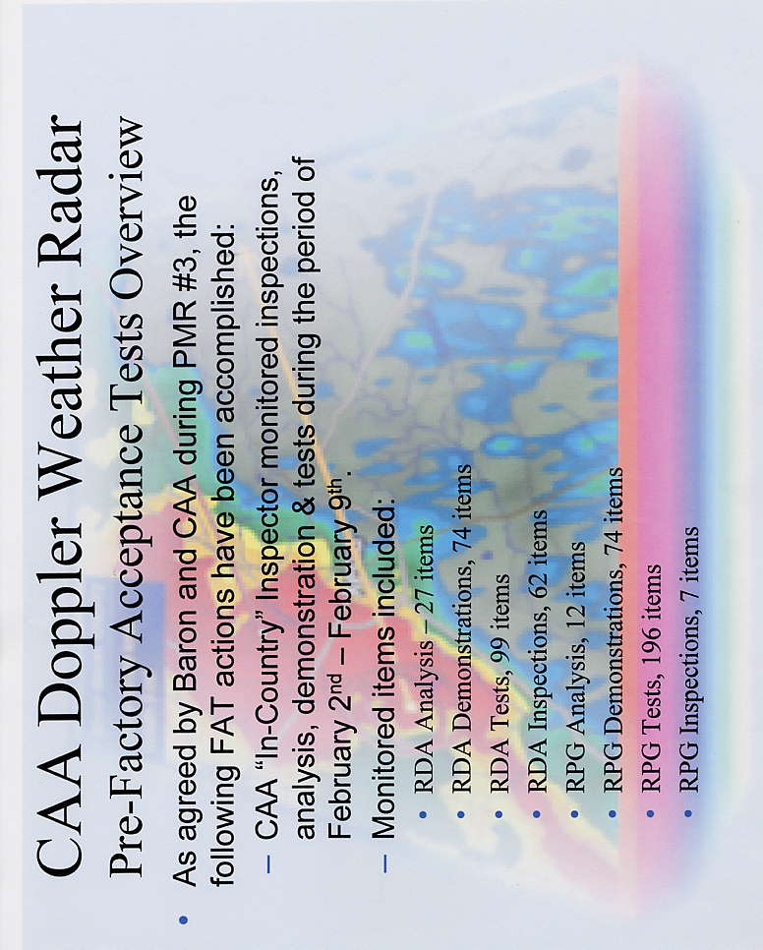

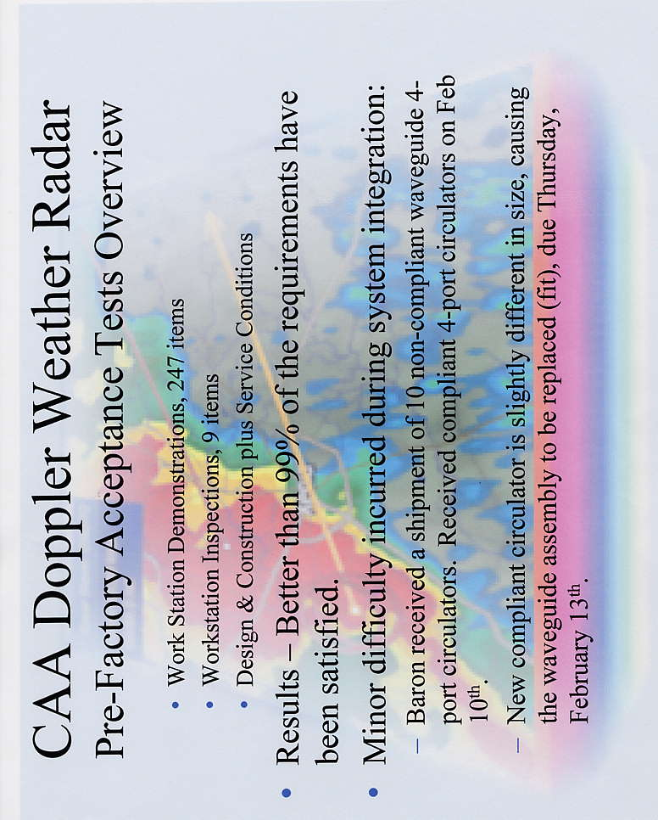

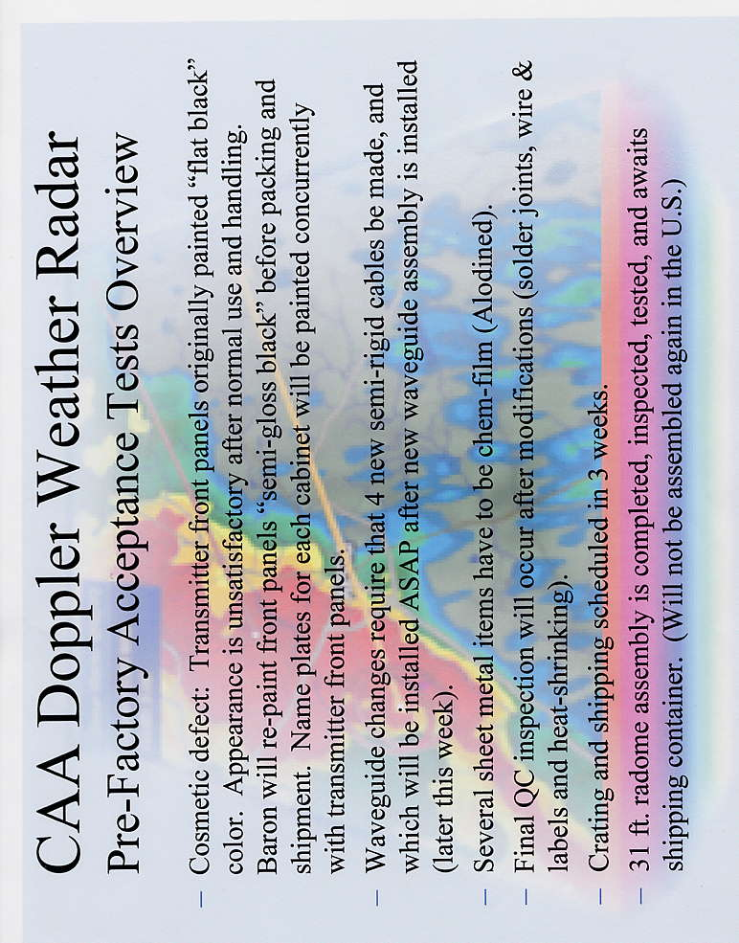

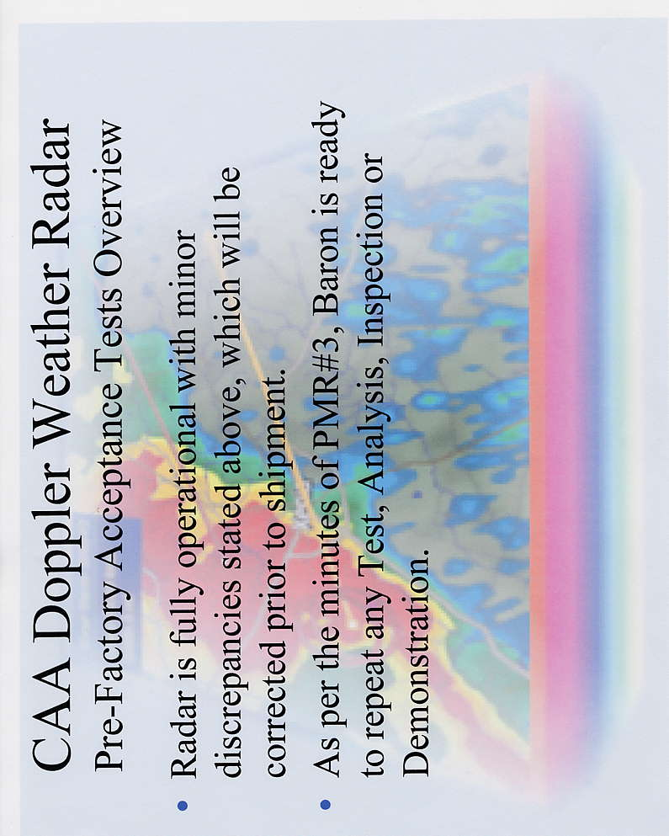

附錄三
工廠驗收測試 (FAT)驗收紀錄

